The approach to DTM&Partners Cooperation - in brief

Why Work Together?

- DTM data are aimed at informing humanitarian response
- DTM data from Location Assessments are shared with all humanitarian actors
- By working together you can make DTM data more useful for response
An analysis of the main reasons for partial use of DTM data highlighted the need for DTM and Partners to work together in order to obtain data and analysis that support humanitarian response.
Modalities for this engagement, as well as roles and tasks have to be jointly agreed and predictable, so that DTM and Partners have a road map for cooperation, that is consistently applied in the field.

How do we work together?
- We use a predictable and consistent approach: DTM and Partners use and expect to use the same approach in all responses
- Proposed approach is built on best practices and shared agreement
- Agreement on this approach was reached through Grand Bargain Needs Assessment Work stream and global level cooperation between DTM and most Global Clusters, WG, AoRs.

How was the approach developed?
The approach and tools described here are based on best practices in the humanitarian sector and developed through consultations with DTM, Global Cluster /AoR/WGs and other partners. They are also adapted from work by the Working Group on Useful and Usable Data and Analysis (EDAUUR) under the Grand Bargain work stream on Needs Assessment. The EDAUUR working group is composed by:
- Global Clusters and AoRs (including Global CCCM Cluster, Global Child Protection AoR, Global Education Cluster, Global Food Security Cluster, Global GBV AoR, Global Health Cluster, Global Protection Cluster, Global Shelter Cluster, Global UNICEF Cluster Coordination Team, Global WASH Cluster)
- UN Offices and Agencies (including UNHCR FICS, WFP VAM, OCHA FIS, OCHA NAAS)
- Donors (including DIFD, ECHO, OFDA)
- NGOs (including MapAction, REACH - Impact, DRC, Geneva Centre for Humanitarian Demining, Terre Des Hommes Lausanne) and
- Other organizations and initiatives, including ACAPS, JIPS, PIM, ICRC.

What are the principles of this approach?
- The main steps of the Assessment Process are common to most humanitarian organizations and groups/clusters.
- Cooperation is especially needed at specific steps of Assessment Process.
- Cooperation must value, respect and make use of different but complementary skillsets:
  - Decision-Makers
  - Subject-Matter Experts
  - Context/Cultural Experts
  - Information Management/Data Experts

- DTM and Partners will engage at crucial steps of the assessment process according to their skillsets.
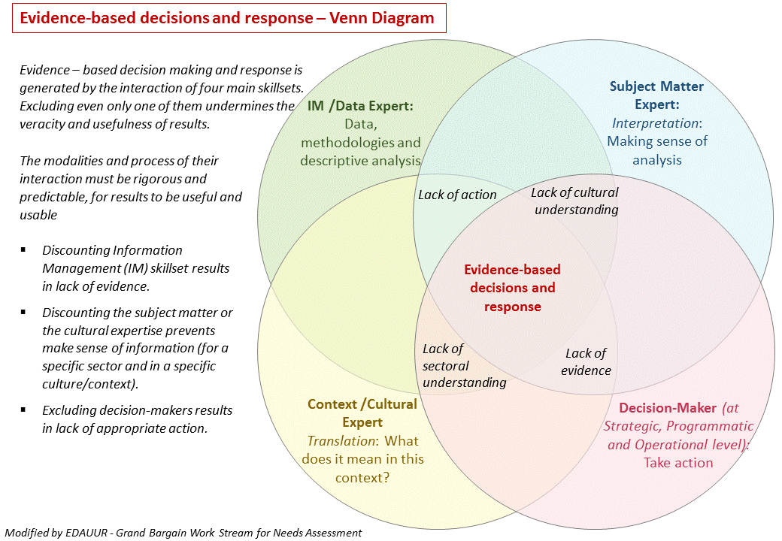
In some cases the same actor may have more than one skillset. Cluster Coordinators and members for example, are often both Decision-Makers (for strategic and operational response) as well as Subject-Matter Experts. Local staff may be at the same time Subject-Matter and Context/Cultural Experts.

