DTM Field Companion Mine Action - Final DRAFT - March 2020
Contents
Proposed questions: 1
Unique ID: TEMP01 - Presence of explosive ordnance in current location 1
Unique ID: TEMP02 - Marked and unmarked presence of explosive ordnance in current location 3
Unique ID: TEMP03 - Locations where conflict is ongoing likely to have recent Explosive Ordnance 4
Unique ID: TEMP04 - Contamination from explosive ordnance – incidents involving humans 5
Unique ID: TEMP05 - Contamination from explosive ordnance – incidents involving animals 6
Unique ID: TEMP06 - Impact of EO contamination on community’s livelihood and food security 7
Unique ID: TEMP07 - Impact of contamination by explosive ordnance on access to goods & services 8
Unique ID: TEMP08 - Communities where explosive ordnance risk education has been provided to specific groups 9
Unique ID: TEMP09 - Communities where EO risk education has been provided and when 10
Unique ID: TEMP10 - Comments for Mine Action 11
Existing questions of interest for Mine Action actors 12
Unique ID: M0350 - specific reason for displacement 12
Unique ID: S0474 - Reason for inability to move safely 13
Unique ID: S0217 - Concerns about place of origin 14
Unique ID: S0483 - Reason preventing return 15
Unique ID: S0484 – Planned Relocation 16
Unique ID: S0485 to S0488 - admin 1 (2,3,and 4) location of intended relocation largest IDP group 17
Unique ID: M0413 to M0427 - Place of origin, largest/second largest/third largest IDP group (admin 1, 2, 3, 4 and 5) 18
Unique ID: S0110 - Accessibility of location (safety and security) 19
Unique ID: S1046 - likely future accidents under 18 years old 20
Unique ID: S0240 - Source where community receives information from 21
Unique ID: M0243 - Main radio station 22
Unique ID: M0244 - Time of day community listens to radio 23
Unique ID: S0247 - Accessible means of communication 24
Unique ID: S0169 - main language spoken on site 25
Unique ID: S0170 - other languages spoken on site 26

Proposed questions:

Unique ID: TEMP01 - Presence of explosive ordnance in current location
- Information Need: Presence of explosive ordnance in current location
- Type of Question: Optional
- Dissemination Category/Modality: Public [carefully consider the possible consequences in your context for Informants, community, enumerators and the organization, both at collection, storing, sharing and analysing phases]
- Instructions for the Form: Select one
- Question Text: Are there places in this location or next to the site that people avoid due to risk of explosive ordnance?
- Response Options: a) Yes, people are avoiding places in and around this location due to the risk of explosive ordnance; b) No; c) do not know/no answer
Preconditions for Data Collection: Ensure that asking this question is not likely to do harm to enumerators, key informants (K)I, communities or organization (IOM, Mine Action AoR). Provide clarification during training and on the questionnaire for enumerators of what is meant by “Explosive ordnance” (consisting of mines, explosive remnants of war, including cluster munitions, and improvised explosive devices – IED) and how to explain it to key informants in your context. Mine Action AoR colleagues should train enumerators and could provide additional resources, including visual examples.
Remember that Key Informants will not be able to be exact on the type of EO: the purpose of this question is to get an initial understanding of where possible contamination is, and then Mine Action colleagues will do a Non-Technical assessment in identified priority locations.
The official definition interprets as encompassing mine action’s response to the following munitions: Mines, Cluster Munitions, Unexploded Ordnance, Abandoned Ordnance, Booby traps, Other devices (as defined by CCW APII), Improvised Explosive Devices (Improvised Explosive Devices (IEDs) meeting the definition of mines, booby-traps or other devices fall under the scope of mine action, when their clearance is undertaken for humanitarian purposes and in areas where active hostilities have ceased.
- Example of Use by Mine Action actors: prioritize locations for sectoral assessments
- Example of Descriptive Analysis: According to KI, in xx assessed sites there are places that people avoid due to risk of explosive ordnance. In xxy sites, there are no places that people avoid due to risk of explosive ordnance. In xy sites, KI could not answer.
- Example of Visualization:
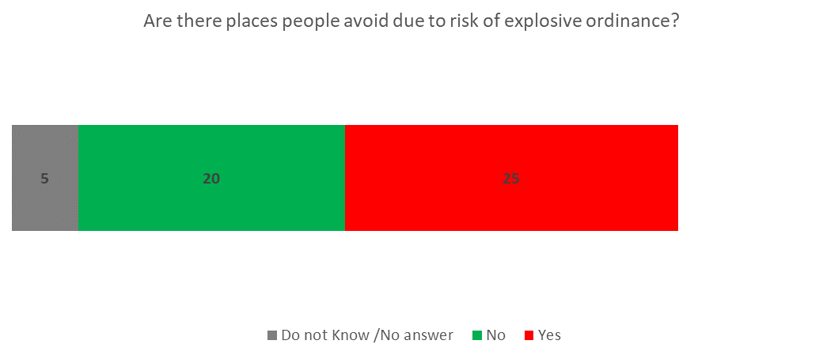

Unique ID: TEMP02 - Marked and unmarked presence of explosive ordnance in current location
- Information Need: Marked and unmarked presence of explosive ordnance in current location
- Type of Question: Optional
- Dissemination Category/Modality: Public [carefully consider the possible consequences in your context for Informants, community, enumerators and the organization, both at collection, storing, sharing and analysing phases]
- Instructions for the Form: Select one
- Question Text: Are there explosive ordnance in this location or next to this site?
- Response Options: a) Yes, we know that there are explosive ordnance in this location or next to it. However, they are not marked by any sign; b) Yes, we know that there are explosive ordnance in this location or next to it. However they are marked by signs; d) No, based on what we know, there are no explosive ordnance in this location or next to it; e) we do not know/no answer
- Preconditions for Data Collection: Ensure that asking this question is not likely to do harm to enumerators, key informants (K)I, communities or organization (IOM, Mine Action AoR). Provide clarification during training and on the questionnaire for enumerators of what is meant by “Explosive ordnance” (consisting of mines, explosive remnants of war, including cluster munitions, and improvised explosive devices – IED) and how to explain it to key informants in your context. Mine Action AoR colleagues should train enumerators and could provide additional resources, including visual examples.
Remember that Key Informants will not be able to be exact on the type of EO: the purpose of this question is to get an initial understanding of where possible contamination is, and then Mine Action colleagues will do a Non-Technical assessment in identified priority locations.
The official definition interprets as encompassing mine action’s response to the following munitions: Mines, Cluster Munitions, Unexploded Ordnance, Abandoned Ordnance, Booby traps, Other devices (as defined by CCW APII), Improvised Explosive Devices (Improvised Explosive Devices (IEDs) meeting the definition of mines, booby-traps or other devices fall under the scope of mine action, when their clearance is undertaken for humanitarian purposes and in areas where active hostilities have ceased.
- Example of Use that can be done by Mine Action actors: prioritizing locations for sectoral assessment: if marked, possibly it is a hazard area known to Mine Action colleagues and may have been assessed. It is however important for Mine Action colleagues to know that there are now people living there. If it is unmarked it may not be known as a hazard area, and it should be prioritized for Mine Action non-technical survey.
- Example of Descriptive Analysis: According to KI, in xx assessed sites there are unmarked explosive ordnance in the sites or next to them. In xxy sites, there are marked explosive ordnance and in zy sites there are no known explosive ordnance. In xy sites, KI could not answer.
- Example of Visualization:

Unique ID: TEMP03 - Locations where conflict is ongoing likely to have recent Explosive Ordnance
- Information Need: Locations where conflict is ongoing likely to have recent Explosive Ordnance
- Type of Question: optional
- Dissemination Category: Public [carefully consider the possible consequences in your context for Informants, community, enumerators and the organization, both at collection, storing, sharing and analysing phases]
- Instructions for the Form: select one
- Question Text: Has your community witnessed any explosion in this location (e.g., Airstrikes, RPG, Mortar, IEDs, Grenade)?
- Response Options: a) No, b) Yes, less than [insert timeframe that is useful in your context], c) Yes, more than [insert timeframe that is useful in your context], d) I don’t know
- Preconditions for Data Collection: Agree on a timeframe that will lead to action (e.g., if explosion is before [time] than we need an assessment team at that location…)
- Example of Use by Mine Action actors: gain an understanding of specific locations where there may be contamination due to active conflict (e.g., strikes, contamination…), to help prioritize assessments/interventions
- Example of Descriptive Analysis: According to KI, community has witnessed explosion in current location in xx out of yy assessed sites in the last [time]. In yx sites, explosions were witnessed [time] before assessment, and in xy sites Key Informants could not recall community having witnessed any explosion in current location. In xy sites, KI could not answer.

- Example of Visualization:

Unique ID: TEMP04 - Contamination from explosive ordnance – incidents involving humans
- Information Need: Contamination from explosive ordnance – incidents involving humans
- Type of Question: Optional
- Dissemination Category/Modality: Public [carefully consider the possible consequences in your context for Informants, community, enumerators and the organization, both at collection, storing, sharing and analysing phases]
- Instructions for the Form: Select all that apply
- Question Text: Was somebody in this community or in the host community injured or killed by an explosive ordnance in the last [reporting period- since the last assessment]?
- Response Options: a) One or more persons were injured or killed by an explosive ordnance in this location in the last [reporting period- since the last assessment]; b) One or more persons were injured or killed in this location before [the reporting period/ before the last assessment], c) One or more persons were injured or killed by an explosive ordnance in their location of origin (where the community comes from), d) Based on what we know, nobody was injured or killed by an explosive ordnance in this location or in the location of origin (where the community comes from); e) do not know/no answer
- Preconditions for Data Collection:
  - Ensure that asking this question is unlikely to do harm to enumerators, KI, communities or organization (IOM, Mine Action AoR).
  - Provide clarification during training and on the questionnaire for enumerators of what is meant by “Explosive ordnance” (consisting of mines, explosive remnants of war, including cluster munitions, and improvised explosive devices - IEDs), and “marked or unmarked”. Mine Action AoR colleagues should train enumerators and could provide additional resources, including visual examples.
  - The IMO is able to keep track of the replies from previous rounds of DTM and does not de-prioritize locations where there have been victims, even if not in the last round.
- Example of Use by Mine Action actors: prioritizing locations for sectoral assessment: if there have been victims, the threat is severe, and the location should be prioritized for Mine Action non-technical survey and victim assistance. Locations where there have been victims, even if not in the last round should not be de-prioritized.
- Example of Descriptive Analysis: According to KI, in xx assessed sites one or more persons were injured or killed by an explosive ordnance in the current location in the last [reporting period]. In xxy sites, nobody was injured or killed by an explosive ordnance in the current location in the last [reporting period], however somebody was injured or killed by an explosive ordnance in the current location before that period. In xxy sites, nobody was injured or killed by an explosive ordnance in the current location, however somebody was injured or killed by an explosive ordnance in their place of origin. In xy sites, KI could not answer.
- Example of Visualization:

Unique ID: TEMP05 - Contamination from explosive ordnance – incidents involving animals
- Information Need: Contamination from explosive ordnance – incidents involving animal
- Type of Question: Optional
- Dissemination Category/Modality: Public [carefully consider the possible consequences in you context for Informants, community, enumerators and the organization, both at collection, storing, sharing and analysing phases]
- Instructions for the Form: Select all that apply
- Question Text: Was any livestock/wild animal/other animal injured or killed by an explosive ordnance in the last [reporting period- since the last assessment]?
- Response Options: a) One or more animals were injured or killed by an explosive ordnance in this location in the last [reporting period- since the last assessment]; b) One or more animal were injured or killed in this location before [the reporting period/ before the last assessment], c) One or more animal were injured or killed by an explosive ordnance in their location of origin (where the community comes from), d) Based on what we know, no animal was injured or killed by an explosive ordnance in this location or in the location of origin (where the community comes from); e) do not know/no answer
- Preconditions for Data Collection:
  - Ensure that asking this question is unlikely to do harm to enumerators, KI, communities or organization (IOM, Mine Action AoR).
  - Provide clarification during training and on the questionnaire for enumerators of what is meant by “Explosive ordnance” (consisting of mines, explosive remnants of war, including cluster munitions, and improvised explosive devices - IEDs), and “marked or unmarked”. Mine Action AoR colleagues should train enumerators and could provide additional resources, including visual examples.
  - The IMO is able to keep track of the replies from previous rounds of DTM and does not de-prioritize locations where there have been victims, even if no positive answer was given in the last round.
- Example of Use by Mine Action actors: prioritizing locations for sectoral assessment: if there has been animal death, the threat may be considered severe, and the relevant location may be prioritized for Mine Action non-technical survey. Locations where there have been deaths of animals, even if not in the last round should not be de-prioritized.
- Example of Descriptive Analysis: According to KI, in xx assessed sites one or more animals (livestock or other animal) were injured or killed by an explosive ordnance in the current location in the last [reporting period]. In xxy sites, no animal was injured or killed by an explosive ordnance in the current location in the last [reporting period], however some was injured or killed by an explosive ordnance in the current location before that period. In xxy sites, no animal was injured or killed by an explosive ordnance in the current location, however some animal was injured or killed by an explosive ordnance in their place of origin. In xy sites, KI could not answer.
- Example of Visualization:

Unique ID: TEMP06 - Impact of EO contamination on community’s livelihood and food security
- Information Need: Impact of Explosive Ordnance contamination on community’s livelihood and food security
- Type of Question: Optional
- Dissemination Category/Modality: Public [carefully consider the possible consequences in your context for Informants, community, enumerators and the organization, both at collection, storing, sharing and analysing phases]
- Instructions for the Form: Select one
- Question Text: Is the presence of explosive ordnance making it difficult for people to earn a living? (e.g., there are explosive ordnance in the agricultural fields, there are explosive ordnance where the livestock would graze, there are explosive ordnance on the way to selling items...)
- Response Options: a) yes, for many people, b) yes, for some people, c) No, d) Do not know/No answer
- Preconditions for Data Collection:
- Example of Use that can be done by Mine Action and Food Security actors: prioritize locations for surveys. Advocacy with donors for alternative livelihood and identifying appropriate modality for short term food security/livelihood response.
- Example of Descriptive Analysis: According to KI, in xx assessed sites, the presence of explosive ordnance making it difficult for many people to earn a living, and in xx assessed sites the presence of explosive ordnance making it difficult for some people to earn a living. In xy sites, KI could not answer.
- Example of Visualization:

Unique ID: TEMP07 - Impact of contamination by explosive ordnance on access to goods & services
- Information Need: impact of explosive ordnance on access to goods and services
- Type of Question: optional
- Dissemination Category: Public [carefully consider the possible consequences in you context for Informants, community, enumerators and the organization, both at collection, storing, sharing and analysing phases]
- Instructions for the Form: select all that apply
- Question Text: If explosive ordnance [explain] are negatively affecting people in this location, what goods /items/locations or services are people from this location unable to access (or they access but at high risk for their health and life)?
- Response Options: Fuel/firewood, Healthcare, Schools/education facilities, Documentation, Water, toilets/latrines, bathing facilities, washing facilities, security services, food distributions, NFI distribution, other distribution (specify), work place/fields for livelihood, market to buy or sell items, support services in the location (contextualise, including protection services), people cannot move around the site; main entrance/exit of the site; other (specify), no explosive ordnance is negatively affecting people in this location, do not know/no answer
- Preconditions for Data Collection: identify options that are relevant in the context
- Recommended Source of information:
- Example of Descriptive Analysis: According to Key informants, in xx% of assessed sites access to goods and services is impacted by contamination /Explosive Ordnance.
- Example of Use by Data Users (e.g. Clusters, WGs…): identify locations where presence of explosive ordnance is impacting people’s access to services and goods, and prioritize locations for Mine Action interventions
- Dataset of Interest for: Mine Action, CCCM, Health, Education, Protection, Child Protection, Livelihood, Cash, Food security, Nutrition, Shelter, WASH
- Example of Visualization:

Unique ID: TEMP08 - Communities where explosive ordnance risk education has been provided to specific groups

- Information Need: Communities where explosive ordnance risk education has been provided to specific groups
- Type of Question: Optional
- Dissemination Category/Modality: Public [carefully consider the possible consequences in your context for Informants, community, enumerators and the organization, both at collection, storing, sharing and analysing phases]
- Instructions for the Form: Select all that apply
- Question Text: Has anybody given information to your community on how to reduce the risk of injury from explosive ordnance?
- Response Options: a) yes to adult women (females 18 or older, b) yes to adult men (males 18 or older), c) yes to girls (female under 18), d) yes to boys (males under 18), e) yes, but we need more information, f) yes, there was a general mass information campaign through mass media; g) No, nobody has given us such information, h) do not know/no answer
- Preconditions for Data Collection: clarify to Mine Action actors that it is not possible to know whether the whole community has been provided with information or only a part of it
- Example of Use by Mine Action actors: identify gaps in Explosive Ordnance Risk Education, also by specific age and gender group, and prioritize education in locations and groups according to need. Combine with data from Explosive Ordnance Risk Education actors and data on victims in this location, if available by age and gender.
- Example of Descriptive Analysis: According to KI, EORE has been provided in xx out of yy assessed sites. In yx sites, EORE was NOT provided to men, in xy sites it was not provided to women, in xx sites it was NOT provided to boys and in xy sites it was not provided to girls. In xy sites, KI could not answer.
- Examples (2) of Visualization:

Unique ID: TEMP09 - Communities where Explosive Ordnance Risk Education (EORE) has been provided and when
- Information Need: Communities where explosive ordnance risk education has been provided and when
- Type of Question: optional
- Dissemination Category: Public [carefully consider the possible consequences in you context for Informants, community, enumerators and the organization, both at collection, storing, sharing and analysing phases]
- Instructions for the Form: select one
- Question Text: Has anybody given information to your community on how to reduce the risk of injury from explosive ordnance (for example, how they look like and to keep yourself safe)?
- Response Options: a) yes, in the last [12 months], b) yes, more than [12 months] ago, c) No, nobody has given us such information, d) do not know/no answer
- Preconditions for Data Collection: clarify to Mine Action actors that it is not possible to know whether the whole community has been provided with information or only a part of it. Agree on a timeframe that will lead to action, if different from 12 months (e.g., if EORE was received more than 12 months ago, and there is contamination, then this location needs a new round of EORE)
- Example of Use by Mine Action actors: identify gaps in risk education, and add two tier priority for Explosive Ordnance Risk Education: 1) those who have not received it at all and 2) those who have received it more than 12 months ago. Combine with data from EORE actors and data on victims in this location, if available by age and gender.
- Example of Descriptive Analysis: According to KI, Explosive Ordnance Risk Education has been provided in xx out of yy assessed sites in the last [time]. In yx sites, EORE was provided more than [time] before assessment, and in xy sites Key Informants could not recall it being provided at all. In xy sites, KI could not answer.

- Example of Visualization:

Unique ID: TEMP10 - Comments for Mine Action
- Information Need: Comments for Mine Action
- Dissemination Category/Modality: private/confidential
- Type of Question: Optional
- Instructions for the Form: Free text
- Question Text: Any observation that may be relevant for Mine Action colleagues to know about this location? (e.g., visible signs of explosive ordnance? Visible warning signs on explosive ordnance? Information about incidents? Contradictory information on presence of explosive ordnance?)
- Response Options: free text
- Preconditions for Data Collection: collect them only if AoR has the capacity to analyse qualitative information from hundreds of locations and there is a documented plan on how to use the information.
- Example of Use by Mine Action actors: [Mine Action colleagues should specify use before including this question]
- Example of Descriptive Analysis: none
- Example of Visualization: None

Existing questions of interest for Mine Action actors

These are existing DTM Field Companion questions that may be of interest to Mine Action colleagues for their analysis, in addition to: Number of Individuals, HH and SADD per location, List of locations hosting displaced population with geographical coordinates

Unique ID: M0350 - specific reason for displacement
- Information Need: specific reason for displacement
- Type of Question: optional
- Dissemination Category: Public
- Instructions for the Form: Select one
- Question Text: Are there IDPs that were displaced due to (specify reason)?
- Response Options: yes; no; Do not know/no answer
- Preconditions for Data Collection: Agree with Mine Action colleagues in country on including this question, with the specific reasons: "Presence or Fear of Explosive Ordnance in place of origin"
- Recommended Source of information:
- Example of Visualization:
- Example of Descriptive Analysis:
- Example of Use that can be done by Data Users (e.g. Clusters, WGs…):
- Dataset of Interest for:

Unique ID: S0474 - Reason for inability to move safely
- Information Need:
- Type of Question: optional
- Dissemination Category: Public
- Instructions for the Form: Select one
- Question Text: If they do not have the ability to safely move from place to place, why not?
- Response Options: Transport unavailable; Transport expensive; Lack of Transport during seasons (e.g., lack of infrastructure or navigable roads for example during rainy season); Insecurity Restrictions (curfew); Other, do not know/no answer
- Preconditions for Data Collection: Agree with Mine Action colleagues on including "Presence or Fear of Explosive Ordnance" as an option for answer Member of residents committee / Protection actor/ Site Manager
- Recommended Source of information:
- Example of Visualization:
- Example of Descriptive Analysis: In xx% of assessed locations where people are not able to safely move, KI stated that the reason is x, in xx% locations it is xzy, and in x% locations the reason identified by KI is xx. In X% assessed locations where people are not able to safely move, KI could not answer
- Example of Use that can be done by Data Users (e.g. Clusters, WGs…):
- Dataset of Interest for: protection, CCCM, Mine Action

Unique ID: S0217 - Concerns about place of origin
- Information Need: concerns about place of origin
- Type of Question: optional
- Dissemination Category: Public
- Instructions for the Form: select up to 3
- Question Text: What are the three issues that mostly concern [population group] population in the location about their place of origin?
- Response Options: conflict/violence; presence of explosive ordnance (consisting of mines, explosive remnants of war including cluster munitions, and improvised explosive devices - IEDs); damaged shelter and infrastructure; discrimination; lack of basic services; lack of livelihood opportunities; competition over resources, others (Specify); do not know/no answer
- Preconditions for Data Collection:
- Recommended Source of information: Site Management
- Example of Descriptive Analysis: According to key informants, the main issues of current concern for IDPs about their place of origin are Lack of livelihood opportunities (in xx% of assessed sites), Lack of basic services (in xx% of assessed sites), Damaged shelter and infrastructure (in xx% of sites)... In xx% of assessed sites, KI could not answer.
- Example of Use by Data Users (e.g. Clusters, WGs…):
- Dataset of Interest for: Protection, Mine Action
- Example of Visualization:

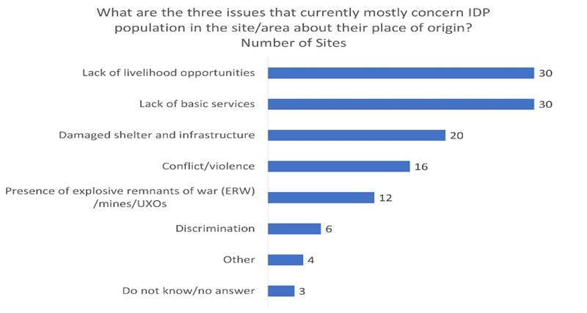

Unique ID: S0483 - Reason preventing return
- Information Need: reason preventing return
- Type of Question: optional
- Dissemination Category: Public
- Instructions for the Form: select one
- Question Text: What is preventing the largest IDP group from returning home?
- Response Options: Accessibility; Lack of food; House damaged/destroyed; Lack of safety; No livelihood; Basic infrastructures damaged/flooded; Nothing; Do not know/no answer; Other (specify)
- Preconditions for Data Collection: Agree with Mine Action colleagues in country on including "Presence or fear of Explosive Ordnance in place of origin"
- Recommended Source of information: Site Management
- Example of Visualization:
- Example of Descriptive Analysis:
- Example of Use by Data Users (e.g. Clusters, WGs…):
- Dataset of Interest for: Protection, Mine Action

Unique ID: S0484 – Planned Relocation
- Information Need: Planned Relocation
- Type of Question: optional
- Dissemination Category: Public
- Instructions for the Form: select one
- Question Text: Is relocation planned for largest group of IDPs?
- Response Options: yes; no; Do not know/no answer
- Preconditions for Data Collection:
- Recommended Source of information: Site Management
- Example of Visualization:
- Example of Descriptive Analysis:
- Example of Use by Data Users (e.g. Clusters, WGs…): Mine Action colleagues should know if relocation is planned and where it is planned to (see next questions) so to de-prioritize interventions in sites where people are moving away from and prioritize sites of planned relocation.
- Dataset of Interest for: All

Unique ID: S0485 to S0488 - admin 1 (2,3,and 4) location of intended relocation largest IDP group
- Information Need: admin 1 (2,3,and 4) location of intended relocation largest IDP group
- Type of Question: optional
- Dissemination Category: Public
- Instructions for the Form:
- Question Text: ADMIN 1to 4 location of intended relocation planned for largest group of IDPs
- Response Options: [text]
- Preconditions for Data Collection:
- Recommended Source of information: Site Management
- Example of Visualization:
- Example of Descriptive Analysis:
- Example of Use by Data Users (e.g. Clusters, WGs…): Mine Action colleagues should know if relocation is planned and where it is planned to (see next questions) so to de-prioritize interventions in sites where people are moving away from and prioritize sites of planned relocation.
- Dataset of Interest for: All

Unique ID: M0413 to M0427 - Place of origin, largest/second largest/third largest IDP group (admin 1, 2, 3, 4 and 5)
- Information Need: Place of origin, largest/second largest/third largest IDP group (admin 1, 2, 3, 4 and 5)
- Type of Question: Core
- Dissemination Category: Public
- Instructions for the Form:
- Question Text: Place of origin of the largest largest/second largest/third largest population group in location (admin 1, 2, 3, 4 and 5)
- Response Options: [text]
- Preconditions for Data Collection:
- Recommended Source of information:
- Example of Visualization:
- Example of Descriptive Analysis:
- Example of Use by Data Users (e.g. Clusters, WGs…): This information can be analysed by Mine Action colleagues to identify what locations of origin of IDPs has been contaminated and prioritize response (e.g., explosive ordnance risk education in place of displacement or demining in PoO)
- Dataset of Interest for:

Unique ID: S0110 - Accessibility of location (safety and security)
- Information Need: Accessibility of location (safety and security)
- Type of Question: recommended by cluster
- Dissemination Category: Public
- Instructions for the Form: Select one
- Question Text: Is it safe and secure to access the location?
- Response Options: Yes; Limited/Intermittently (due to constraints such as criminality, road-blocks, or armed conflict); No; do not know/no answer
- Preconditions for Data Collection:
- Recommended Source of information: Site management
- Example of Descriptive Analysis: According to key informants xx% of sites have limited access due to insecurity. In xx% of assessed sites, KI could not answer.
- Example of Use by Data Users (e.g. Clusters, WGs…): identify where access of population to humanitarian assistance is restricted or limited. Results over successive rounds can be analysed over time to identify access (e.g., by OCHA).
- Dataset of Interest for: All, protection, OCHA access monitoring
- Example of Visualization:

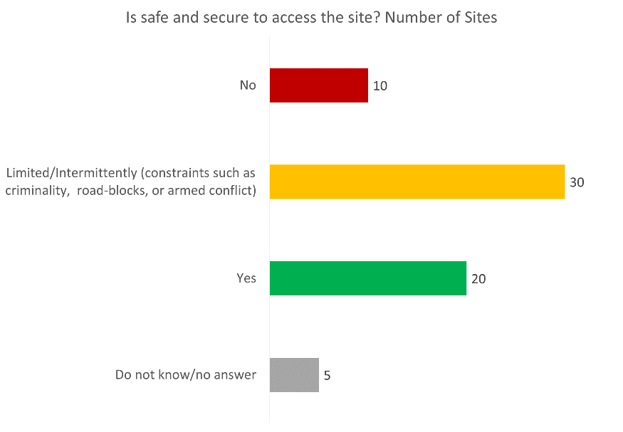

Unique ID: S1046 - likely future accidents under 18 years old
- Information Need: likely future accidents under 18 years old
- Type of Question: required by cluster for severity analysis
- Dissemination Category: Confidential
- Instructions for the Form: Select one
- Question Text: What type of accidents are children under 18 years very likely to be injured or killed by in or around the site within the next 30 days?
- Response Options: Accidents from physical dangers include issues with construction, site layout, weather, objects, animals. It does not include violence. Minor common home accidents; Exposure of some children to minor accidents: falling into open holes/ditches, injuries due to poor lighting, burns from cooking fires etc); Exposure of some children to serious accidents: electrocution due to exposed wiring, vehicle accident, undomesticated animals etc.; Exposure of many children to serious accidents: extreme weather, wide-spread fire on the site etc.; Exposure of many children to critical accidents related to explosive ordnance; Do not know/no answer
- Preconditions for Data Collection:
- Recommended Source of information: Site Management, Child Protection actor, (women and man) members of residents committee, protection actors, education professional
- Example of Descriptive Analysis:
- Example of Use that can be done by Data Users (e.g. Clusters, WGs…):
- Dataset of Interest for: Child protection, protection, GBV, Mine Action
- Example of Visualization:
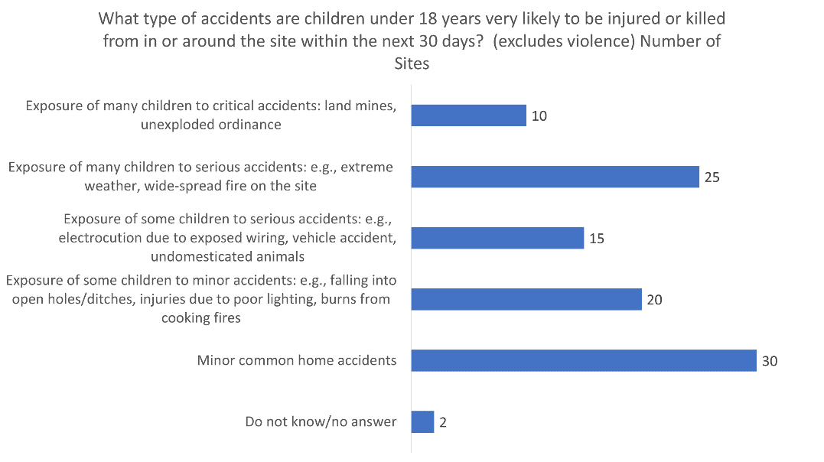

Unique ID: S0240 - Source where community receives information from
- Information Need: Source where community receives information from
- Type of Question: optional
- Dissemination Category: Public
- Instructions for the Form: Select up to 3
- Question Text: Where do residents mostly get their information from?
- Response Options: Mouth to mouth (family/friends); local leaders; site management authorities; radio/news; telephone voice call; SMS; social media; do not receive any information; other (specify); do not know/no answer
- Preconditions for Data Collection:
- Recommended Source of information: Site Management, Members of residents committee (woman and man)
- Example of Descriptive Analysis: According to Key informants, in xx% of assessed sites residents mostly get their information from mobile phones, in xx% of the sites, from local leaders, in xx% of sites from Family and friends, in xx% of sites from social media, in xx% of sites from authorities, in xx% of sites from site management, in xx% of sites form other sources. KI in xx% of sites stated that residents do not receive information, and in xx% of sites KI could not answer
- Example of Use by Data Users (e.g. Clusters, WGs…): to plan information campaigns (also Explosive Ordnance Risk Education)
- Dataset of Interest for: AAP/PSEA CCCM Health Protection CWC, Mine Action
- Example of Visualization:
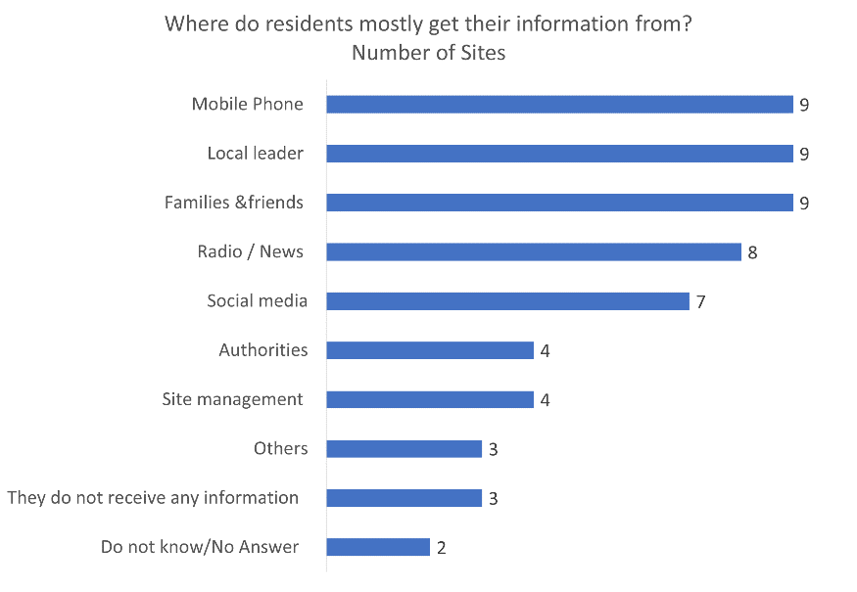

Unique ID: M0243 - Main radio station
- Information Need: Main radio station
- Type of Question: optional
- Dissemination Category: Public
- Instructions for the Form:
- Question Text: What is the main radio station people listen to now?
- Response Options: Free [text]
- Preconditions for Data Collection:
- Recommended Source of information: Site Management, Members of residents committee (woman and man)
- Example of Descriptive Analysis: According to Key informants, in xx% of assessed sites people listen mainly to Radio 1, while in xx% of sites, people listen mainly to Radio 2, and in xx% sites they listen mainly to Radio 3. In xx% of sites they could not answer
- Example of Use by Data Users (e.g. Clusters, WGs…): plan info campaign
- Dataset of Interest for: AAP/PSEA CCCM Education Health Protection CWC, Mine Action
- Example of Visualization:

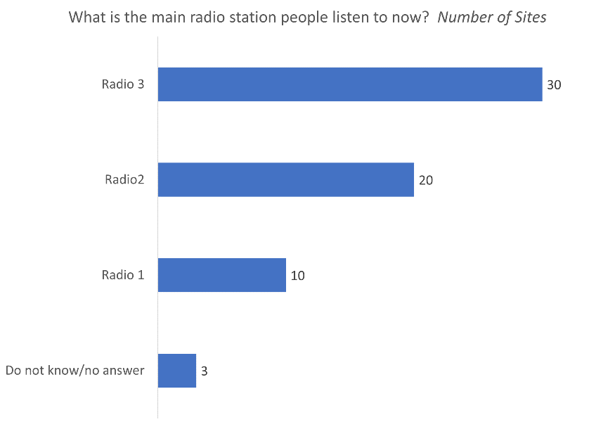

Unique ID: M0244 - Time of day community listens to radio
- Information Need: Time of day community listens to radio
- Type of Question: optional
- Dissemination Category: Public
- Instructions for the Form:
- Question Text: When do people mostly listen to the radio?
- Response Options: answers should be contextualized
- Preconditions for Data Collection:
- Recommended Source of information: Site Management, Members of residents committee (woman and man)
- Example of Descriptive Analysis: According to Key informants, in xx% of assessed sites people listen to the radio mostly during midday, while in xx% of sites people mostly listen in the morning, and in xx% sites in the evening….. In xx% of sites they could not answer
- Example of Use by Data Users (e.g. Clusters, WGs…): plan info campaigns
- Dataset of Interest for: AAP/PSEA CCCM Education Health Protection CWC, Mine Action
- Example of Visualization:
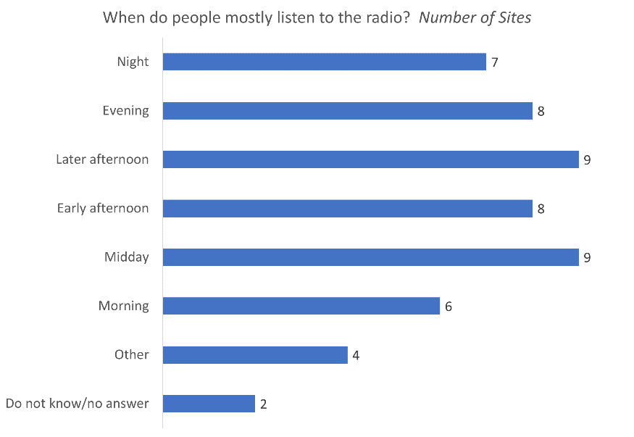

Unique ID: S0247 - Accessible means of communication
- Information Need: Accessible means of communication
- Type of Question: optional
- Dissemination Category: Public
- Instructions for the Form: Select all that apply
- Question Text: What means of communication are available now within a 10 minute walk from your home
- Response Options: Cellular voice; Cellular data; Satellite internet; Satellite phone; BGAN Radio; Other (specify); None; Do not know/No answer
- Preconditions for Data Collection:
- Recommended Source of information: Site Management, Members of residents committee (woman and man)
- Example of Descriptive Analysis: According to Key informants, in xx% of assessed sites radio is available within 10 min walk, in xx% of sites cellular phone is available within 10 min walk,, in xx% of sites, it is cellular data that is available within 10 min walk, and in xx% of sites, satellite phone is available within 10 min walk... KI in xx% of sites stated that no mean of communication is available within 10 min walk, and in xx% of sites they could not answer
- Example of Use by Data Users (e.g. Clusters, WGs…): to plan information campaigns
- Dataset of Interest for: AAP/PSEA CCCM Health Protection CWC, Mine Action
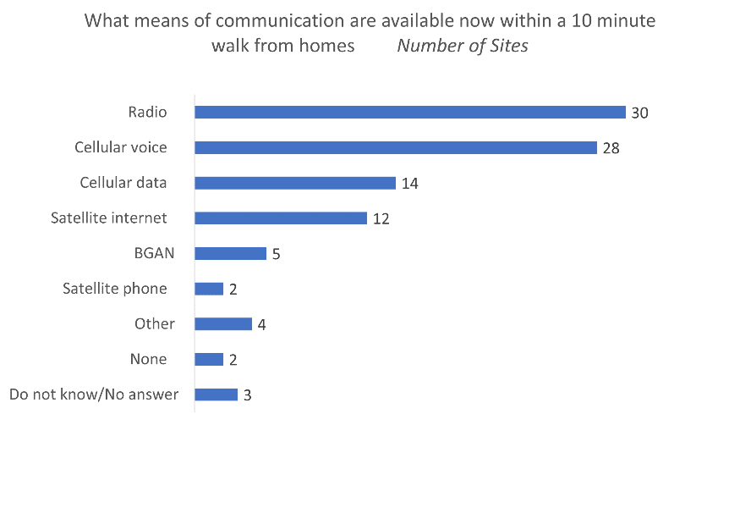
- Example of Visualization:

Unique ID: S0169 - main language spoken on site
- Information Need: main language spoken on site
- Type of Question: recommended by expert
- Dissemination Category: Private
- Instructions for the Form: select one
- Question Text: what is the main language/dialect spoken by [population group] in this location?
- Response Options:
- Preconditions for Data Collection: include options relevant to the context- Discuss with CCCM, CWC and Protection on options for languages
- Recommended Source of information: teachers, social workers, health workers, member of residents committee/ IDP representatives, Camp Management
- Example of Descriptive Analysis: According to KI, XX language is the main spoken language in z% of assessed sites, ZX language in z% sites, and y language in x% of assessed sites…. KI could not answer in xx% of sites
- Example of Use by Data Users (e.g. Clusters, WGs…): For information material and campaign planning
- Dataset of Interest for: AAP/PSEA CCCM Health Protection CWC, Mine Action
- Example of Visualization:
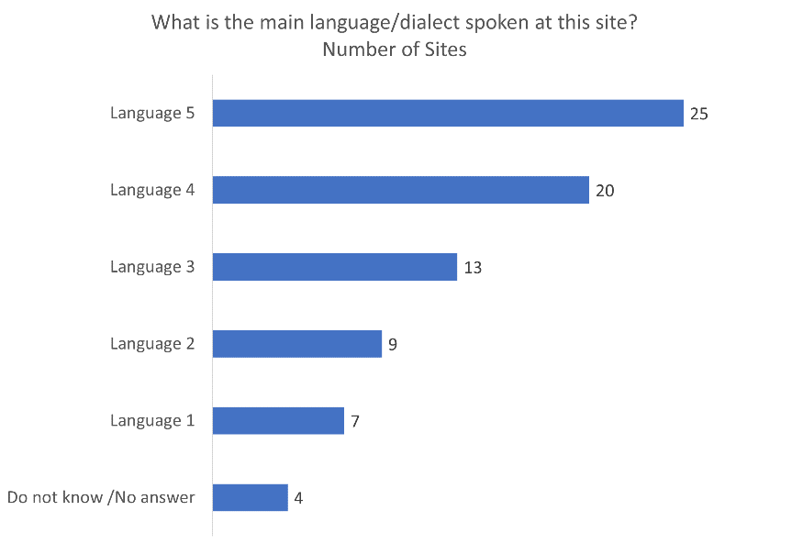

Unique ID: S0170 - other languages spoken on site
- Information Need: other languages spoken on site
- Type of Question: recommended by expert
- Dissemination Category: Private
- Instructions for the Form: select one
- Question Text: what other language(s) are spoken by [population group] in the location?
- Response Options:
- Preconditions for Data Collection: include options relevant to the context. Discuss with CCCM, CWC and Protection on options for languages
- Recommended Source of information: teachers, social workers, health workers, member of residents committee/ IDP representatives, Camp Management
- Example of Descriptive Analysis: According to KI, additional languages are spoken in sites: XX language in z% of assessed sites, ZX language in z% sites, and y language in x% of assessed sites. .. KI could not answer in xx% of sites
- Example of Use by Data Users (e.g. Clusters, WGs…): For information material and campaign planning
- Dataset of Interest for: AAP/PSEA CCCM Health Protection CWC, Mine Action
- Example of Visualization:
