IOM - DTM FAQs - Displacement Tracking Matrix Frequently Asked Questions for the Global Protection Cluster
What is DTM?
The Displacement Tracking Matrix (DTM) is a system to track and monitor displacement and population mobility, provide critical information to decision-makers and responders during crises, and contribute to better understandings of population flows. DTM was first conceptualized in 2004 to monitor internal displacement in Iraq and has since been adapted for implementation in over 60 countries, including in contexts of conflict, natural disaster, complex emergencies and protracted crises.
How does DTM work?
DTM’s effectiveness in meeting varying objectives in a diverse range of contexts relies on its ability to maintain a lightweight, flexible and modular structure, enabling quick adjustments and adaptation. To preserve operational flexibility, while promoting quality and coherence across DTM activities, various components, tools and methods have proven effective for quantifying displacement and mobility in DTM operations worldwide. The four DTM Components are illustrated in the visual below:
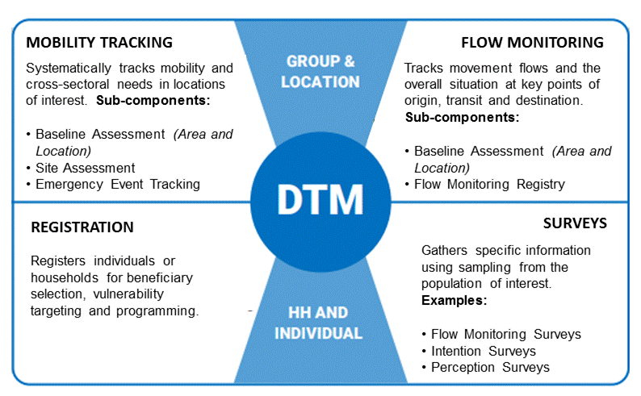
How are data collected?
DTM teams use a variety of methods for collecting data. For Baseline Assessment usually DTM interviews key informants, while observation generally accompanies key informants interviews in Site Assessments. Counting, key informants and observation can be used in flow monitoring registry. For Registration and Surveys DTM teams directly interview individuals or households. Information on the type of Key Informants that were interviewed is included in the data collected.
What DTM information may be useful for Protection Cluster response?
DTM produces a variety of datasets, and sometimes datasets varies between operations. Here are some of the commonly collected types of information that can be relevant to the Protection Cluster from the Mobility Tracking component.
Baseline Assessment usually can provide list of locations (e.g., camps, sites, communities) where displaced persons are, and initial information on the number of people, types of settlement they live in, type of population, reasons for displacement and places of origin, sectors of need.
Site Assessment usually collects information per each location, including access, number of persons, an indication of sex and age disaggregated data, an indication of scale of specific groups, available services, obstacles to accessing services and assistance, site management and security set-up, access to infrastructure by groups, scale of population per dwellings and settlement types.
Emergency Event Tracking is collecting very initial information on displacements caused by particular events. It can provide timely updates on new displacement events occurring between regular DTM assessment rounds on population group description and numbers, location the group is displaced from and displaced to. It can also include an initial sense of the settlement arrangements and some of the urgent sectoral needs.
How can Protection Clusters in countries use DTM information?
DTM data are often used to understand scope and scale of displacement, as well as trends. However, they are also used operationally, for example to raise alerts and red flags on locations in urgent sectoral need, and to help prioritize locations for follow up actions.

Methods and context have an impact on the information collected in any such exercise. DTM is not a Protection Monitoring or Protection Needs Assessment tool. In its mobility tracking component, DTM does not interview individuals, and DTM enumerators and key informants are not protection experts. DTM, however, has a large and consistent coverage of crisis, can be adjusted to collect information that clusters need, and provides regular updates on critical issues. In addition, its data are collected over time, and can indicate how displacement and conditions of displaced populations evolve over time.

DTM questions are designed to be answered by non-sectoral experts, in a way that results can be used by sectoral experts for analysis. Ideally, DTM teams provide the clusters with information and possibly descriptive analysis (with Cluster IM experts). Information is then jointly analysed by the cluster members (subject matter experts/decision makers) and context/cultural experts, bringing together available information from all sources.
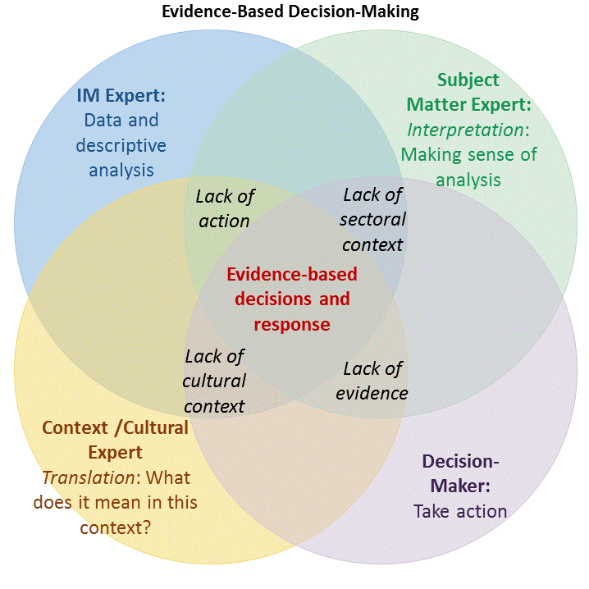
Ideally, Cluster (Sectoral experts/decision makers) and Context Experts will analyse data provided by DTM and other courses, supported by DTM and/ Cluster IMO. Notice the complementarity among skillsets, and the risks of limited engagement.

How can DTM and Protection Clusters further engage for the benefit of displaced persons?
At global level: In order to increase usefulness and usability of DTM data by clusters and cluster members, DTM is working at global level with the Global Protection Cluster, to identify the basic set of information clusters may need in most contexts. These are transformed into proposed questions, and included in the DTM data dictionary. DTM teams in countries use this data dictionary for guidance, when designing/amending their questionnaires.
At country level: Ideally, DTM teams and clusters in the countries will also find the time to jointly discuss the type of information clusters are missing that could be collected by DTM. After identifying the missing information, they will also jointly agree on the phrasing of the questions and on a plan for the final descriptive analysis.
DTM teams may identify issues for urgent follow up by the protection cluster or its members. Ideally, the protection cluster in each country will advise DTM teams on the most appropriate modality to communicate such issues to protection actors, or inform beneficiaries of relevant focal points.
For more info, see the DTM&Partners Toolkit at: https://displacement.iom.int/dtm-toolkit/dtm-partners-toolkit
Are all DTM components rolled out in every country?
Not necessarily: DTM is implemented according to need, so different components may be rolled out in different countries, as need for information varies.
Where can I find DTM reports and data?
DTM public data and reports are online and available at: https://displacement.iom.int/, http://migration.iom.int/europe/ and http://www.globaldtm.info/ (through a search by Country). For support, contact the DTM coordinator in your country (ask DTMSupport@iom.int for his/her contact details).

