



Sector severity and priority IDP locations with DTM data

A UNICEF step-by-step guide for Child Protection, WASH and Education Cluster Coordinators and IMOs

November 2018

Table of content

1. Purpose and scope of the guidance 3

2. Approach 5

A) Information needs 5

B) Process and Responsibilities 8

3. Data Processing and Analysis Tips 10

1. Screening questions 10

2. Severity question 15

3. Underlying factors 18

4. Priority Concerns 23

5. Priority Groups 26

4. Annex Analysis 101 29

5. Annex WASH 32

A) WASH Analysis Framework 32

A) WASH Questions 33

B) WASH Example of Report Using DTM Data 37

6. Annex Child Protection 39

A) Child Protection Analysis Framework 39

B) Child Protection Questions 40

C) Child Protection Example of Report Using DTM Data 45

7. Annex Education in Emergencies 47

A) Education in Emergencies Analysis Framework 47

B) Education Questions 48

C) Education Example of Report Using DTM Data 52

8. Annex Demo workbook 54

Table of Figures

Figure 1 Sample extract of the database for WASH screening questions 11

Figure 2 Example of processing sub and final deprivation score for WASH screening questions 12

Figure 3 Example of visualization of deprivation scores for each issue and geographic area 13

Figure 4 Example of visualization of deprivation scores by sub-sector and geographic area 13

Figure 5 Example of weighting scheme used for screening questions 14

Figure 6 Example of severity scale transformation from 5 to 7 points for the WASH sector 16

Figure 7 Example of the WASH dataset with the severity and deprivation score side-by-side 16

Figure 8 Example of use of severity question to calculate percentage and number of IDPs in each WASH severity class 17

Figure 9 Example of use of WASH median severity scores to indicate degree of severity by settlement type 17

Figure 10 Categorisation of underlying factors 18

Figure 11 Sample WASH underlying factor dataset using “Select top three” response option 20

Figure 12 Sample WASH underlying factor dataset using “Rank to three” response option 20

Figure 13 Example of Borda count to calculate main underlying factors contributing to WASH humanitarian conditions 21

Figure 14 Example of heat table showing frequency count of underlying factors 22

Figure 15 Example of heat table showing frequency count of underlying factors by category and geographical area 22

Figure 16 Sample WASH priority concerns dataset using “Select top three” response option 24

Figure 17 Sample WASH priority concerns dataset using “Rank to three” response option 24

Figure 18 Example of heat table for WASH priority concerns 25

Figure 19 Example of heat table showing frequency count of priority concerns 25

Figure 20 Sample WASH priority group dataset using “Select top three” response option 26

Figure 21 Sample WASH priority group dataset using “Rank to three” response option 27

Figure 22 Example of heat table for WASH priority groups 27

Figure 23 Example of heat table showing frequency count of priority group for the WASH sector 28

# Purpose and scope of the guidance

UNICEF and IOM strengthened their collaboration in 2017 to enhance complementarities between the DTM, Education, WASH and Child Protection Information tools and systems. The joint approach aimed at improving the quality and relevance of the information collected by DTM and enable clusters and AoRs to better identify urgent needs and gaps. One aspect of the collaboration focused on the selection of relevant sectoral questions to be inserted in the DTM location assessment tool and designed to answer key analytical questions of interest to the Cluster/AoRs. The agreed questions are now part of the DTM field companion and are available for reference for each Cluster/AoRs country teams for use when they approach DTM team to discuss collaboration.

Discussions held with UNICEF led Global Clusters and AoR in 2018 (WASH, Education and Child Protection) regarding expected analytical outputs highlighted five clear objectives for the use of DTM data by clusters and AoRs in the field:

1. Establish priorities, i.e. identify IDPs sites or locations with the most unmet sectoral needs;
2. Establish severity or levels of risks, i.e. identify severity of conditions in IDPs sites or locations, within humanitarian sectors;
3. Identify underlying factors, i.e. identify main factors or barriers contributing to humanitarian outcomes, such as access, availability or quality issues;
4. Identify information needs, i.e. identify locations, sectors and affected groups requiring further assessments;
5. Identify gaps, i.e. monitor needs and response gaps over time.

**Strengths and Limitations:** This guidance details how to use some of the data produced by DTM location assessments in order to achieve the above-mentioned objectives. To accurately interpret and use the data collected, it is important for end users to understand the methodology and data collection techniques used to collect the information.

DTM location assessments are conducted at regular intervals (rounds) and are based on key informant interviews and direct observation. As for all assessment and monitoring tools using these data collection techniques, the accuracy of the data is highly dependent upon the skills of the enumerators, the role of the key informant in the considered location, the sectoral knowledge that they have, their proximity to the affected population and any personal or cultural bias that may affect their answers to sensitive questions.

DTM sectoral results are intended to provide with an overview of a humanitarian situation at point and over time and are not intended to provide data at the level of detail or precision that can be achieved using specialized household level surveys. For this reason, the sectoral data collected during location assessment exercises is indicative only, should be interpreted carefully by sector experts and systematically triangulated with existing sectoral secondary data.

The result will prove very useful to monitor needs on a continuous basis and support high-level analysis and decision-making, i.e. to estimate the severity of conditions, identify priority IDPs locations and trigger more in-depth sectoral assessments if necessary. DTM sectoral results should not be used to inform the design of localized operations without proceeding first to a sectoral assessment using sector specific assessment tools, methodologies and specialists.

Any data interpretation process should be based on an in-depth understanding of the methodology and context by which the data was produced, including considerations of key informant’s selection, knowledge base, access limitations, etc. At field level, it is strongly recommended to Clusters and AoRs members to liaise with the DTM teams who will be available to assist and explain in more details the methodology used, its limitations as well as its strengths and how the data can be accurately interpreted.

This guide aims at helping WASH, Child Protection and Education Cluster /AoRs in the field use DTM data to identify sectors severity and priority IDPs locations for response. The document is divided in two parts, each for a different audience:

* An introduction to approach and principles is provided for Cluster and AoR Coordinators, Members and IMOs /Need Assessment/Analysis experts (Section 2 – Approach). This chapter presents a general introduction to the information needs covered by DTM location assessments as well as the process and responsibilities of different stakeholders for the design of the assessment, the collection of the data, the analysis of the results and the communication of findings.
* Instructions and examples of Data Processing and Analysis are detailed in Section 3 to guide Clusters IMOs and Need Assessment/Analysis experts prepare and analyse DTM data for their response. This chapter provides instructions to process and analyse the data and details each question type used for the methodology, how they can be adapted, the subsequent format of the data in the dataset, and how to process and visualize the data.

In addition, several annexes are proposed for each Cluster/AoR, including:

* An **Analysis** section, explaining the basics of analysis in humanitarian settings
* Sectoral annexes, each containing:
  + **A draft Cluster/AoR Analytical framework** that organizes and summarizes the main topics of interest for each, based on a review of Cluster/AoRs guidance and needs assessment reports[1];
  + **The sectoral questions** included in the DTM location assessment;
  + **A two-page sample report using DTM location assessment data** as an example of appropriate visualization and interpretation of the data. It is assumed that DTM data will always be made available to Cluster/AoRs in an excel format. *There is no plug and play solution to automatically visualize the results from DTM data. This is mostly because the scope of topics covered by DTM sites assessment vary from one country to another. Any automated solution would require that data collection is standard, which would impact on DTM flexibility to respond to Partners’ needs.*
* **A demo excel workbook** containing dummy data for WASH, Education and Child Protection clusters and AoR accompanies this guidance and represents an ideal output for storing the data collected using the core questions proposed in the field companion.

The guidance supposes knowledge and familiarity with the following:

* DTM’s different approaches, data collection systems, benefits and limitations. For more information, refer to the [Methodological Framework used in Displacement Tracking Matrix Operations for Quantifying Displacement and Mobility](https://displacement.iom.int/system/tdf/Methodological%20Framework%20used%20in%20DTM%20Operations%20for%20Quantifying%20Displacement%20and%20Mobility.pdf?file=1&type=node&id=2389). The methodology of interest is the location assessment.
* Generic data collection and analysis workflow, including key outputs and activities for each step as well as roles and responsibilities of DTM and UNICEF led Cluster/AoR teams. For more information, refer to the [pocket guide](https://www.dropbox.com/s/6zbb90cz45wnawe/Pocket%20Guide%20to%20the%20shared%20approach%20for%20printing.pdf?dl=0) in the [DTM & partners toolkit for Useful and Usable Data](https://drive.google.com/drive/folders/16qplwTsonfqHO1s-CDUji8Z1X9dn_LSR?usp=sharing)
* The UNICEF led Cluster/AoR analysis frameworks (See annexes)
* Questionnaire design key principles. For more information refer to [Questionnaire Design Summary, ACAPS 2015.](https://www.acaps.org/sites/acaps/files/resources/files/acaps_questionnaire_design_summary_july_2016.pdf)
* Dataset design principles. For more information refer to [How to approach a dataset: Part 1 – Database Design, ACAPS 2013](https://www.acaps.org/how-approach-dataset-part-1-database-design) and its [Demo Workbook](https://www.acaps.org/library/assessment#resource-535)
* Basic excel skills and data literacy

The following guidance applies to all those countries where DTM has operational presence but the Child Protection Needs Identification and Analysis Framework (CP NIAF) is not taking place. In case of implementation of the CP NIAF in the country, contact the Global CP AoR team for getting further guidance on how DTM is getting integrated into the NIAF framework.

# Approach

## Information needs

DTM and UNICEF led Cluster/AoRs collaborated at global level in 2018 to establish a core list of questions (see sector annexes). Some of those questions were carefully designed and selected to:

* Fulfil the objectives identified by Global Clusters and AoR, listed in Section 1 of this document
* Be adapted to the data collection techniques and key informants’ types used by DTM
* Be aligned with key information needs of the clusters/AoR
* Allow for complementarity, triangulation and verification of results between questions

As questions might be refined over time, Cluster/AoR field teams should always refer to the most up to date version of the questions which are available in the [field companion](https://www.dropbox.com/sh/7orjkqvqdn0857l/AABkQh41SWwuUlmtkTmATiyFa?dl=0) and discuss with the DTM field teams which one can be inserted. This section details only the question selected for the analysis of severity and priorities between IDPs sites. More questions might be available in the field companion for each sector (e.g. type of water source used), but they are not used to estimate severity and priorities across IDPs sites. The key questions relevant to this objective are listed below:

1. *Screening* questions allow to identify the proportion of IDPs in the assessed location who are exposed to a particular problem or alternatively, the degree of unmet needs for a particular topic. Proposed screening questions all have answers coded along a ranking scheme, from 1 (e.g. No problem/nobody exposed to this issue) to 5 (e.g. critical problem/everybody exposed to the issue). Screening questions cover key topics of each Cluster/AoR analysis framework which are measurable using general Key Informants Interviews and/or not requiring specialized enumerators. They are used to calculate a deprivation score[2]. Alternatively, each screening question can receive a weight from “1” (low risk/importance) to “3” (high risk/importance) which is used to calculate a risk score. An example of screening question is provided below:

***Currently, are there enough teachers to teach primary & secondary level classes for IDP children (Select only one)?***

1. *Enough teachers are available, classrooms are not crowded,*
2. *Enough teachers are available, classrooms are a little bit/sometimes crowded,*
3. *Not enough teachers are available, classrooms are quite/often crowded,*
4. *Largely insufficient number of teachers are available, classrooms are largely/always crowded,*
5. *No or not enough teachers are available, classes are not functional,*
6. *Do not know/No answer*
7. The *severity* question allows Key Informants to provide with an estimate of the severity of humanitarian conditions for a given sector and location. Statements are organized from low (1) to high (5) humanitarian impact and are based on mixed constructs (shortages, coping capacity, life threatening risks, etc.). The severity questions are related, however fundamentally different from the screening questions. They summarize humanitarian conditions and especially the severity of the humanitarian outcomes, using life-threatening and risk concepts. While screening questions typically measure the number of people exposed to a shortage or a deficiency, severity question are concerned with the consequences of this gap, and especially its impact on physical and mental wellbeing. **In situations where large system disruption and shortages exist, this allow to better discriminate and prioritize IDPs locations**. An example of severity question is provided below:

***To summarize the current conditions of the children, which of the following statement would you say is true in your area (Select only one)?***

*1) Children are well taken care of and not exposed to any form of danger or violence,*

*2) A few children are exposed to harm, injuries or violence,*

*3) Many or all children are exposed to harm, injuries or violence,*

*4) Because of dangers, harm and violence, we might soon see some children dying,*

*5) Because of dangers, harm and violence, a few children have died already,*

*6) Because of dangers, harm and violence, many children have died already,*

*7) Do not know/No answer*

1. *Underlying factors* question(s) seek to identify the set of deficiencies or mechanisms which contribute directly or indirectly to humanitarian outcomes. For instance, increased watery diarrhoea (humanitarian outcome) can result from a lack of clean water and/or a lack of hygiene (underlying factor). Identifying underlying factors allows the design of programs that tackle the root causes of the problem and not only their symptoms. Typically, we consider that humanitarian outcomes originate from deficiencies/obstacles/barriers in access, availability, quality, use and awareness of basic goods and services. Since DTM primarily uses Key Informants Interviews, the list of potential underlying factors selected is mostly focus on issues related to accessibility, availability and quality of goods and services[3]. An example of underlying factor question is presented below:

***Please indicate the three most important problems in the community in relation to sanitation (let the respondent speak and confirm with him/her the three main issues before noting them down. Select only the three most important):***

1. *Lack of sanitation facilities (latrines/toilets) or facilities too crowded;*
2. *Sanitation facilities (latrines/toilets) are not functioning or full;*
3. *Sanitation facilities (latrines/toilets) are unclean/unhygienic;*
4. *Sanitation facilities (latrines/toilets) are not private (no locks/door/walls/lighting etc.);*
5. *Sanitation facilities (latrines/toilets) are not segregated between men and women;*
6. *Sanitation facilities (latrines/toilets) are too far;*
7. *Going to the sanitation facilities (latrines/toilets) is dangerous;*
8. *Some groups (children, women, elderly, ethnic minorities, etc.) do not have access to sanitation facilities (latrines/toilets);*
9. *Garbage is not collected and remains in the street;*
10. *There is no drainage system;*
11. *Other, please specify*
12. *Do not know/No answer;*
13. *Priority concerns* questions seek to identify the humanitarian issues requiring immediate assistance. Key Informants are requested to identify and prioritize the most important sub-sector issues, using a ranking question. In practice, this allows to prioritize issues listed in the screening questions. This allows to further target better sectoral assessments or interventions. An example of priority concern question is presented below:

***We discussed earlier issues related to protecting children from violence, exploitation, abuse and neglect. You mentioned that X, X, X, and X were an issue affecting children under 18 in this location. Would you be able to tell us which ones do you consider a priority for intervention? (let the respondent speak and confirm with him the three main issues before noting them down. Select top three only):***

*a) Children that have been arrested and deprived of liberty;*

*b) Children that have gone missing;*

*c) Children at risk of injury due to physical dangers in the site;*

*d) Children begging in public places,*

*e) Children earning money doing dangerous work;*

*f) Increasing rates of child marriage;*

*g) Children without any adult caregiver for them;*

*h) Children that have been accidentally separated from their families;*

*i) Children at risk of violence due to inadequate lighting in the site;*

*j) Children at risk of exploitation or neglect due to inadequate food provision;*

*k) Children at risk of violence due to inadequate shelter;*

*l) Children at risk of violence due to a lack of protective learning spaces;*

*m) Children at risk of violence due to distance they must walk to obtain safe drinking water,*

*n) Other*

1. *Priority population groups* questions seek to identify the population groups facing the most unmet needs or the most at risk. Key Informants are requested to identify and prioritize population groups the most in need, using a ranking question. This allows to further target better sectoral assessments or interventions. An example of priority concern question is presented below:

***Overall, what are the demographic groups of displaced children that are facing the most safety and protection issues? (Select top three)***

* 1. *Girls 0-5 years old*
  2. *Boys 0-5 years old*
  3. *Girls 6-12 years old*
  4. *Boys 6-12 years old*
  5. *Girls 13-17 years old*
  6. *Boys 13-17 years old*

1. *Do not know/No answer*

## Process and Responsibilities

For an appropriate use of the approach, it is necessary to clearly understand roles and responsibilities between UNICEF led Cluster/AoR and DTM teams in the field.

**Design:** The question’s type presented in the previous section (screening, severity, underlying factors, etc.) were selected and validated by global Clusters/AoRs to serve a specific purpose. They are interconnected and dependent on each other’s. Key analytical outputs (severity, priority, underlying factors, information and response gaps) are all contained in the analysis of those questions and allow for enough redundancy to triangulate results and reduce uncertainty. Additional questions from the field companion can be added and used for other purposes However, removing any of the question’s type presented above will reduce analytical and triangulation opportunities. It is the responsibility of the Clusters/AoRs staff in country to coordinate with the DTM team regarding the questions to include. If resources are lacking, it is recommended to remove first the questions related to priority groups and concerns, then underlying factors. Screening and severity questions are key to establish problem type, exposure and degree of harm, from which priorities can be easily derived.

The order of the questions matters for the flow of the discussion and to minimize cognitive overload on the respondents. In the questionnaire, make sure that the flow of questions respects the following sequence: (i) Screening questions; (ii) Severity question; (iii) Underlying factors questions; (iv) Priority concerns and (v) Priority population groups.

The type of response answer also matters. The number of points in the scales (screening and severity questions) should be the same for all sectors, or processing will get cumbersome and painful. The question’s instructions (Select only one, select all that apply, etc.) should be respected, although some variations can be envisaged to reduce the burden on enumerators and respondents, e.g. *Select top three* instead of *Rank top three*. The final dataset design or preferred format should also be discussed with DTM teams. The ideal design will mostly depend on the tool being used by Cluster/AoR IMOs to visualize the data (e.g. excel, power BI, tableau software, among others). A link to an ideal dataset structure is proposed in section 8 of this document.

**Data acquisition**: Data collection will be coordinated and performed by DTM enumerators. Clusters/AoRs should support DTM enumerators and provide appropriate training and guidance (e.g. FAQ on DTM for the CPAoR and FAQ on DTM for the Education Cluster) and contextually relevant definitions for specific terms (e.g. unaccompanied children, etc.). While DTM is focusing on collecting primary data, Clusters/AoRs should continuously collate available secondary data so as to interpret DTM data in the light of other sector specific data, e.g. pre-crisis data, needs assessment reports, etc.

**Preparation:** Assessment of the strength of the evidence and identification of potential issues in the data are the responsibility of DTM, in coordination with the Clusters/AoRs. If Cluster/AoRs desire their data in a specific format, this should be discussed and agreed with DTM team prior to the data collection. At the end of each round, it is recommended that the DTM coordinator and the Clusters/AoRs IMOs meet[4] and discuss the data collected for this round, including:

* Any potential problems encountered during the data collection, e.g. accessibility, respondent’s availability, number and type of key informants, misinterpretation of misunderstanding of some questions or response items, missing values, prevalence of “others” items, etc.
* Any issue related to the capacity of Key Informants to answer technical questions or of the enumerators in asking or recording correctly the question
* Sampling, or the extent to which it was possible to visit all IDPs locations or if some areas were under visited during this round due to security issues, etc.
* Any issue or explanations related to other variable of interest, such as geocoordinate, type of settlements, location, number of IDPs, area of origin, date of arrival, etc.

**Analysis.** Unless agreed otherwise, DTM will provide clusters/AoRs with the raw data at the end of each round of data collection. The processing of the data as well as the data analysis are the responsibility of the Clusters/AoRs. Cluster/AoRs IMOs should process the data and present it to Clusters/AoRs experts for interpretation and comparison with other existing information, i.e. secondary data. An introduction to analysis in humanitarian settings is available in Chapter 4 of this document. In addition, a few basic principles should be applied when analysing DTM sector data:

* **Focus:** Discussions held with UNICEF led Clusters and AoR in 2018 regarding expected analytical outputs highlighted five clear objectives for the use of DTM data: (i) Establishing the severity of conditions or risks; (ii) priority locations; (iii) main underlying factors; (iv) information gaps; and (v) response gaps. It is important that the analysis focuses on answering those key analytical questions, as the methodology and questions included in the DTM location assessment tool are tailored to this function.
* **Triangulation:** When analysing DTM data, be sure to integrate secondary data analysis as much as possible, as an essential complement to primary data. Secondary data is used not only to triangulate and validate primary data findings, but also to help comparing, explaining, interpreting, forecasting and recommending. When findings are presented in the assessment report, this should include both primary and secondary findings and highlight differences where relevant.
* **Collaboration:** Some levels of analysis, (especially interpretive, anticipatory and prescriptive levels, see section 4), require the involvement of Cluster/AoRs experts who have a sound knowledge about the context and current/expected programme design[5]. The Cluster/AoRs should plan for regular joint analysis (e.g. workshops) in which they bring cluster/sector members together (with the DTM team if necessary) to discuss and analyse the findings.
* **Comparison:** Based on context, results can be broken down using different categories of interest, e.g. rural vs urban, camps vs non-camps, etc. The choice of those categories largely depends on the situation and what is relevant. Cluster/AoRs analytical focus and categories of analysis should be decided upfront and discussed with the DTM team so the primary data collection allow for the relevant disaggregation and provide sufficient usable information to allow meaningful comparison between categories. In some cases, this data might not be available in the DTM data set but might be available from other partner or secondary data. It is then the responsibility of the Cluster/AoR IMO to merge this data with the DTM dataset as to allow further analysis and break down, e.g. categorisation of geographical areas by degree of humanitarian access, intensity of conflict, ethnicity, livelihood characteristics, disabilities, level of assistance, etc.

In DTM, common categories of analysis are primarily time-related, spatial and group-based:

1. **Time**: The DTM being a monitoring information system, it allows for repeated measures over time and trend analysis, e.g. comparison before-after, year by year, quarterly, rainy season vs dry season, etc.
2. **Geographical**: DTM results can be broken down based on spatial characteristics, such as:
   * Administrative area, i.e. District A vs. District B. Comparative analysis between different administrative divisions is used to answer question such as: In which District IDP children are facing the most protection risks following the typhoon?
   * Setting, e.g. urban/rural, etc. Comparative analysis between different settings is used to answer questions such as: is access to safe water different for IDPs sites in rural vs urban areas?
3. **Population groups** are often available in DTM and allow to breakdown results for different population characteristics
   * Age/Gender: This can be used to answer questions such as: Is the impact on children different for girls compared to boys? Which age/gender groups have specific vulnerabilities or capacities.
   * Settlements. This can be used to answer questions such as: Is the impact on children education different for IDPs in collective centres vs IDPs in self-settled camps?

**Communication:** The reporting of such analysis is the responsibility of Cluster/AoRs, unless agreed differently with the DTM country teams. Key messages agreed upon during the analysis workshop should be reported accurately in the final report. Cluster/AoR coordinator and IMO should validate the report before dissemination. Summarizing data into tables may be enough for analysts and decision makers to draw important meaning from the data. However, at times it may be difficult to make sense of the information if it is only presented as numbers in a table. Being able to clearly see the data in an organized way is key for meaningful communication and will require to visually and effectively represent the data. This entails using specialized visualization tools, e.g. excel, Power BI, Tableau, ArcGIS, QGIS, etc.

# Data Processing and Analysis Tips

This section provides methodological and technical details regarding the processing of the variables listed in the field companion and reach the key analytical conclusions detailed in the objectives. We used the WASH segment of the demo workbook to illustrate and provide practical recommendation in this section. Same principles and procedures will apply to the analysis of Education and Child Protection questions. For each question type, guidance is provided to:

* Explain what the question is for and how/when to adapt them
* Provide recommendations regarding the structure and the preparation of the database
* Detail adequate data processing methods; illustrate types of analysis and visual display

### Screening questions

**What is it?** Screening questions allow to calculate a sector deprivation score for each IDP location. This score demonstrates a lack of access to goods, utilities or services required to satisfy basic needs or rights in a given sector and is used to highlight the types and magnitude of gaps or shortage to which the population is exposed.

* The types of issues are generally aligned with the pillars and sub-pillars detailed in the sector analysis framework (See sectoral annexes). From those were selected issues that could be measured using generalist key informants and non-specialised enumerators. The more screening questions are added to the questionnaire, the more thorough is the screening of possible sector issues.
* The magnitude of the issue is measured using a five-point scale including scores from “1” (no problem/nobody exposed to this issue) to “5” (critical problem/everybody exposed to the issue), reflecting on the number of IDPs in the location exposed to the issue and by default, the magnitude of the problem.

***How many people have enough water to cook, bath, do laundry and personal hygiene? (Read all options out loud, select only one)***

1. *Everyone (around 100%)*
2. *Most (around 75%)*
3. *About half (around 50%)*
4. *A few (around 25%)*
5. *Nobody (around 0%)*
6. *Do not know /No Answer*

**How to adapt screening questions?** The number of screening questions to include in the questionnaire can vary, but not their structure.

* From the field companion, IMOs should select all screening questions relevant to the context and discard those that do not apply. The total number of questions is only limited by the capacity of general key informants to answer technical questions and the capacity of DTM team to manage many questions.
* All screening questions should be answered using a 5-point scale, where 1 is the ideal/normal situation and 5 is the most harmful/critical/. This should apply to all sectors using screening questions.
* Screening questions requesting for a number, e.g. *Approximately how many children under 18 years have gone missing from your community during the last month?* should be transformed into a score from 1 to 5, for instance based on the % of children gone missing in the location.

**Dataset.** In the dataset, screening questions are organized each by column. In each cell, the corresponding level in the scale is represented. In the demo workbook, nine screening questions are available for the WASH sector. At the top of each question, the related sub-sector or topic can be filled manually. In figure 1 below, water supply has two questions, hygiene four and sanitation three. When preparing the data, make sure that each question response item was recoded/transformed using the numeric score, where “1” is the ideal/normal situation and “5” is the most severe/harmful situation. Make sure also that no score is lower than “0” and higher than “5”. Conditional formatting in excel allows the background colour of each cell to be used to quickly indicate higher and lower values, as in the example below.

Figure 1 Sample extract of the database for WASH screening questions



**Dataset good practice.** A dataset is a tool that stores data and lets you create, read, update, and delete the data in some manner. People unfamiliar with survey dataset should read the [2013 ACAPS guidance How to approach a dataset Part 1: Database design.](https://www.acaps.org/sites/acaps/files/resources/files/how_to_approach_a_dataset-part_1_database_design_august_2013.pdf) In a well-designed dataset, each row represents a unit for which several variables are measured. In a DTM location assessment database, each row contains all questions answer for one location. Questions labels are generally displayed in columns and can be organised in blocks (see below the block “screening questions”). Each block can be processed individually to generate summary statistics and graphs. On the left side, make sure all the data necessary to understand the unit is available, e.g. the location ID, its location, the number of people in this location, the type of setting or settlement, etc. If you identify variable of particular importance for comparison, highlight them in a separate colour (blue section in the example below). This will further allow to breakdown results from questions by relevant categories of analysis, e.g. aggregate questions result by province, settlement type, etc.

**How to process the deprivation score?** For preparing the deprivation score, we need to summarize all values obtained for sub-sectors and sector. The recommended aggregation method is the Median. Being ordinal data, averages are not valid, as the distance between score “1” and “2” is not the same as the distance between “3” and “4”. The median can be calculated for each sub-sector (i.e. sanitation, water supply and Hygiene for the WASH sector) as well as across the entire range of questions, using the excel formula:

= MEDIAN (number1; [number2]; …)

The Median is a powerful summary statistic allowing to identify the “middle value”, or the value separating the higher half from the lower half of a data sample. It is generally preferred to the mean (often simply described as the "average") as it is not skewed so much by extremely large or small values and gives a better idea of a "typical" value. By using this method, each IDP location will receive a final deprivation score, as well as sub-sectors ones, as shown in Figure 2 below.

**Tip:** When calculating the final deprivation score, make sure the value is calculated using individual screening questions scores, and not the sub-sector scores. The median of sub-scores, e.g. MEDIAN (Hygiene, Water supply; Sanitation) might return an inaccurate value.

Figure 2 Example of processing sub and final deprivation score for WASH screening questions

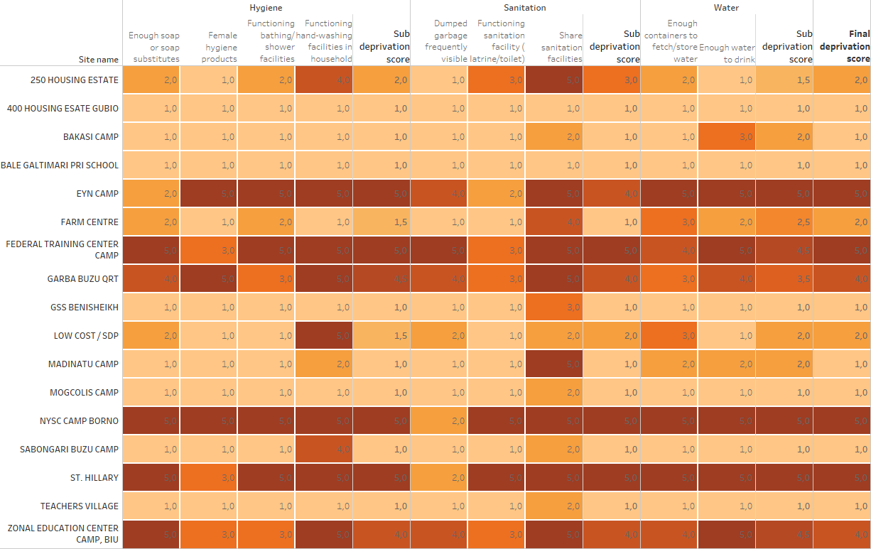

**How to interpret scores.** The basic assumption is that exposition to multiple shortages increases significantly the level of needs of the IDP population in the location. The higher the deprivation score, the higher the needs. A deprivation score of “5” means that the entire IDP population in a given location is exposed to at least half of the issues screened. Always using the median score, visualizations can be organized to show deprivation differences and similarities between geographical areas, settlement types, etc. Figure 3 below reveals that deprivation is the highest in Biu, KalaBalge, Magumeri and Ngala geographical areas.

Figure 3 Example of visualization of deprivation scores for each issue and geographic area

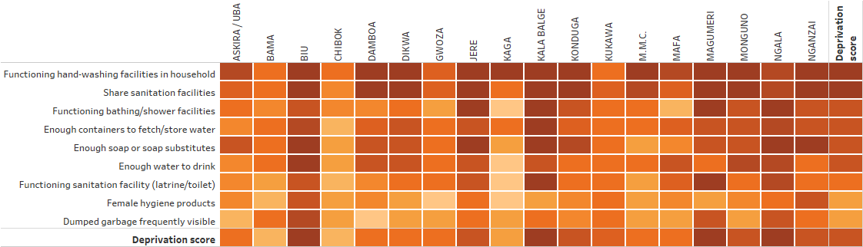

Grouping issues by sub-sector allows to aggregate the data at a higher level and obtain a quick overview of the situation for each. For instance, results in figure 4 below indicates that hygiene is particularly an issue in Jere, Biu, Kalabalge, Magumeri and Ngala.

Figure 4 Example of visualization of deprivation scores by sub-sector and geographic area

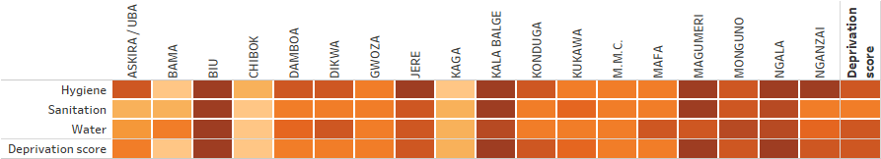

**Weighting issues.** Screening questions enables checking if some issues are present in each location and the size of the population exposed to them. In some instances, Cluster/AoRs might decide that some of the screening questions should have greater importance (or higher weighting) than other screening questions, due to perceived differences in the risk likelihood or impact of specific issues on the IDP population. For instance, open defecation during rainy season might present additional risk to public health in comparison to open defecation during the dry season. In a nutshell and based on context, weighted deprivation score allows calculating a risk score for each location. The weighting system and its processing is described in this section for the WASH sector.

1. Establish weighting scheme: Cluster/AoRs experts gather and establish a weighting scheme for each of the issues considered in the screening questions. Weights will often be context dependent and should be discussed and agreed upon by Cluster/AoR experts. It is recommended to use only three weights, for ease of consensus as well as of calculation: “1” for issues that are somewhat important, “2” for those that are very important, and “3” for the extremely important ones.

Figure 5 shows an arbitrary example of weighting for the nine screening questions in the WASH sector for one location. The *importance weight* column corresponds to the weights agreed upon by Clusters experts for each screening question. The *score column* correspond to the answer provided by key informants to each question.

Figure 5 Example of weighting scheme used for screening questions

|  |  |  |  |
| --- | --- | --- | --- |
| **Screening questions** | **Importance weight** | **Scores** |  |
| How many people have enough containers to fetch/store water? | 2 | 2 |  |
| How many people have enough soap or soap substitutes? | 3 | 3 |  |
| How many people have access to functioning hand-washing facilities in their household? | 2 | 4 |  |
| How many people have access to functioning bathing/shower facilities? | 1 | 5 |  |
| How many females have enough female hygiene products? | 2 | 4 |  |
| How many people share sanitation facilities (latrines/toilets) with other households? | 1 | 3 |  |
| How many people have enough water to drink? | 3 | 2 |  |
| How many people live in areas where dumped garbage is frequently visible? | 2 | 1 |  |
| How many people have access to a functioning sanitation facility (latrine/toilet)? | 2 | 2 |  |

1. Calculate risk score: The risk score for each IDP location is calculated taking into account the differing weights of each screening question. Technically, the calculation goes through three steps. In the first, the medians are calculated separately for all screening question with importance weights of “1”, then those with weights of “2”, then those with weights of “3”. In the second step, compensatory calculations are made to each median obtained in step 1. In the third step, the risk score is calculated by selecting the max value of the previous step. The generic formula is:

*Risk score = the maximum of:*

* (Median of ratings of issues with weight 1) - 2,
* (Median of ratings of issues with weight 2) - 1,
* (Median of ratings of issues with weight 3) - 0,

In our example above, the calculation would be as follows:

1. Calculate medians for all scores of same weights:
   1. For the two scores with a weight of “1”. The result is MEDIAN (5;3) = 4
   2. For the five scores with a weight of “2”. The result is MEDIAN (2;4;4;1;2) = 2
   3. For the two scores with a weight of “3”. The result is MEDIAN (3;2) = 2.5
2. Apply compensatory measure to each medians score:
   1. For median score using weight of “1”, subtract 2. The result is 4-2=2
   2. For median score using weight of “2”, subtract 1. The result is 2-1=1
   3. For median score using weight of “3”, subtract 0. The result is 2.5-0=2.5
3. Select the maximum value obtained in step 2:

= MAX (2;1;2.5) = 2.5

**Summary.** Screening questions are used primarily as a checklist system, but also to establish levels or deprivation and risks faced by the IDPs in each location or group of locations. With screening questions, Cluster/AoRS IMOs and expert can:

* Identify types of issues for a given location or grouping of location, as well as to identify when an issue is not present;
* Identify the magnitude of a particular shortage or gap in a given location or for a group of location;
* Identify the number of IDPs exposed to a given issue in a given location or for a group of locations. Using the variable in the dataset capturing the number of individuals or household in a given location and filtering to those locations where the deprivation score is equal to 4 or 5, it is easy to calculate the total number of IDPs facing high deprivation levels;
* Establish a deprivation score for each IDP location or group of locations;
* Establish a risk score (in practice, a weighted deprivation score) for each location or group of locations.

### Severity question

**What is it?** Within each sector, Key Informants are requested to provide an informed opinion on the severity of humanitarian conditions. The severity question is used to summarize the humanitarian conditions within a given sector and establish the degree of harm to which the population is exposed to, using mix concepts of deprivation and impact on physical wellbeing. As explained before, both screening and severity questions provide with insights regarding the intensity of issues. However, screening questions focus on the size of the population exposed to accessibility, quality, use or availability issues while severity questions focus on the degree of negative consequences that those combined issues have. We recommend the use of a severity scale from “1” to “5”, where severity ratings “3”, “4” and “5” indicate life threatening conditions. When such rates are observed, this additional layer of information can easily be used to filter down the results to those locations where key informant reported potential life-threatening conditions, allowing to identify number of IDPs or locations in moderate or severe need of external assistance. An example of severity scale for the WASH sector is provided below:

***To summarize the IDP’s conditions in term of water, hygiene and sanitation, which of the following statement would you say is true in your area? (Select only one)***

*1) No more people than usual are sick*

*2) More people than usual are sick*

*3) All people are sick*

*4) We might soon see people dying*

*5) Some people already died*

*6) Do not know/no answer*

**How to adapt the severity question?** A few principles should be respected when using severity questions.

* Use severity questions only if key Informants are proven reliable or if enumerators are well trained. If deaths or life-threatening situations are reported, enumerators should ask for more explanations or evidence.
* The severity question should be placed directly after the screening questions. This is important for the flow of the discussion. As screening questions are used as a checklist of issues, enumerators mentally record the prevalence of particular issues, which can prompt additional discussion with the key informant in case the severity score is lower or higher than expected.
* Statements in the scale are organized from low (1) to high (5) humanitarian impact. In some countries, other severity scale might be used at intersectoral level (i.e. HNO) and it might be necessary to adapt the number of points in the scale, so the levels correspond. In any case, make sure all sector severity questions use the same number of points in their scale, for compatibility purposes and to ease the processing.
* Each point in the scale should be categorized so that a numeric score is associated to each severity class, e.g. 1=low, 2=moderate, 3=high, 4=severe, 5=critical

**Adapting severity scales to context.** In some countries, severity scales might already be used for different purposes or strategic decision-making processes such as HNOs or HRP. In that case and to reduce the processing burden, it might be necessary to adapt the severity scale used by sectors in the DTM to allow inter-operability with the scale used at inter-sector level.

The process is relatively easy:

* Identify the appropriate number of points in the scale to ensure compatibility between scale. Generally, the number is odd, e.g. 3, 5 or 7 to allow for a mid-point category
* Describe the severity class (severe, critical, moderate, etc.)
* Define screening questions threshold for each category, e.g. around 50% of IDPs are facing the issue, etc.

Figure 6 shows two examples of severity scales for the WASH sector.

Figure 6 Example of severity scale transformation from 5 to 7 points for the WASH sector

|  |  |  |  |  |  |  |
| --- | --- | --- | --- | --- | --- | --- |
| **5-point severity scale** | | |  | **7-point severity scale** | | |
| **Response items** | **Problem severity** | |  | **Response items** | **Problem severity** | |
| Because of WASH shortages, some people already died | 5 | Critical |  | Because of WASH shortages, some people already died and more will if no external assistance is provided | 7 | Catastrophic |
| Because of WASH shortages, we might soon see people dying | 4 | Severe |  | Because of WASH shortages, some people already died | 6 | Critical |
| Because of WASH shortages, all people are sick | 3 | Major |  | Because of WASH shortages, we might soon see people dying | 5 | Severe |
| Because of WASH shortages, more people than usual are sick | 2 | Of concern |  | Because of WASH shortages, all people are sick | 4 | Serious |
| No more people than usual are sick | 1 | No problem |  | Because of WASH shortages, more people than usual are sick | 3 | Moderate |
|  | | | | Because of WASH shortages, slightly more people than usual are sick | 2 | Minor |
| No more people than usual are sick | 1 | No problem |

**Dataset.** In the dataset, the severity question uses one column only, as shown in figure 7. Each cell can take only one value, and for each location and sector, the corresponding level in the scale is represented by its numeric score, ranging from “1” to “5” in figure 7. Similar to screening questions, conditional formatting in excel allow to colour the background of each cell as to quickly indicate higher and lower values. It is good practice to place the severity score from key informants and the deprivation score side by side in order to compare results and highlight key differences.

Figure 7 Example of the WASH dataset with the severity and deprivation score side-by-side



**How to process severity questions data?** As a single variable, the analysis of the severity score is quite simple. The score can be treated as a categorical variable, for instance to calculate the percentage and number of IDPs falling in each severity class.

The example in figure 8 shows the results of these calculations, aggregated first then broken down by geographical area.

Figure 8 Example of use of severity question to calculate percentage and number of IDPs in each WASH severity class

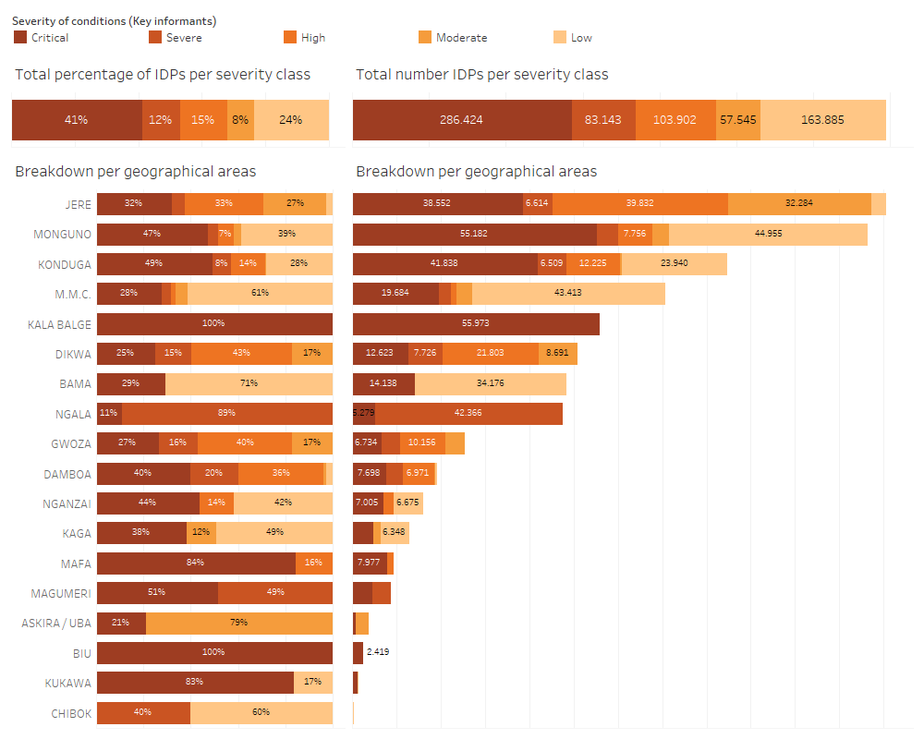

The score can also be treated as a numeric variable and can be aggregated using the median, i.e. similar to what was proposed before for the screening questions. For instance, in figure 9, a summarization of severity scores across main type of shelter indicates that the overall WASH situation is critical for IDPs in emergency and self-made/makeshift shelters, i.e. some fatalities are already being reported due to shortages in the WASH sector.

Figure 9 Example of use of WASH median severity scores to indicate degree of severity by settlement type

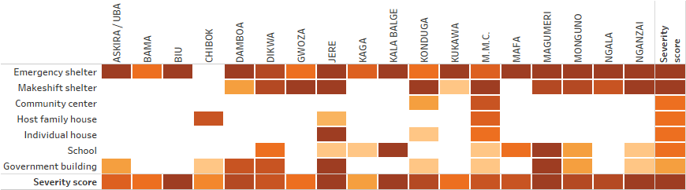

**Summary.** Severity questions are used:

* To summarize the severity of the situation for a given sector, location or group of locations;
* To identify if life-threatening conditions are present for a given sector, location of group of locations;
* Provide an estimate to the number/proportion of those assessed at each severity level.

### Underlying factors

**What is it?** *Underlying factors* question(s) seek to identify the set of deficiencies or mechanisms which contribute directly or indirectly to humanitarian conditions. For instance, increased watery diarrhoea can result from a lack of clean water and/or a lack of hygiene. Identifying underlying factors allows the design of programs that tackle the root causes of the problem and not only their symptoms. Typically, we consider that humanitarian outcomes originate from deficiencies/obstacles/barriers in access, availability, quality, use and awareness of basic goods and services. Since DTM uses primarily Key Informants Interviews, the list of potential underlying factors selected is mostly focused on issues related to accessibility, availability and quality of goods and services[6]. An example of underlying factor question is presented below:

***Please indicate the three most important problems in the community in relation to sanitation (let the respondent speak and confirm with him the three main issues before to note them down. Select only the three most important):***

1. *Lack of sanitation facilities (latrines/toilets) or facilities too crowded;*
2. *Sanitation facilities (latrines/toilets) are not functioning or full;*
3. *Sanitation facilities (latrines/toilets) are unclean/unhygienic;*
4. *Sanitation facilities (latrines/toilets) are not private (no locks/door/walls/lighting etc.);*
5. *Sanitation facilities (latrines/toilets) are not segregated between men and women;*
6. *Sanitation facilities (latrines/toilets) are too far;*
7. *Going to the sanitation facilities (latrines/toilets) is dangerous;*
8. *Some groups (children, women, elderly, ethnic minorities, etc.) do not have access to sanitation facilities (latrines/toilets);*
9. *Garbage is not collected and remains in the street;*
10. *There is no drainage system;*
11. *Other, please specify*
12. *Do not know/No answer;*

A typology of underlying factors commonly influencing humanitarian outcomes is proposed in figure 10 and can be adapted at country level. The categorization includes five main categories of underlying factors and consider that humanitarian outcomes are most often due to one or a combination of a lack of quality, availability awareness or use of or access to goods or services.

Figure 10 Categorisation of underlying factors

Examples and definitions for each category and sub-category are provided below:

|  |  |  |
| --- | --- | --- |
| **Availability issues** | | |
| * **Production:** Lack of goods and services produced in the area (bad harvest, disruption, destruction or interruption of local production, etc.)**.** * **Trade**: Lack of goods and services brought into the area through market mechanisms due to disruption of supply chain (transportation issues, lack of fuel, etc.)**.** * **Stock:** Lack or deficiency of goods or services held by traders or in government reserves (lack of medicines, ambulance, reconstruction materials, spare parts, fuel, etc.)**.** * **Transfer:** Lack of goods and services supplied by the government and/or aid agencies (lack of qualified staff (teacher, physicians, school teachers, health centre, etc.).  |  | | --- | | **Accessibility issues** | | * **Physical and logistical:** Long distance, transport issues, fuel, road lack of road maintenance, bridge destroyed, etc.). * **Security:** Security constraints interrupting access or supply to/of goods and services (insecurity, checkpoints, attacks, etc.). * **Financial:** Lack of income, resources or financial means (price inflation, loss of purchasing power, etc.). * **Social discrimination:** Ability to access and benefit from services and goods to as many people as possible. |  |  | | --- | | **Quality issues** | | * **Human Resources:** Number of people and possession of the required skills and knowledge to perform the service. * **Safety:** Beneficiary of the good or service is free from danger, risk or doubt including physical safety, financial security and confidentiality. * **Reliability:** Ability to perform the promised service in a dependable and accurate manner. * **Diversity:** Ability to meet the variety of demand and needs expressed. * **Dignity:** Capacity of the service to be delivered in accordance and respect of local custom and culture | | | |
| **Use issues** |
| * **Knowledge:** A familiarity with someone or something, which can include facts, information, descriptions, or skills acquired through experience or education. It can refer to the theoretical or practical understanding of a subject. * **Attitude/Belief**: Refer to a person's general feelings about an issue, object, or person. Attitudes are interlinked with the person's knowledge, beliefs, emotions, and values, either positive or negative. * **Practices:** The actual application or use of an idea, belief, or method as opposed to theories about such application or use. |
| **Awareness issues** | |
| * **Message:** Message appropriateness: Is it correct? Is it understandable (language, can people read)? * **Channel:** Outreach? Trusted (from someone the community trusts)? * **Frequency:** Message updated? Repeated over time? | |

**How to adapt the underlying factor question?** A few principles should be respected when using the underlying factors question:

* The underlying factor question(s) should be placed directly after the severity question. This is important for the flow of the discussion. The previous question provides with an estimate of the severity of conditions, and the underlying factors questions ask “why” this is the case and what are the main reasons for this. Especially for locations with high levels of severity, it will be important to answer this question so as to design appropriate response or focus better in-depth assessments.
* The response options can be adapted to reflect on the context. Irrelevant options can be deleted.
* Two options are possible for the answers:
  + “Select only top three” reasons/factors/barriers will return a frequency of time one item was mentioned as being one of the top three reasons. This is the simplest option and the least demanding for key informants.
  + “Rank top three” reasons/factors/barriers will return the items contributing the most to current humanitarian conditions. This option forces key informants in being very selective about the issues, and among the top three, to identify which are the most important. Ranking discriminates more than the previous option, hence has more information value. Also, if the ranking option is chosen, it is possible to recode the values and obtain the top three reasons easily. The contrary, however, is not possible.
* Enumerators should be trained in identifying underlying factors and which category they belong to. As reading the entire list of underlying factors would be impractical for respondents, it is recommended to ask an open question and let enumerators select the right response options after they receive the answer. This implies appropriate training as to recode appropriately the respondent’s response. Enumerators should always confirm with the respondents which options they select.

**Dataset.** In the dataset, underlying factor questions may take a lot of space. Since all options can be selected at least once, each response option has his own column. How cells are filled depends on which of the two options presented above was selected:

* If “Select only top three” was the chosen option, then each row should have only three “1” for the options selected, and “0” in the other cells. See figure 11 for an example.
* If “Rank top three” was selected, then the option selected as most important problem is coded as “3”, the second most important is coded as “2” and the third most important problem as “1”. All other options should be coded “0”. See figure 12 for an example.

Figure 11 Sample WASH underlying factor dataset using “Select top three” response option



Figure 12 Sample WASH underlying factor dataset using “Rank to three” response option



**How to process data obtained from underlying factor questions?** The processing of the underlying factors question will depend on the choice for the response option (“Rank top three” or “Select only top three”). The two processing options are detailed below.

1. Processing “Rank top three” questions implies calculating a priority score for each response item. The calculation method for the score is

= SUM (value) / COUNTD (location ID)

This will return a priority score ranging from “0” (it was never mentioned as one of the top three priorities) up to 3 (all locations mentioned this response items as the first priority). This calculation method is inspired by Borda count, a single winner election method in which voters rank items in order of preference[7]. To ease the understanding, it is recommended to produce a heat table where each cell background colour is proportional to the value and where the darkest colour show the highest priority score, as shown in the example below.

Figure 13 Example of Borda count to calculate main underlying factors contributing to WASH humanitarian conditions

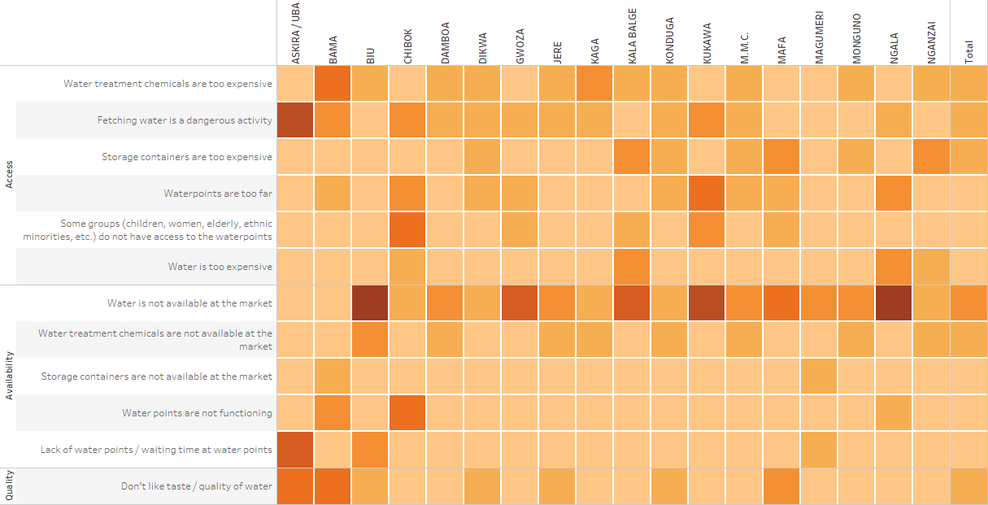

Low High

In Figure 13, IMOs can clearly identify the main underlying factors prevailing in each geographical area. The lack of water available at local market (problem of availability/production) is clearly one of the major issues across geographical area. In Chibok and Kukawa, discrimination against children, elderly or ethnic minorities is identified as a barrier to access to water points (problem of access/social discrimination). In Askira/Uba, fetching water was reported as being a dangerous activity (problem of access/safety). The Borda count is a powerful calculation method to identify broadly mentioned issues rather than those identified by the majority. It is a consensus-based selection system rather than a majoritarian one.

Identifying underlying factors is an important analytical task. It allows to identify areas to further focus on during more in-depth assessment, but also to provide insight regarding the type of programme required to improve humanitarian conditions, e.g. restoring access to safe water, improving quality of water or simply increasing the availability of safe water in IDPs camps. The value of this information for response analysis and planning is particularly significant, as access, availability or quality issues call for tailored response modalities, e.g. cash programs for access/financial issues, water point rehabilitation or construction for availability/production issues, etc.

1. Processing “Select only top three” questions implies calculating frequency count. The calculation method here is a simple percentage of total values:

= SUM (value) * 100 / COUNTD (location ID).

This calculation returns the percentage of locations mentioning a particular underlying factor as one of the top three problem for a given geographical area. In figure 14, 100% of locations in Biu indicated that the non-availability of water on local market was one of the top three problem.

Figure 14 Example of heat table showing frequency count of underlying factors

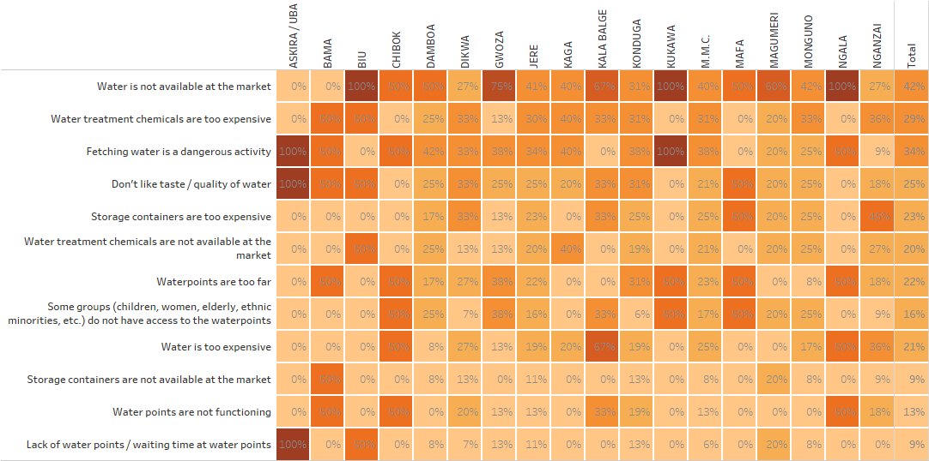

The same procedure can be followed to aggregate percentages at upper category level (percentage of time an access, availability or quality issue was mentioned as top three problem). In figure 15, nearly 50% of locations reported that accessibility is one of the top three reasons/factors/barriers contributing to current humanitarian conditions, while quality issues are reported as one of the top priority problems only for 8% of locations. Geographical areas where the highest percentage of locations reported accessibility issues are Chibok and Kukawa (67% of locations). Geographical areas where the highest percentage of locations reported availability issues are Biu (67%), Kalabalge and Ngala (50%).

Figure 15 Example of heat table showing frequency count of underlying factors by category and geographical area

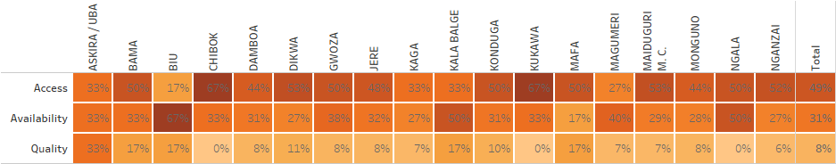

**Summary.** Underlying factors questions are used:

* To identify main reasons/factors/barriers contributing the most to current humanitarian conditions;
* To identify the focus and objectives of further in-depth assessment, e.g. measuring accessibility to basic services or goods, market analysis, cash feasibility assessment, etc.
* To support Cluster/AoRs response analysis by identifying most common reasons/factors/barriers contributing to humanitarian outcomes and selecting most appropriate response options, e.g. cash grants in case of financial accessibility, distribution in case of unavailability, etc.

### Priority Concerns

**What is it?** *Priority concerns* questions seek to identify the humanitarian issues requiring immediate assistance. Key Informants are requested to identify and prioritize the most important sub-sector issues, using a ranking question. This allows to further target sectoral assessments or interventions. An example of priority concern question is presented below:

***We discussed earlier issues related to water, hygiene and sanitation. You mentioned that X, X, X, X, X and X were an issue in this location. Could you tell us which are the ones you consider as a priority for intervention? (Select only top three):***

1. *People who do not have enough water to drink*
2. *People who do not have enough water to cook, bath, do laundry and personal hygiene*
3. *People who do not have enough containers to fetch/store water*
4. *People who do not treat their water before drinking it*
5. *People who do not have enough soap or soap substitutes*
6. *People who do not have access to functioning hand-washing facilities*
7. *People who do not have access to functioning bathing/shower facilities*
8. *Women who do not have enough female hygiene products*
9. *People who do not have access to functioning sanitation facilities (latrines/toilets)*
10. *People who live in areas where sanitation facilities (latrines/toilets) are shared between several households*
11. *People who live in areas where open defecation is frequently visible*
12. *People who live in areas where dumped garbage is frequently visible*
13. *People who live in areas where wastewater is frequently visible (sewage problems)*

*n) Other*

**How to adapt the priority concern question?** A few principles should be respected when using the priority concern question:

* The priority concern question(s) should be placed directly after the underlying factor question. This is important for the flow of the interview and to start wrapping up the discussion with the key informants.
* The response items should be aligned with the issues available in the screening questions. Issues discarded in the screening questions should also be discarded from the response options in the priority concern question.
* Similar to the underlying factor questions, two options are possible for the answers:
  + “Select only top three concerns” will return a frequency of time one item was mentioned as being one of the top three concern. This is the simplest option and the least demanding for key informants.
  + “Rank top three concerns” will return concerns ranked by order of importance. This options forces key informants in being very selective about the issues, and among the top three, to identify which one is the most important. Ranking discriminates more than the previous option, however requires more attention from key informants. Also, if the ranking option is chosen, it is possible to recode the values and obtain the top three concern easily. The contrary, however, is not possible.
* Enumerators should be trained in identifying concerns. As reading the entire list of concerns would be impractical for respondents, it is recommended to ask an open question and let enumerators select the right response options after they receive the answer. Enumerators should always confirm with the respondents which options they select to see if this reflect accurately his/her response.

**Dataset.** Since all options can be selected at least once, each response item has his own column in the dataset. How cells are filled depends on which of the two options presented above was selected. If “Select only top three concerns” was the chosen option, then each row should have maximum three “1” for the items selected, and “0” in the other cells (see figure 16). If “Rank top three concerns” was selected, then the item selected as most important problems is coded as “3”, the second most important is coded as “2” and the third most important problem as “1” (See figure 17). All other options should be coded with a zero. Conditional formatting in excel allow to colour the background of each cell as to quickly indicate higher and lower values.

Figure 16 Sample WASH priority concerns dataset using “Select top three” response option



Figure 17 Sample WASH priority concerns dataset using “Rank to three” response option



**How to process data obtained from priority concerns questions?** Similar to what was explained above for the underlying factor questions, the processing of the priority concerns questions will depend on the choice for the response option (“Rank top three” or “Select only top three”). The two processing options are detailed below.

1. Processing “Rank top three” questions implies calculating a priority score for each response item, derived from the Borda count election theory. The calculation method for the score is:

= SUM (value) / COUNTD (location ID)

This will return a priority score ranging from “0” (it was never mentioned as one of the top three priorities) up to 3 (all locations mentioned this response items as the first priority).

To ease the understanding, it is recommended to produce a heat table where each cell background colour is proportional to the value and where the darkest colour show the highest priority score, as shown in figure 18.

Figure 18 Example of heat table for WASH priority concerns

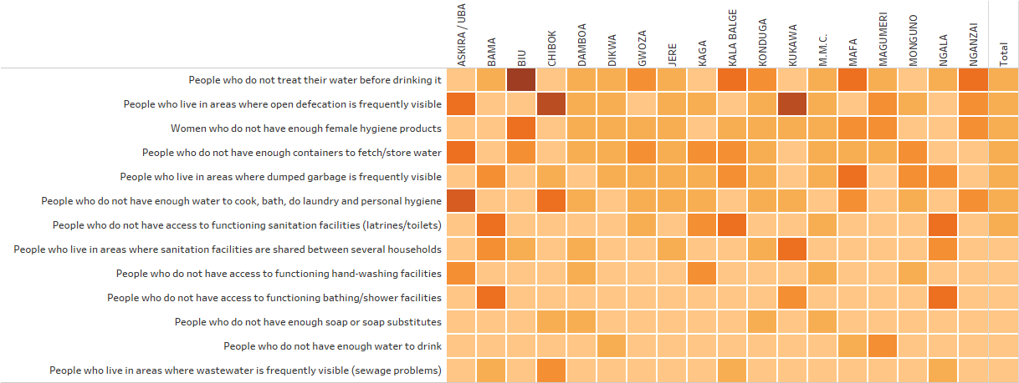 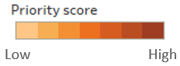

1. Processing “Select top three” questions implies calculating frequency count. The calculation method here is a simple percentage of total values:

= SUM (value) * 100 / COUNTD (location ID)

This calculation returns the percentage of locations mentioning a particular issue as one of the top three concern for a given geographical area. In figure 19, 100% of locations in Kukawa indicated that open defecation was one of the top three concern.

Figure 19 Example of heat table showing frequency count of priority concerns

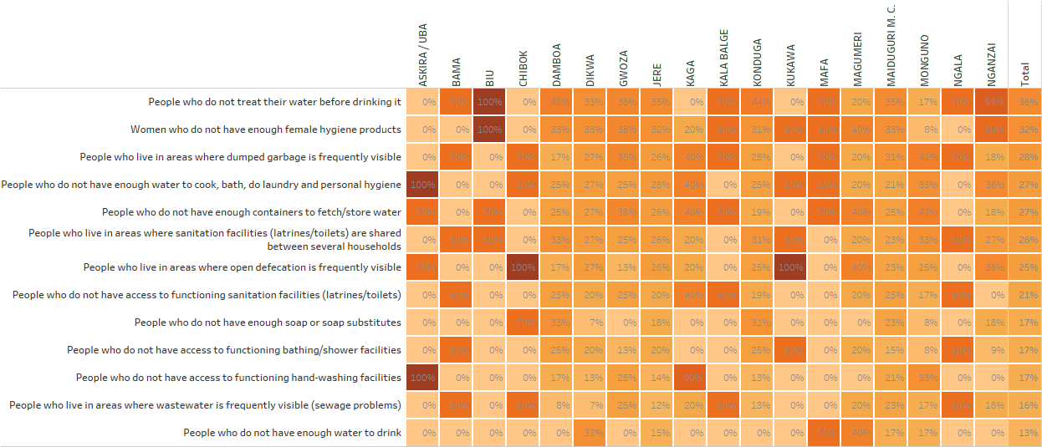

This information from the Key Informants can also be used to identify new areas of concerns not previously considered important and revise the weights used to calculate the risk score. Cluster/AoR experts can discuss findings and decide to revise a weight for an issue based on the information provided by Key Informants.

**Summary.** Priority concern questions are used:

* To start wrapping up the discussion with Key Informants and draw main conclusions;
* To identify concerns requiring more in-depth assessments;
* To support Cluster/AoRs response analysis by identifying most pressing issues requiring assistance;
* To revise the weights, use for calculating the risk score.

### Priority Groups

**What is it?** *Priority groups* questions seek to identify the population groups the most in need of assistance. Key Informants are requested to identify and prioritize population groups the most in need, using a ranking question. This allows to further target sectoral assessments or interventions. An example of priority concern question is presented below:

***Overall, what are the demographic groups facing the most severe issues related with water, sanitation and hygiene? (Rank top three)***

* 1. *Adult males*
  2. *Adult females*
  3. *Elderly males*
  4. *Elderly females*
  5. *Child males*
  6. *Child females*
  7. *Do not know/No answer*

**How to adapt the priority groups question?** A few principles should be respected when using the priority groups question:

* The priority group question(s) should be placed directly after the priority concerns question. This is important for the flow of the discussion and finish wrapping up the discussion with key informants.
* Similar to the underlying factor and the priority concern questions, two options are possible for the answers:
  + “Select only top three groups” will return a frequency of time one group was mentioned as being one of the top three priority group for assistance. This is the simplest option and the least demanding for key informants.
  + “Rank top three groups” will return groups ranked by order of importance. This options forces key informants in being very selective about the groups, and among the top three, to identify which one is the most important. Ranking discriminates more than the previous option, however requires more attention from key informants. Also, if the ranking option is chosen, it is possible to recode the values and obtain the top three concern easily. The contrary, however, is not possible.
* Efforts should be made to ensure standard groups categories are used (sex, age interval, socio demographic characteristics, etc.) across sectors to allow for comparability, and that clear definitions are provided to the enumerators during training.

**Dataset.** Since all groups listed in the question can be selected at least once, each response item has his own column in the dataset. How cells are filled depends on which of the two options presented above was selected. If “Select only top three groups” was the chosen option, then each row should have maximum three “1” for the items selected, and “0” in the other cells (See figure 20). If “Rank top three groups” was selected, then the item selected as most important group is coded as “3”, the second most important is coded as “2” and the third most important as “1” (See figure 21). All other options should be coded with a zero.

Figure 20 Sample WASH priority group dataset using “Select top three” response option



Figure 21 Sample WASH priority group dataset using “Rank to three” response option



**How to process data obtained from priority concerns questions?** Similar to what was explained above for the underlying factor and the priority concerns questions, the processing of the priority group questions will depend on the choice for the response option (“Rank top three groups” or “Select only top three groups”). The two processing options are detailed below.

1. Processing “Rank top three groups” questions implies calculating a priority score for each response item, derived from the Borda count election theory. The calculation method for the score is:

= SUM (value) / COUNTD (location ID)

This will return a priority score ranging from “0” (it was never mentioned as one of the top three priorities) up to “3” (all locations mentioned this response items as the first priority). To ease the understanding, it is recommended to produce a heat table where each cell background colour is proportional to the value and where the darkest colour show the highest priority score, as shown in figure 22.

Figure 22 Example of heat table for WASH priority groups

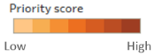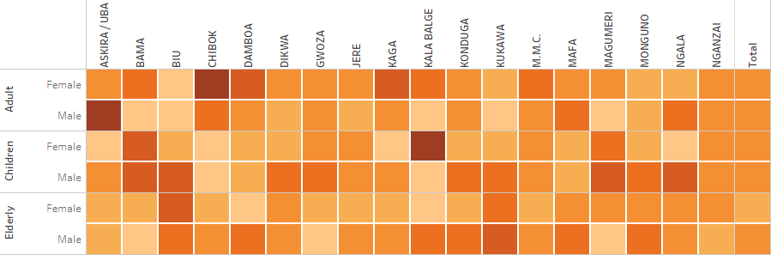

1. Processing “Select top three” questions implies calculating frequency count. The calculation method here is a simple percentage of total values:

= SUM (value) * 100 / COUNTD (location ID)

This calculation returns the percentage of locations mentioning a particular group as one of the top three priority for a given geographical area. In figure 23, 100% of locations in Kalabalge area indicated that female children are a priority group for assistance.

Figure 23 Example of heat table showing frequency count of priority group for the WASH sector

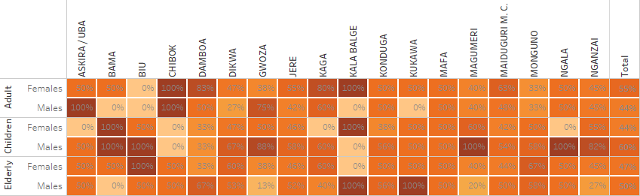

**Summary.** Priority groups questions are used:

* To identify main population groups requiring more in-depth assessments;
* To support cluster/AoRs response analysis by identifying population groups most in need of assistance;
* To finish wrapping up the discussion with Key Informants and capturing their informed opinion on the situation.

# Annex Analysis 101

Analysis in humanitarian setting refers to the organized and collaborative process of transforming raw data into actionable insights for better decision-making. It is an iterative sense-making process which continues until it is possible to draw conclusions that answer the original questions, with a reasonable degree of certainty. The goal of DTM sector data analysis is to provide informed opinions about gaps, underlying factors, adaptive strategies and existing or forecasted humanitarian conditions. This includes a systematic set of procedures undertaken for the purposes of setting priorities based on severity of gaps or risks faced by the affected population.

Analysis is more of a process than an action, and there are procedures and steps Cluster/AoRs staff can rely on to take them from uncertainty to understanding, from results to findings. Most forms of analysis can be described as levels, where one builds on another, each increasing the understanding of the findings and revealing progressively what the data means, what may happen next and what could or should be done about it. Five levels are commonly used for analysis of humanitarian needs, represented in the diagram below.

The Analysis Spectrum (adapted from ACAPS 2014 and Pherson 2010)

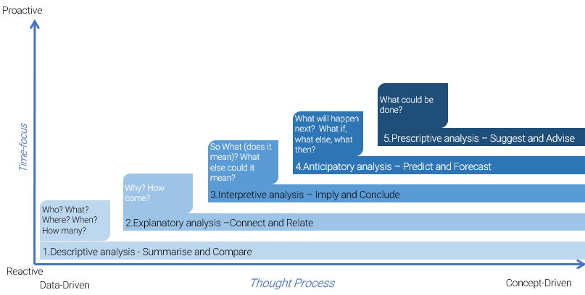

* **Descriptive analysis**: Describing data means to summarize and reduce large amount of data to a representation where it is easier to compare between them and identify the main points, important stories and relevant messages, e.g. a percentage, average, mean, mode, etc. The Cluster/AoR Information Management Officer (IMO) consolidates key variables from the DTM location assessment dataset and prepares descriptive outputs by comparing results between relevant categories of analysis (province A vs province B, camp vs non-camp settlements, etc. as agreed upon with DTM team). Comparing and contrasting results helps to identify and confirm similarities and differences between or within categories of analysis, and further investigation allow for identifying patterns, trends, outliers or anomalies. The goals of descriptive analysis are:
* To identify most relevant categories of analysis and most accurate ways of summarizing and describing data
* To refine ideas about what the data are saying, e.g. type of issues, diversity and location of gaps
* To examine commonalities and differences, prompt further questioning, see details and variations previously missed and confirm patterns and trends
* Identify key assumptions, e.g. based on information gaps, small samples, etc.
* **Explanatory analysis** looks for associations, correlations and more generally for connections between observations and measurements. It is an extension of the descriptive phase and allows for formulation of better hypothesis or theories, based on careful investigation of relationships, underlying processes or causal mechanisms. Identifying relationships is an important part of the analytic process because it prepares for moving from a simple description of the population conditions and settings to explanations of why and how things happened as they did, and what could happen in the future if conditions persist or change. This level of analysis implies carefully connecting the dots and assessing whether two or more variables, conditions or observations vary according to a pattern, the strength of the relationship linking them and if one is cause of or contributor to another. In this analytical step, the Cluster/AoR IMO, subject–matter and cultural/context experts (e.g., coordinators, members, local staff and NGOs…) identify and rank main underlying mechanisms/barriers/factors (problems of access, availability, use, quality and awareness of/to basic goods and services) that contribute to the existence of persistence of humanitarian conditions, i.e. problems of physical and mental wellbeing). This analysis is critical as it allows to identify the causes of current conditions, which should be addressed during the response. The goal of explanatory analysis is:
* To go beyond the nature and frequency of the problems and identify factors or conditions that contribute to the existence, aggravation or continuation of an issue
* To identify changes and patterns of associations or correlation and explore the strength of the relationships between observations
* To clarify causal mechanisms, underlying processes and functions at play
* To provide a foundation and groundwork for forecasting and prescriptive analysis
* **Interpretive analysis** aims at moving beyond findings to identify key messages and drawing well-supported conclusions, through careful argumentation, evaluation of the strength of evidence available and attention to plausibility in context. While the previous analysis steps focused mainly on understanding what happened and what the data say, interpretation is primarily interested in what it means for the decision makers and articulating credible, coherent and meaningful conclusions. Interpretation highlights important messages in relation to the original research question, assessing the degree of certainty attached to the final conclusions and answering the question “so what?”. In this analytical step, Cluster/AoR experts discuss the results produced by the IMO and establish critical gaps and humanitarian conditions and set priority geographical areas for further assessments. They also evaluate the body of evidence to assess the strength of the evidence, express their degree of confidence in the findings and identify information gaps. The goal of interpretive analysis is:
* Determining what is important (severity of gaps and priorities) and why it is important (size of population exposed to gaps)
* Building coherent, reasoned and well supported conclusions
* Evaluating the evidence that supports conclusions and contextualizing the findings to assess their plausibility
* **Anticipatory analysis** identifies the likelihood of future events and outcomes at a specific time, based on current and historical data. It combines predictions (a one-off estimate of a specific event in the future – What will happen?) and forecast (a set of possible futures that include probability estimates of occurring – What else might happen?). Predicting and forecasting are an integral part of scenario building and risk analysis that will also inform preparedness activities. In this analytical step and based on secondary data and risk analysis, Cluster/AoRs IMO and experts discuss relevant scenario, estimate future potential gaps and refine the list of priority geographical areas if necessary, e.g. in case of further influx of IDPs into a particular geographical area. The specific objectives of anticipative analysis are to:
* Go beyond current conditions and provide forward looking assessment and best estimates on what might happen in the future (in opposition to what will happen in the future).
* Prolong the shelf-life of the analysis by integrating a forward-looking perspective into the analysis of the current situation.
* **Prescriptive analysis** entails both response analysis and planning. This process is generally conducted in a workshop setting and uses results from both secondary and primary data collection. In this step, Cluster/AoRs IMO and experts discuss and agree on a strategy and objectives to change or prevent humanitarian conditions and recommend a set of appropriate and proportionate response options (this process is also called response analysis). They define the activities and resources required to achieve the objectives (response planning) and any risks or assumptions. The goal of prescriptive analysis is to:
* Define strategic objectives and targets geographical areas/groups, so as to reduce current and forecasted humanitarian consequences or deficiencies
* Identify, screen and select potential response options or the set of interventions considered to solve a particular gap or deficiency
* Plan programmes, activities and strategic recommendations for response
* Recommendations regarding further or more in-depth sectoral assessments

# Annex WASH

## WASH Analysis Framework

The WASH Analysis Framework was designed in 2018 based on a review of WASH existing guidance and needs assessment reports. The framework represents the different topics and sub-topics generally being measured during WASH needs assessment. It is a working model and does not reflect a global endorsement by the WASH Cluster.

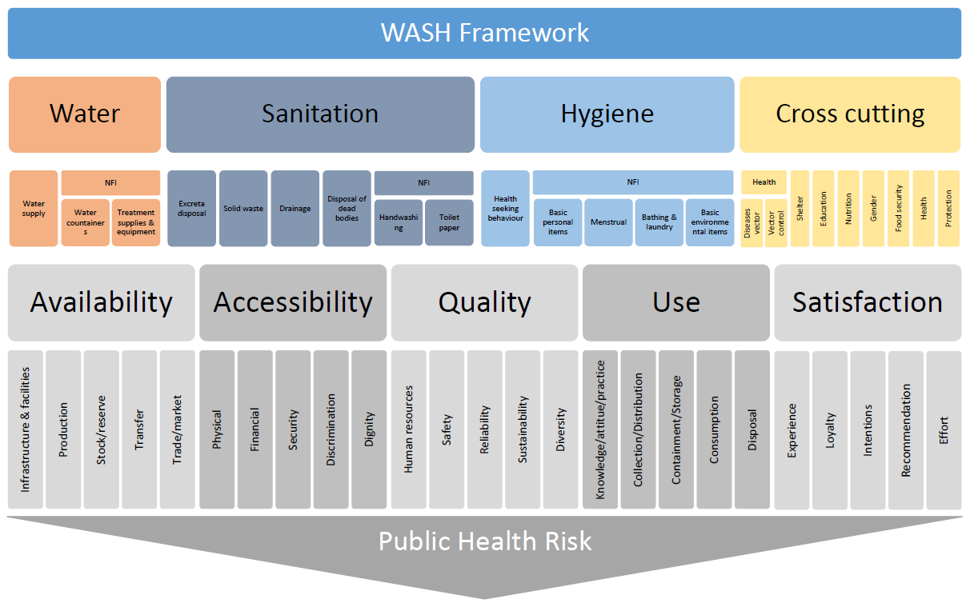

## WASH Questions

|  |  |  |  |  |  |  |  |  |  |  |  |  |  |  |  |  |
| --- | --- | --- | --- | --- | --- | --- | --- | --- | --- | --- | --- | --- | --- | --- | --- | --- |
| **Screening questions** | | | | | | | | | | | | | | | | |
| **Section** | **Priority** | **Indicator** | **Questions** | **Response items** | | | | | | | | | | | | **Instruction** |
| Water | 1 | Proportion of IDP sites having access to an improved water source | What is the main source of water used by IDPs for drinking? | Piped water into dwelling; Piped water to yard / plot; Piped water to neighbor; Public tap / standpipe; Tube well / borehole; Protected dug well; Unprotected dug well; Protected spring; Unprotected spring; Rainwater; Tanker-truck; Cart with small tank; Water kiosk; Surface water; Bottled water; Sachet water *(aggregate/adapt to the context as needed)* | | | | | | | | | | | | Select one |
| Water | 2 | Proportion of IDP sites having access to an improved water source | Do IDPs use other sources of water for drinking and other purposes such as cooking and washing? If yes, what sources do they use? | No other source is used; Piped water into dwelling; Piped water to yard / plot; Piped water to neighbor; Public tap / standpipe; Tube well / borehole; Protected dug well; Unprotected dug well; Protected spring; Unprotected spring; Rainwater; Tanker-truck; Cart with small tank; Water kiosk; Surface water; Bottled water; Sachet water *(aggregate/adapt to the context as needed)* | | | | | | | | | | | | Select all that applies |
| Water | 1 | Proportion of IDP sites having access to a sufficient quantity of water | Approximately, how many IDPs have enough water to drink, cook, bath, do laundry and personal hygiene? | Everyone  (around 100%) | | Most (around 75%) | | About half (around 50%) | | A few (around 25%) | | Nobody (around 0%) | | Don’t know/No answer | Select one | |
| Water | 2 | Proportion of IDP sites having access to a sufficient quantity of water | Approximately, how many IDPs have enough water to drink? | Everyone  (around 100%) | | Most (around 75%) | | About half (around 50%) | | A few (around 25%) | | Nobody (around 0%) | | Don’t know/No answer | Select one | |
| Water | 2 | Proportion of IDP sites having access to a sufficient quantity of water | Approximately, how many IDPs have enough water to cook, bath, do laundry and personal hygiene? | Everyone  (around 100%) | | Most (around 75%) | | About half (around 50%) | | A few (around 25%) | | Nobody (around 0%) | | Don’t know/No answer | Select one | |
| Water | 2 | Proportion of IDP sites having enough water containers | Approximately, how many IDPs have enough containers to fetch/store water? | Everyone  (around 100%) | | Most (around 75%) | | About half (around 50%) | | A few (around 25%) | | Nobody (around 0%) | | Don’t know/No answer | Select one | |
| Hygiene | 1 | Proportion of IDP sites having enough soap | Approximately, how many IDPs have enough soap or soap substitutes? | Everyone  (around 100%) | | Most (around 75%) | | About half (around 50%) | | A few (around 25%) | | Nobody (around 0%) | | Don’t know/No answer | Select one | |
| Hygiene | 2 | Proportion of IDP sites having access to functioning handwashing facilities | Approximately, how many IDPs have access to functioning hand-washing facilities (in their household)? | Everyone  (around 100%) | | Most (around 75%) | | About half (around 50%) | | A few (around 25%) | | Nobody (around 0%) | | Don’t know/No answer | Select one | |
| Hygiene | 2 | Proportion of IDP sites having access to functioning bathing/shower facilities | Approximately, how many IDPs have access to functioning bathing/shower facilities? | Everyone  (around 100%) | | Most (around 75%) | | About half (around 50%) | | A few (around 25%) | | Nobody (around 0%) | | Don’t know/No answer | Select one | |
| Hygiene | 2 | Proportion of IDP sites having access to enough menstrual hygiene products | Approximately, how many women IDPs have enough female hygiene products? | Everyone  (around 100%) | | Most (around 75%) | | About half (around 50%) | | A few (around 25%) | | Nobody (around 0%) | | Don’t know/No answer | Select one | |
| Sanitation | 1 | Proportion of IDP sites with access to functioning sanitation facility | Approximately, how many IDPs have access to a functioning sanitation facility (latrine/toilet)? | Everyone  (around 100%) | | Most (around 75%) | | About half (around 50%) | | A few (around 25%) | | Nobody (around 0%) | | Don’t know/No answer | Select one | |
| Sanitation | 2 | Proportion of IDP sites with access to improved sanitation facility | What is the most common type of sanitation facilities (latrines/toilets) used by IDPs? | *Types of latrines from MICS:* Flush to piped sewer system; Flush to septic tank; Flush to pit latrine; Flush to open drain; Flush to DK where; Ventilated improved pit latrine; Pit latrine with slab; Pit latrine without slab / open pit; Composting toilet; Bucket toilet; Hanging toilet / hanging latrine; No facility / bush / field (*aggregate/adapt to the context as needed)* | | | | | | | | | | | | Select one |
| Sanitation | 2 | Proportion of IDP sites having access to private sanitation facility | Approximately, how many IDPs share sanitation facilities (latrines/toilets) with other households? | Nobody (around 0%) | A few (around 25%) | | About half (around 50%) | | Most (around 75%) | | Everyone  (around 100%) | | Don’t know/No answer | | Select one | |
| Sanitation | 2 | Proportion of IDP sites facing environmental sanitation problems | Approximately, how many IDPs live in areas where open defecation is frequently visible? | Nobody (around 0%) | A few (around 25%) | | About half (around 50%) | | Most (around 75%) | | Everyone  (around 100%) | | Don’t know/No answer | | Select one | |
| Sanitation | 2 | Proportion of IDP sites facing environmental sanitation problems | Approximately, how many IDPs live in areas where dumped garbage is frequently visible? | Nobody (around 0%) | A few (around 25%) | | About half (around 50%) | | Most (around 75%) | | Everyone  (around 100%) | | Don’t know/No answer | | Select one | |
| Sanitation | 2 | Proportion of IDP sites facing environmental sanitation problems | Approximately, how many IDPs live in areas where wastewater is frequently visible (sewage problems)? | Nobody (around 0%) | A few (around 25%) | | About half (around 50%) | | Most (around 75%) | | Everyone  (around 100%) | | Don’t know/No answer | | Select one | |

|  |  |  |  |
| --- | --- | --- | --- |
| **Description** | **Water** | **Hygiene** | **Sanitation** |
| **Coping mechanism questions** | How does the community cope with lack of water? (Keep the question open. Enumerators recode based on response. Tick all that apply)   1. Rely on less preferred (unimproved/untreated) water sources for drinking water 2. Rely on surface water for drinking water 3. Rely on less preferred and unimproved/untreated water sources for other purposes such as cooking and washing 4. Rely on surface water for other purposes such as cooking and washing 5. Fetch water at a source further than the usual one 6. Send children to fetch water 7. Fetch water at a source that could be dangerous 8. Spend money (or credit) on water that should otherwise be used for other purposes 9. Reduce drinking water consumption (drink less) 10. Reduce water consumption for other purposes (bathe less, etc.) 11. None of the above 12. Don’t know/no answer 13. Other, please specify | How does the community cope with lack of basic hygiene items (soap, feminine hygiene products, baby diapers, toothpaste/brush)? (Keep the question open. Enumerators recode based on response. Tick all that apply)   1. Rely on less preferred types of NFI 2. Rely on soap substitutes (sand or other rubbing agents for soap, clothing for diapers, etc.) 3. Buying NFI at a market place further than the usual one 4. Buying NFI at a market place in a dangerous place 5. Borrow NFI from a friend or relative 6. Spend money (or credit) on NFI that should otherwise be used for other purposes 7. Reduce NFI consumption for personal hygiene 8. Reduce NFI consumption for other purposes (cleaning dishes, laundry, etc.) 9. None of the above 10. Don’t know/no answer 11. Other, please specify | How does the community cope with lack of sanitation facilities (latrines/toilets)? (Keep the question open. Enumerators recode based on response. Tick all that apply)   1. Rely on less preferred (unhygienic/unimproved) sanitation facilities (latrines/toilets) 2. Rely on communal sanitation facilities (latrines/toilets) 3. Defecate in a plastic bag 4. Defecate in the open 5. Going to a sanitation facility (latrine/toilet) further than the usual one 6. Going to a sanitation facility (latrine/toilet) in a dangerous place 7. Going to a sanitation facility (latrine/toilet) at night 8. Don’t know/no answer 9. Other, please specify |
| **Severity question** | To summarize the conditions of the affected population in term of water, hygiene and sanitation, which of the following statement would you say is true in your area (select only one):   1. *No more people than usual are sick* 2. *More people than usual are sick* 3. *All people are sick* 4. *We might soon see people dying* 5. *Some people already died* 6. *Don’t know*/no answer | | |
| **Underlying factors question** | Please indicate if this is a common problem in the community (Keep the question open. Enumerators recode based on response. rank top three or select only top three):   1. (Access/Physical): Waterpoints are too far 2. (Access/Security): Fetching water is a dangerous activity 3. (Access/Discrimination): Some groups (children, women, elderly, ethnic minorities, etc.) do not have access to the waterpoints 4. (Access/Affordability): Water is too expensive 5. (Access/Affordability): Storage containers are too expensive 6. (Availability/Infrastructure): Lack of water points / waiting time at water points 7. (Availability/Infrastructure/Maintenance): Water points are not functioning 8. (Availability/Market): Water is not available at the market 9. (Availability/Market): Storage containers are not available at the market 10. (Quality/Safety and experience): Don’t like taste / quality of water 11. (Availability/Market): Water treatment chemicals are not available at the market 12. (Access/ Affordability): Water treatment chemicals are too expensive 13. *Don’t know*/no answer 14. Other, please specify | Please indicate if this is a common problem in the community (Keep the question open. Enumerators recode based on response. rank top three or select only top three):   1. (Availability/Infrastructure): Lack of bathing/shower/handwashing facilities or facilities too crowded 2. (Availability/ Maintenance): Bathing/shower/handwashing facilities are not functioning 3. (Access/Dignity): Bathing/shower/handwashing are not private (no locks/door/walls/lighting etc.) 4. (Access/Dignity): Bathing/shower/handwashing are not segregated between men and women 5. (Access/Physical): Bathing/shower/handwashing facilities are too far 6. (Access/Security): Bathing/showering/handwashing is dangerous 7. (Access/Discrimination): Some groups (children, women, elderly, ethnic minorities, etc.) do not have access to bathing/shower/handwashing facilities 8. (Access/Affordability): Soap and other hygiene items are too expensive 9. (Availability/Market): Soap and other hygiene items are not available at the market 10. (Attitude/Beliefs): People do not think hygiene is important 11. *Don’t know*/no answer 12. Other, please specify | Please indicate if this is a common problem in the community (Keep the question open. Enumerators recode based on response. Rank top three or select only top three):   1. (Availability/Infrastructure): Lack of sanitation facilities (latrines/toilets) or facilities too crowded 2. (Availability/ Maintenance): Sanitation facilities (latrines/toilets) are not functioning or full 3. (Availability/ Maintenance): Sanitation facilities (latrines/toilets) are unclean/unhygienic 4. ((Access/Dignity): Sanitation facilities (latrines/toilets) are not private (no locks/door/walls/lighting etc.) 5. (Access/Dignity): Sanitation facilities (latrines/toilets) are not segregated between men and women 6. (Access/Physical): Sanitation facilities (latrines/toilets) are too far 7. (Access/Security): Going to the sanitation facilities (latrines/toilets) is dangerous 8. (Access/Discrimination): Some groups (children, women, elderly, ethnic minorities, etc.) do not have access to sanitation facilities (latrines/toilets) 9. (Availability/Maintenance): Garbage is not collected and remains in the street 10. (Availability/Infrastructure): There is no drainage system 11. *Don’t know*/no answer 12. Other, please specify |
| **Priority concerns** | We discussed earlier issues related to water, hygiene and sanitation. You mentioned that X, X, X, X, X and X were an issue in this IDP site. Could you tell us which are the ones you consider as a priority for intervention? (Rank top three or select only top three):   1. People who do not have enough water to drink. 2. People who do not have enough water to cook, bath, do laundry and personal hygiene. 3. People who do not have enough containers to fetch/store water. 4. People who do not treat their water before drinking it. 5. People who do not have enough soap or soap substitutes. 6. People who do not have access to functioning hand-washing facilities. 7. People who do not have access to functioning bathing/shower facilities. 8. Women who do not have enough female hygiene products. 9. People who do not have access to functioning sanitation facilities (latrines/toilets). 10. People who live in areas where sanitation facilities (latrines/toilets) are shared between several households. 11. People who live in areas where open defecation is frequently visible. 12. People who live in areas where dumped garbage is frequently visible. 13. People who live in areas where wastewater is frequently visible (sewage problems). | | |
| **Priority groups** | Overall, what are the demographic groups facing the most severe issues related with water, sanitation and hygiene? (Rank top three or select only top three)   1. Adult males 2. Adult females 3. Elderly males 4. Elderly females 5. Child males 6. Child females | | |

## WASH Example of Report Using DTM Data

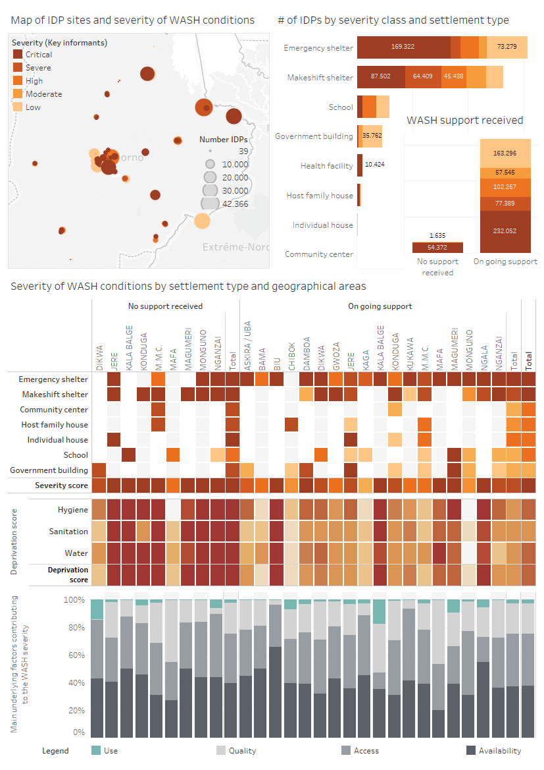**Key findings:**

* **WASH actors need to scale up interventions for IDPs in emergency and makeshift shelters**. Out of 700.000 IDPs in the affected areas, 463.000 are facing high, severe or critical WASH conditions. 88% reside in self-made/makeshift or emergency shelter. Of those sites receiving assistance, only 26% can meet their basic WASH needs. IDPs in government building are generally and receiving assistance are generally better off than other IDPs.
* **WASH response coverage is nearly complete.** Despite improved geographical coverage from WASH actors, 40 sites (~55.000 IDPS) not receiving assistance still face high, severe or critical unmet needs, the large majority of them located in Jere, Konduga, Monguno and M.M.C. WASH needs assessments are urgently required in those sites to launch appropriate response.
* **Integrated WASH assistance is required in sites who haven’t received assistance yet.** In sites not receiving WASH assistance, water supply, sanitation and hygiene gaps affect nearly all IDPs, except in Dikwa and Mafa. In sites already receiving WASH assistance, critical gaps in the three sub-sectors were identified in Biu, Kalabalge and Ngala. Immediate follow up WASH assessment are required in those locations to identify and address unmet needs and mitigate public health risks. The priority concerns heat table next page indicates the focus of individual assessments.
* **Interventions needs to be tailored to each site context and based on in-depth assessments.** Types of underlying factors vary frequently, mostly depending on security, level of assistance and access to markets. IDPs living in sites not receiving WASH assistance primarily suffer availability issues, mostly due to distance to water points and security. Quality was frequently mentioned as a key issue in Mafa and M.M.C., mostly due to water taste. IDPs living in sites receiving WASH assistance report a lack of safe water on local market but also a lack of functioning water points and long waiting time at the water points. Quality issues were more frequently mentioned in Kalabalge and Mafa.
* **Children and elderly’s WASH needs should be assessed more in-depth.** No strong patterns emerge from the identification of priority population groups, indicating that all suffer identically of WASH shortages. In IDPs sites not receiving WASH assistance, females were generally considered more of a priority, especially elderly and children. In IDPs sites already receiving WASH assistance, children and male elderly were considered more of a priority. To understand better the issue, focus group discussions with both children and elderly should be undertaken in assessed sites.

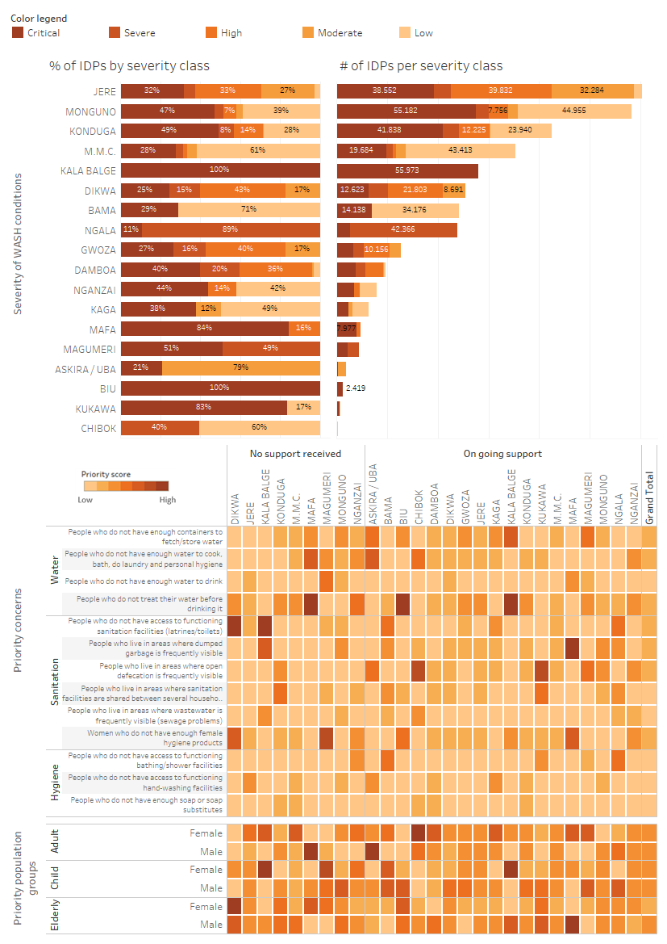

# Annex Child Protection

## Child Protection Analysis Framework

The Child Protection Analysis Framework was designed in 2018 based on a review of CP existing guidance and needs assessment reports. The Framework represents the different topics and sub-topics generally being measured during CP needs analysis through direct or proxy indicators.

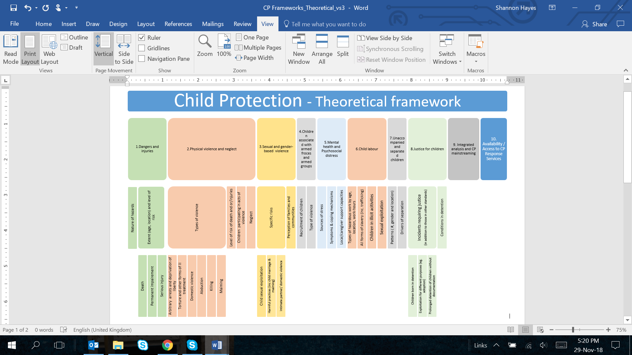

## Child Protection Questions

|  |  |  |  |  |  |  |  |  |  |  |  |
| --- | --- | --- | --- | --- | --- | --- | --- | --- | --- | --- | --- |
| **Screening questions** | | | | | | | | | | | |
| **Section** | **Priority** | **Indicator** | **Questions** | **Response items** | | | | | | | **Instruction** |
|  |  |  |  | **No problem & minor problem** | **Moderate problem** | **Major problem** | **Severe problem** | **Critical problem** | **Catastrophic problem** | **DNK/**  **No Answer** |  |
| Physical violence and other harmful practices | 2 | # children abducted per site | Approximately how many children under 18 years have gone missing from your community during the last month? | # | | | | | | Don’t know/No answer | Will be analyzed according to severity under section “Analyze” |
| Physical violence and other harmful practices | 3 | # children detained per site | Approximately how many children under 18 years from this site have been detained by authorities within the past month? | # | | | | | | Don’t know/No answer | Analyzed according to severity under section “Analyze” |
| Unaccompanied and separated children | 1 | # UACs per site | Approximately how many children under 18 years in the site are living with no mother, no father or any other adult family members? | # | | | | | | Don’t know/No answer | Analyzed according to severity under section “Analyze” |
| Child labour & exploitation | 1 | # children being exploited per site | Approximately how many children under 18 years in the site are begging in public places? | # | | | | | | Don’t know/No answer | Analyzed according to severity under section “Analyze” |
| Child labour & exploitation | 1 | Proportion of sites where children are engaged into hazardous work | Approximately how many children under 18 years in the site have been involved in the type of work and/or other activity that puts their health or safety at risk? | Nobody  (0 children) | Few (10%) | Some (around 25%) | About half (around 50%) | Most (around 75%) | Everyone  (around 100%) | Don’t know/No answer | Select one |
| Physical violence and other harmful practices | 1 | Proportion of sites where child marriage is increasing | Has the number of marriages of girls under 18 living in the site increased in the last (recall period)? | No marriages of girls under 18 | Decreased | Stayed the same | Increased by up to 25% | Increased by more than 25% | Increased by more than 25% | Don’t know/No answer | Only ask at the first round in each site |
| Physical violence and other harmful practices | 1 | Proportion of sites where child marriage is increasing | Approximately how many girls under 18 years in the site got married during the last (recall period)? | # | | | | | | Don’t know/No answer | Ask at all rounds |
| Physical dangers and injuries | 1 | Proportion of sites where children are exposed to physical dangers | What type of accidents are children under 18 years very likely to be injured or killed from in or around the site within the next 30 days? Accidents from physical dangers include issues with construction, site layout, weather, objects, animals. It does not include violence. | Minor common home accidents | Minor common home accidents | Exposure of some children to minor accidents: falling into open holes/ditches, injuries due to poor lighting, burns from cooking fires etc) | Exposure of some children to serious accidents: electrocution due to exposed wiring, vehicle accident, undomesticated animals etc. | Exposure of many children to serious accidents: extreme weather, wide-spread fire on the site etc. | Exposure of many children to critical accidents: land mines, unexploded ordinance | Don’t know/No answer | Enumerators to select all that apply, however only the highest will be analyzed for severity |
| Unaccompanied and separated children | 1 | Proportion of sites with UASCs at higher risk due to unplanned separation | For children that have been separated from their normal caregivers, to what extent was this separation planned? | No child separation | Very well planned (In regular contact with family, have money for travel, have planned assistance at destination) | Very well planned (In regular contact with family, have money for travel, have planned assistance at destination) | Somewhat planned (Occasional contact with family, and family know which city/town they are in) | Not planned (unintentional separation) | Not planned (unintentional separation) | Don’t know/No answer |  |

|  |  |  |  |  |  |  |  |  |  |  |  |
| --- | --- | --- | --- | --- | --- | --- | --- | --- | --- | --- | --- |
| **PROXY indicators for CP risk** | | | | | | | | | | | |
| PROXY exploitation, neglect, child labour, child marriage |  | Proportion of sites with risks of exploitation, neglect and child marriage due to inadequate access to food | In the past week, what proportion of households ate fewer than 3 meals per day because there was not enough food to eat? | Nobody (around 0%) | Some (around 25%) | | About half (around 50%) | Most (around 75%) | Everyone  (around 100%) | Don’t know/No answer | Select one |
| PROXY physical violence, sexual violence, |  | Proportion of sites with risks of violence due to inadequate lighting | What proportion of communal spaces have adequate lighting? | All  (100% having lighting) | Most  (around 75%) | | About Half (around 50%) | Some (around 25% have lighting) | None  (0% have lighting) | Don’t know/No answer | Select one |
| **PROXY - AGGREGATES of multiple questions in DTM** | | | | | | | | | | | |
| PROXY physical violence, sexual violence |  | Proportion of sites with risk of violence due to inadequate shelter | Aggregate of 2 shelter questions. % of households with no shelter, or emergency shelters. | Nobody (around 0%) | Some (around 25%) | | About half (around 50%) | Most (around 75%) | Everyone  (around 100%) | Don’t know/No answer | Calculate |
| **Threshold for Screening questions using numbers** | | | | | | | | | | | |
| % abducted |  | Proportion of sites where children are abducted | Analyze proportion abducted to displaced children total | TBD | TBD | TBD | TBD | TBD | TBD | No data |  |
| % detained |  | Proportion of sites where children are detained | Analyze proportion detained to displaced children total | TBD | TBD | TBD | TBD | TBD | TBD | No data |  |
| % UACs |  | Proportion of sites with unaccompanied children | Analyze proportion of UACs to displaced children total | TBD | TBD | TBD | TBD | TBD | TBD | No data |  |
| % exploited |  | Proportion of sites where children are begging /at risk of exploitation | Analyze % exploited / displaced children total | TBD | TBD | TBD | TBD | TBD | TBD | No data |  |
| Child marriage increase |  | Proportion of sites where child marriage is increasing | Analyze the changes of numbers over time. However, the answer to the question (“*have child marriages increased in the last period*”) which is asked only at the first round will enable analysis also at the first round. | TBD | TBD | TBD | TBD | TBD | TBD | No data |  |
| **Result of WASH and Education severity ranking** | | | | | | | | | | | |
| **WASH** | 1 |  | WASH severity ranking | Result n/a No issue | Result low | Result Medium | Result high | Result severe | Result critical | No Data | Calculate |
| **EDUCATION** | 1 |  | Education severity ranking | Result n/a No issue | Result low | Result Medium | Result high | Result severe | Result critical | No Data | Calculate |

|  |  |
| --- | --- |
| **Description** |  |
| **Severity question** | To summarize the conditions of the children under 18 years old in this site, which of the following statement would you say is true in your area (select only one):   1. Children are well taken care of and not exposed to any form of danger or violence 2. A few children are exposed to harm, injuries or violence 3. Many or all children are exposed to harm, injuries or violence 4. Because of dangers, harms and violence, we might soon see some children dying 5. Because of dangers, harms and violence, a few children died already 6. Because of dangers, harms and violence, many children died already 7. Do not know/No answer |
| **Underlying factors questions** | In your opinion, what are the main barriers to receiving appropriate child protection services? (Child protection services include: identification of unaccompanied and separated children, family tracing and reunification services, referral services and case management to help children exposed to violence or abuse, safe spaces in the community where children participate in structured recreational activities to help relieve anxiety and mentally recover from stress or trauma). (Keep the question open. Enumerators recode based on response. Rank top three or select only top three):   1. Bad terrain, distance or transport constraints 2. Insecurity/criminality, dangers or fear of physical injuries en-route to, or near child protection service providers 3. Social discrimination due to ethnicity, religion, poverty, gender, disability, etc. 4. Lack of documentation 5. Lack of money to pay for protection services 6. Lack Information on available services 7. Lack of trained professionals in the area 8. ack of financial resources to open/maintain services 9. Lack of physical space/buildings 10. Services discontinued due to conflict/violence in the area 11. Mobile teams that are not always in the site 12. Others (Specify) 13. Do not know/no answer |
| **Priority concerns** | We discussed earlier issues related to protecting children from violence, exploitation, abuse and neglect. You mentioned that X, X, X, X, X and X were issues affecting under 18 years old children in this site. Would you be able to tell us which ones do you consider a priority for intervention? (Rank top three or select only top three):   * Children that have been arrested and deprived of liberty * Children that have gone missing * Children at risk of injury due to physical dangers in the site * Children begging in public places or exchanging sexual acts for food or money * Children earning money doing dangerous work * Increasing rates of child marriage * Children without any adult caregiver for them * Children that have been accidentally separated from their families   Extended list (include only if those questions are not included in other sectors):   * Children at risk of violence due to inadequate lighting in the site * Children at risk of exploitation or neglect due to inadequate food provision * Children at risk of violence due to inadequate shelter * Children at risk of violence due to a lack of protective learning spaces * Children at risk of violence due to distance they must walk to obtain safe drinking water |
| **Priority groups** | Overall, what are the demographic groups facing the most safety and protection issues for displaced children? (Rank top three or select only top three)   * Girls 0-5 years old * Boys 0-5 years old * Girls 6-12 years old * Boys 6-12 years old * Girls 13-17 years old * Boys 13-17 years old |

## Child Protection Example of Report Using DTM Data

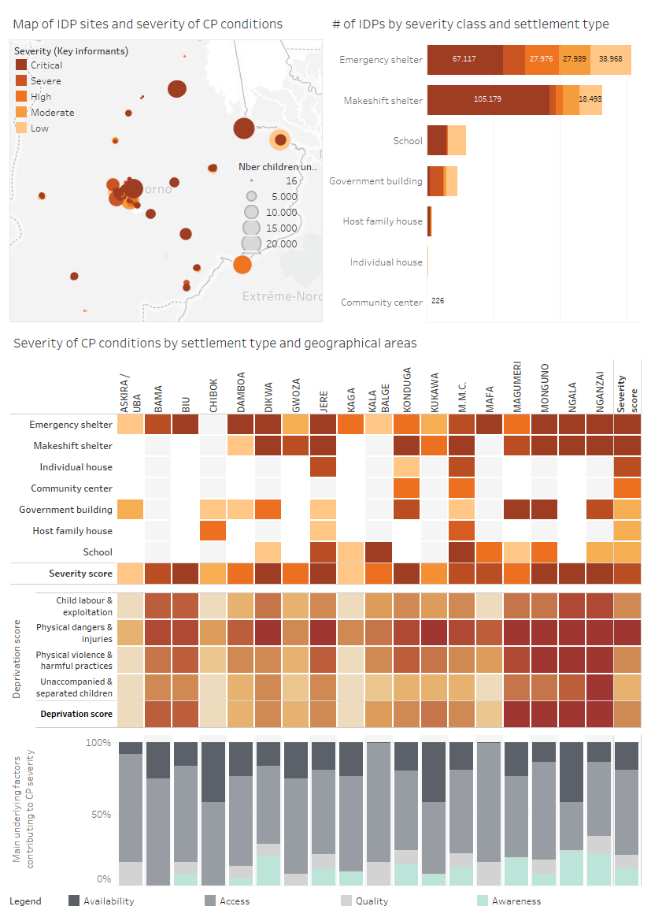**Key findings:**

* **Child Protection AoR need to scale up interventions for children IDPs in emergency, makeshift shelters and schools**. Out of 400.000 children IDPs in the affected areas, 270.000 are facing high, severe or critical protection conditions. 85% of them reside in self-made/makeshift or emergency shelter.
* **Child protection conditions** are particularly severe in Biu, Dikwa, Jere, Konduga, Mondugo, Ngala and Nganzai.Child Protection needs assessments are urgently required in those geographical areas to launch appropriate response.
* **Risks linked to physical dangers, injuries, physical violence and other harmful practices are particularly high** in Magumuri, Monguno, Ngala and Nganzai geographical areas. In those same location, high numbers of unaccompanied and separate children are also reported. Child protection assessments should focus on those three issues in the concerned geographical areas.
* **Inaccessibility to protection services due to discrimination and insecurity** are the underlying factors contributing the most to child protection conditions. Unavailability (lack of physical space, service totally discontinued, etc.) of protection services was the most reported in Chibok, Kukawa and Ngala geographical areas.
* **Male children (especially 13-17 years old) and female (especially 0-5 and 13-17 years old) were more frequently mentioned as priority group for child protection assistance**. Infant females were frequently mentioned as priorities in Ngala, Mafa, Kukawa, Gwoza and Bama geographical areas. To understand better the issue, focus group discussions with both male and female children and caregivers should be undertaken in assessed sites.
* **Priority areas for Child protection and Education are very similar.** It is recommended to coordinate with the Education cluster to conduct needs assessment, mobilize joint resources and avoid duplication.

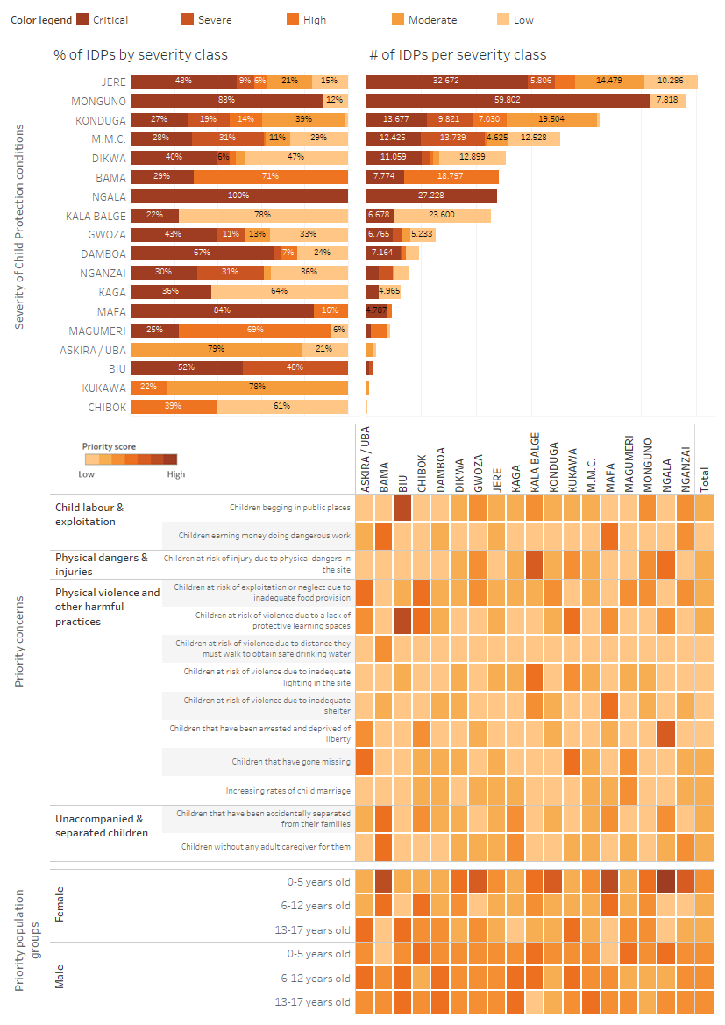

# Annex Education in Emergencies

## Education in Emergencies Analysis Framework

The Education in emergencies Analysis Framework was designed in 2018 based on a review of education existing guidance and needs assessment reports. The Framework represents the different topics and sub-topics generally being measured during education needs assessment. It is a working model and does not reflect a global endorsement by the Education Cluster.

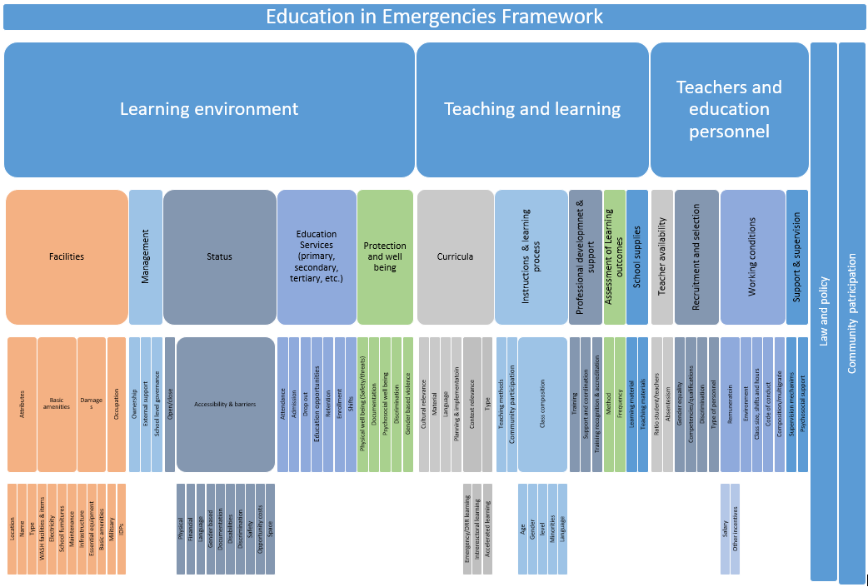

## Education Questions

|  |  |  |  |  |  |  |  |  |
| --- | --- | --- | --- | --- | --- | --- | --- | --- |
| **Screening questions** | | | | | | | | |
| **Section** | **Indicator** | **Questions** | **Response items** | | | | | |
| **Low** | **Medium** | **High** | **Severe** | **Critical** | **Other/DNK** |
| Availability and learning | Proportion of sites with available pre-school learning space | Is there sufficient learning space/classrooms for IDP pre-school children (3-5 years). | a) Yes, there is enough learning space for IDP children, classrooms are not crowded | *b) Yes*, there is enough learning space for IDP children, however classrooms are a little/sometimes crowded; | c) No, there is not enough learning space, classrooms are quite/often crowded and/or some classes are held outside | d) No, there is not enough learning space, classrooms are largely/always crowded, and **some** IDP children are not going to school because of lack of space | e) No, there is not enough learning space or no school. **Most or** **all** IDP children are not going to school because of lack of space | f) Do Not Know/No Answer |
| Availability and learning | Proportion of sites with available primary and secondary learning space | Is there sufficient learning space/classrooms for IDP primary and secondary school children | a) Yes, there is enough learning space for IDP children, classrooms are not crowded | b) Yes, there is enough learning space for IDP children, however classrooms are a little/sometimes crowded | c*)* No, there is not enough learning space, classrooms are quite/often crowded and/or some classes are held outside | d) No, there is not enough learning space, classrooms are largely/always crowded, and **some** IDP children are not going to school because of lack of space | e) No, there is not enough learning space or no school. **Most or** **all** IDP children are not going to school because of lack of space | f) Do Not Know/No Answer |
| Availability and learning | Proportion of sites with available pre-school teachers | Are there enough teachers to teach pre-school level (that is IDP children 3-5 years old)? | a) Enough teachers are available, classrooms are not crowded | b) Enough teachers are available, classrooms are a little bit/sometimes crowded | c) Not enough teachers are available, classrooms are quite/often crowded | d) Largely insufficient number of teachers are available, classrooms are largely/always crowded | e) No or not enough teachers are available, classes are not functional | f) Do Not Know/No Answer |
| Availability and learning | Proportion of sites with available primary and secondary teachers | Are there enough teachers to teach primary & secondary level classes for IDP children? | a) Enough teachers are available, classrooms are not crowded | b) Enough teachers are available, classrooms are a little bit/sometimes crowded | c) Not enough teachers are available, classrooms are quite/often crowded | d) Largely insufficient number of teachers are available, classrooms are largely/always crowded | e) No or not enough teachers are available, classes are not functional | f) Do Not Know/No Answer |
| Cross cutting | Proportion of sites with schools without segregated latrines | How many schools have separate toilets /latrines for boys and girls? | a) All (around 100%) | b) Most (around 75%) | c)About half (around 50%) | b) A few (around 25%) | e) None (around 0%) | f) Do not know /No Answer |
| Access and learning | Proportion of sites where children 3-5 years old do not access learning | How many displaced children 3-5 years old attend school? | a) Everyone (around 100%) | b) Most (around 75%) | c) About half (around 50%) | d) A few (around 25%) | e) Nobody (around 0%) | f) Do not know /No Answer |
| Access and learning | Proportion of sites where children 6-12 years old do not access learning | How many displaced children 6-12 years old attend school? | a) Everyone (around 100%) | b) Most (around 75%) | c)About half (around 50%) | d) A few (around 25%) | e) Nobody (around 0%) | f) Do not know /No Answer |
| Access and learning | Proportion of sites where children 13-17 years old do not access learning | How many displaced children 13-17 years old attend school? | a) Everyone (around 100%) | b) Most (around 75%) | c)About half (around 50%) | d) A few (around 25%) | e) Nobody (around 0%) | f) Do not know /No Answer |
| Access and learning | Proportion of sites without accessible learning facilities for 3-5 years | What is the walking distance to the nearest education facility for displaced children 3-5 years? | a) Less than 20 minutes | b) Less than 20 minutes | c)Less than 20 minutes | d)Over 20 minutes | e) Over 20 minutes | f) Do Not Know/No Answer |
| Access and learning | Proportion of sites without accessible learning facilities for 6-12 years | What is the walking distance to the nearest education facility for displaced children 6-12 years? | a) Less than 20 minutes | b) Less than 20 minutes | c)20-40  minutes | d)Over 40 minutes | e) Over 40 minutes | f) Do Not Know/No Answer |
| Access and learning | Proportion of sites without accessible learning facilities for 13-17 years | What is the walking distance to the nearest education facility for displaced children 13-17 years? | a) Less than 40 minutes | b) Less than 40 minutes | c)40-60 minutes | d)Over 60 minutes | e) Over 60 minutes | f) Do Not Know/No Answer |

|  |  |  |  |
| --- | --- | --- | --- |
| **Severity questions** | To summarize the conditions in term of education for the school aged children in displaced families in this site, how many children would you say face challenges in accessing education services in your area (select only one)?   1. Nobody (around 0%) 2. A few (around 25%) 3. About half (around 50%) 4. Most (around 75%) 5. All (around 100%) | | |
| **Underlying factors questions** | In your opinion, what are the main causes of education issues for children 3-5 years old? (Keep the question open. Enumerators recode based on response. Rank top three or select only top three):   1. Access: Bad terrain, distance or transport constraint 2. Access: Insecurity or fear of physical injuries 3. Access: Social discrimination due to ethnicity, religion, poverty, gender, health, disability or other. 4. Access: Lack of documentation (e.g., birth certificate, certificate of completion of primary education etc.) 5. Access: Lack of money to pay school fees 6. Access: Families have other priorities for children, such as collecting water or working. 7. Availability: Lack of infrastructure (school buildings or classrooms) to accommodate all students 8. Availability: Lack of teachers 9. Availability: Lack of teaching materials 10. Availability: Lack of learning materials 11. Availability: School is used for other purpose | In your opinion, what are the main causes of education issues for children 6-12 years old? (Keep the question open. Enumerators recode based on response. Rank top three or select only top three):   1. Access: Bad terrain, distance or transport constraint 2. Access: Insecurity or fear of physical injuries 3. Access: Social discrimination due to ethnicity, religion, poverty, gender, health, disability or other. 4. Access: Lack of documentation (e.g., birth certificate, certificate of completion of primary education etc.) 5. Access: Lack of money to pay school fees 6. Access: Families have other priorities for children, such as collecting water or working. 7. Availability: Lack of infrastructure (school buildings or classrooms) to accommodate all students 8. Availability: Lack of teachers 9. Availability: Lack of teaching materials 10. Availability: Lack of learning materials 11. Availability: School is used for other purpose | In your opinion, what are the main causes of education issues for children 13-17 years old? (Keep the question open. Enumerators recode based on response. Rank top three or select only top three):   1. Access: Bad terrain, distance or transport constraint 2. Access: Insecurity or fear of physical injuries 3. Access: Social discrimination due to ethnicity, religion, poverty, gender, health, disability or other. 4. Access: Lack of documentation (e.g., birth certificate, certificate of completion of primary education etc.) 5. Access: Lack of money to pay school fees 6. Access: Families have other priorities for children, such as collecting water or working. 7. Availability: Lack of infrastructure (school buildings or classrooms) to accommodate all students 8. Availability: Lack of teachers 9. Availability: Lack of teaching materials 10. Availability: Lack of learning materials 11. Availability: School is used for other purpose |
| **Priority problems to address** | We discussed earlier issues related to education. You mentioned that X, X, X, X, X and X were issues affecting children education in this site. Would you be able to tell us which ones are the most serious problem and require immediate intervention? (Rank top three or select only top three):   1. Lack of learning space (infrastructure, building, maintenance, etc.) at reasonable distance 2. One or more school level is not available (pre-primary, primary, secondary, tertiary) 3. Lack of safety and security for children in school or on their way to school 4. Lack of teachers 5. Lack of teaching material 6. Lack of learning materials 7. Lack of basic amenities (clean water, segregated toilets, heat, electricity) | | |
| **Priority groups** | Overall, what are the age groups facing the most severe issues in education (Rank top three or select only top three)?   1. Girls 3-5 years old 2. Boys 3-5 years old 3. Girls 6-12 years old 4. Boys 6-12 years old 5. Girls 13-17 years old 6. Boys 13-17 years old 7. Girls >18 years old 8. Boys >18 years old | | |

## Education Example of Report Using DTM Data

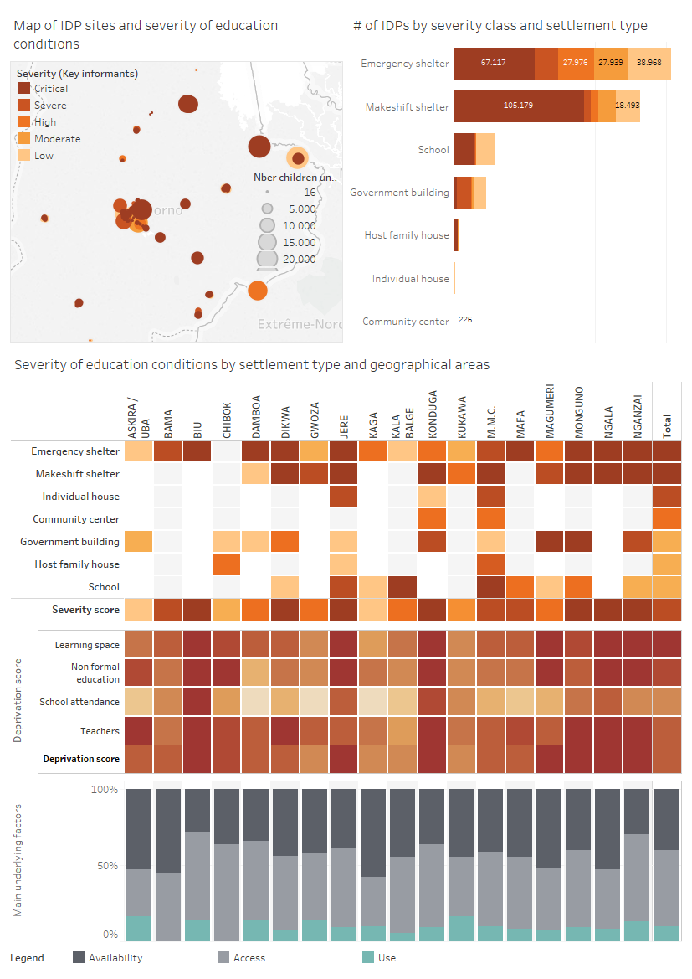**Key Findings:**

* **The education cluster need to scale up interventions for children IDPs in emergency, makeshift shelters and schools**. Out of 700.000 children IDPs in the affected areas, 470.000 are facing high, severe or critical protection conditions. 91% of them reside in self-made/makeshift, emergency shelter or schools.
* **Education conditions** are particularly poor in Biu, Dikwa, Jere, Konduga, Mondugo, Ngala and Nganzai.Education needs assessments are urgently required in those geographical areas to identify and launch appropriate response.
* **In the most severely affected areas, lack of learning space, teachers and non-formal education are most frequently reported.** As an effect, lower school attendance rates are recorded in those locations. Education assessments should focus on those three issues in the concerned geographical areas.
* **Inaccessibility** **to appropriate** **education services,** and mostly lack of learning spaces, teachers and advanced curriculumare the underlying factors contributing the most to poor education conditions. In most geographical areas, school dropout (to work or due to early marriage) is also reported as a reason for non-attendance.
* **Female children were more frequently mentioned as priority groups for education interventions**. Male children of 13-17 years old were reported as priority group in Askira/uba area. To understand better the issue, focus group discussions with both teachers and parents should be undertaken in visited sites.
* **Priority areas for Education and Child protection are very similar.** It is recommended to coordinate with the Child Protection AoR to conduct needs assessment, mobilize joint resources and avoid duplication.

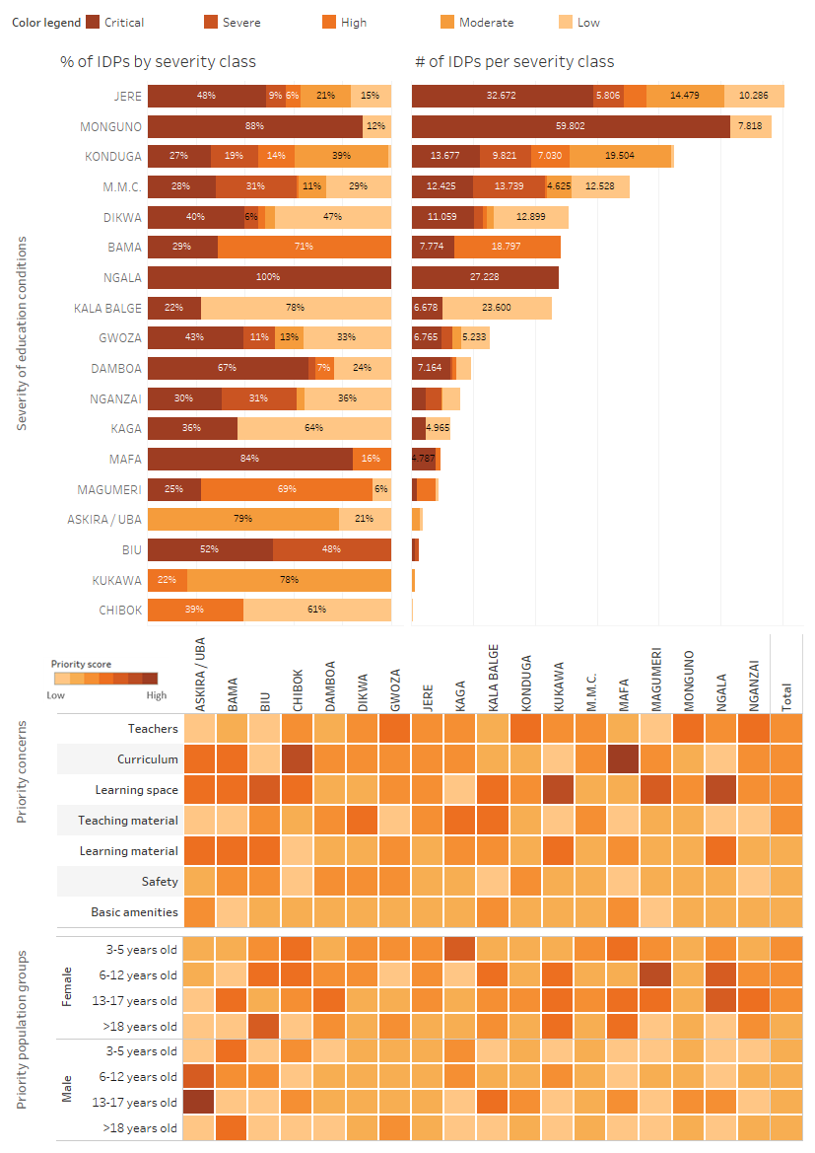

# Annex Demo workbook

An excel demo workbook is offered as a companion to this guidance. Double click on the icon below to open the excel file:

1. Read the tab “To read first” that provide with an explanation of the fields available in the dataset.
2. Remember that the data is fictitious and should not be used for operational purposes.
3. Calculated fields such as deprivation score or risk score contains formulas that can be easily replicated in other workbook or datasets.

1. The proposed analysis frameworks are draft only, designed to map the topics of interest of the different clusters/AoR based on a review of existing practice and guidance. They should be considered as working version only and do not reflect a global endorsement
2. See screening questions under section 3. Data processing and Analysis Tips
3. Issues related to awareness and use generally require household-based assessment approaches, so are not considered by DTM location assessment which are based on general key informants’ interviews.
4. In the interest of time, such discussions could happen in the presence of all Clusters/AoRs, including through IMWG or similar fora.
5. For roles in evidence-based decision making, refer to DTM & partners Guide: “Approach, Roles and Guiding Questions for Data you can use”. The guide is available at: <https://drive.google.com/file/d/1l4798CecSLwQL5EF_O_cFYvzGE75ilPh/view?usp=sharing>
6. Issues related to awareness and use generally require household-based assessment approaches
7. For more on Borda count, see ACAPS technical note “[Heat maps as tools to summarize priorities expressed in needs assessments](https://www.acaps.org/sites/acaps/files/resources/files/heat_maps_as_tools_to_summarise_priorities_2011.pdf)”, Aldo Benini 2011