DTM Field Companion for

Multi Sectoral Location Assessment Sectoral Questions for Key Informants & Observation

The DTM Field Companion Sectoral Questions and relative Data Analysis Plan were developed by Global CCCM, Education, Health, NFI & Shelter, Protection, WASH, Clusters, Global Child Protection and GBV AoRs, CASH WG in Geneva, Translators Without Borders, DTM and IASC experts on AAP and PSEA, and IOM DTM staff.

The Field Companion was created to support DTM and Partners field operations, as part of the DG ECHO -funded initiative to increase usefulness and usability of DTM data for response. It is part of the DTM and Partners Toolkit, available on IOM DTM website: http://displacement.iom.int/dtm-toolkit/dtm-partners-toolkit
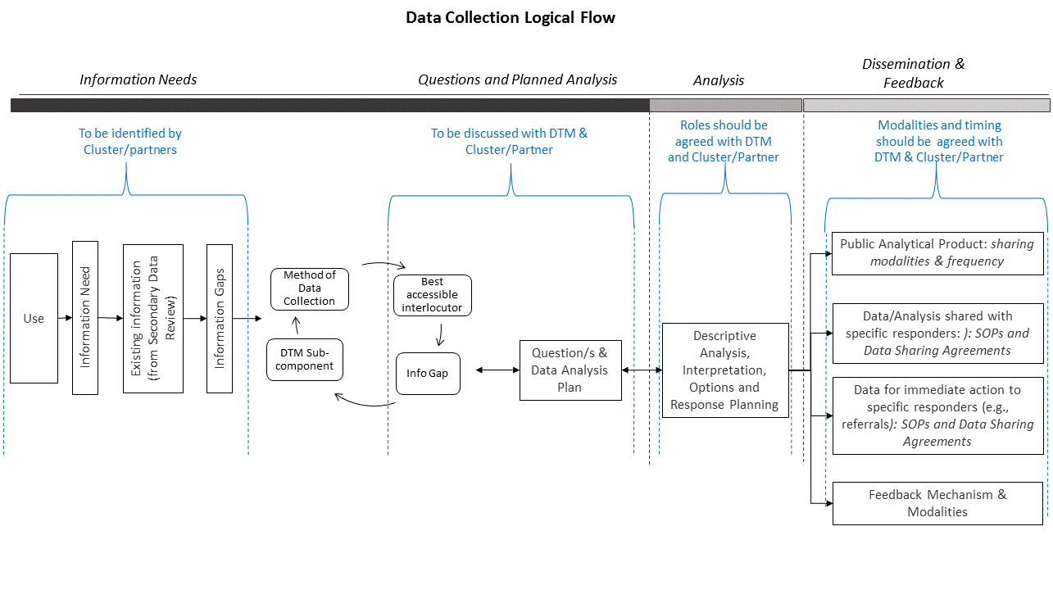
DTM is grateful for the contribution to the entire DTM & Partners Toolkit, made possible thanks to the unwavering support of colleagues from Global Clusters, AoRs, WGs and DTM, at global as well as Regional and National level.

Geneva - Athens, December 2018

DTM Field Companion for Multi Sectoral Location Assessment - Sectoral Questions

What is the Field Companion?
The DTM Field Companion for Sectoral Questions in Multi Sectoral Location Assessment is the list of common information needs identified with global Clusters, WGs, and other sectoral experts . A suggested phrasing of questions and reply options for each information need was also developed specifically for Key Informants Interviews. These questions are included in the DTM Data Dictionary.
The Field Companion is available in two formats, Pdf and Excel. There are extracts for each humanitarian sector, in addition to a specific one for AAP/PSEA, one for Sex and Age Disaggregated Data (SADD) and one for sectoral actors’ presence and contact details.
The Field Companion can be used as Data Analysis and Dissemination plan for the questions in the Data Dictionary.
Field DTM and Partners colleagues can use the field companion questions if they are effective for the information needs identified and for the context and culture of the country. Colleagues in the field can select some questions, modify others and add questions to capture their specific information needs in the context.
The result will be the country DTM Data Analysis Plan The purpose of a data plan is to visualize the final descriptive analysis and verify whether it provides the information originally identified as needed by decision makers. Data Plan has to be shared with data users during planning so to verify such correspondence.
In the Field Companion, each question is clearly linked to:
- Information it provides
- Suggested use of its results
- Suggested descriptive analysis
- Suggested visualization
- How the information should be shared (e.g., publicly or not)
- Sector, WG, Cluster or specialized organization potentially interested in the results.
- Preconditions that must be in place to include question in the questionnaire
- Recommended key informant for that question
- Reply Options and instructions for the questionnaire form
- Type of question (e.g., whether core or standard in DTM data dictionary)

How does the Field Companion help?
The Field Companion is designed to help DTM Coordinators in the field as well as Sector/Cluster/WG/partners along their cooperation in the data collection and analysis process.
DTM and partners can use it jointly:
- Looking at the information need, DTM coordinators and partners can select the questions for the questionnaire among those in the Field Companion, after information needs are clearly identified by partner.
- Looking at the options for answer, they can use such options or modify them for the context.
- Looking at the descriptive analysis and visualization mock-up, they can then verify that the selected questions are indeed providing the needed info, at the right level of detail. They can also agree on the type of descriptive analysis DTM (or partner IMO) will do of results. This will ensure shared analysis will meet needs of partners.
- Looking at the suggested use (and modifying it when necessary) they can clearly identify and document the link between the use and the question, to ensure results are used for response planning.
- Looking at the dissemination modality of each dataset, they will be able to agree on how non-public datasets will be shared (and enter in necessary data sharing agreements, to enable safe and timely data sharing). DTM can also use this opportunity to ensure partners know when and where the public datasets are shared.
- Looking at dataset of interest to sectors may be useful for an initial understanding of potential partners’ interest, as well as guide sharing of data. Including in the questionnaire those questions of interest to more than one sector may help save on time and resources by collecting data that are useful to more partners.
- When under time pressure in the beginning of an exercise, if immediate engagement with all partners is not feasible, DTM can include the sectoral questions in the field companion in the questionnaire, as they were developed by Global Clusters, AoRs and others. Engagement with all partners will still be pursued, as the first rounds are ongoing. DTM will start by collecting partners information needs, and only after, the DTM Field Companion will be used to select and modify questions.

Roles when using the Field Companion to develop a joint Data Analysis Plan:
- The Field Companion is formatted as a Data Analysis Plan. A Data Analysis Plan links Use, Analysis, Information Need, Questions and Options for Answer. It helps DTM and Partners reach a shared understanding on what questions provides what results, & how results fill information gaps. Questions developed without a Data Analysis Plan will likely be de-linked from their analysis & use: DTM will still collect data but data may not support partners’ response.
- The Field companion can be adapted by Partners and DTM to become the country joint Data Analysis Plan, by verifying what existing questions are appropriate to obtain needed data, keeping those existing questions and their analysis, while adding, changing or deleting questions depending on the context and identified information needs. Remember that the Field Companion only includes sectoral questions for key informants and observation. DTM data dictionary also includes many Inter-sectoral questions and Focus Group Discussion questions, which will be useful for Partners.
- DTM and Partner IM experts develop draft questions and options for answer with support of sectoral and cultural experts (e.g., Cluster Coordinator and members, local staff and local NGOs).
They answer the following:
  - In this context, using this methodology and this level of measurement, what questions should we ask in order to obtain the data we need?
  - In this context, using this methodology and this level of measurement, what options for answers we should give in order to obtain the data we need?
  - Is this question safe and does not put anybody at risk?
- DTM & Partner IM experts visualize and describe results using fake data (mock-up charts).
- Partner decision-makers, sectoral and cultural experts use the description and visualization to verify that drafted questions can indeed provide needed information and link questions to expected use.
- DTM & Partner IM experts make necessary changes to the questions, finalize and share the data plan with Partner decision-makers, subject matter and cultural experts.

Description of Field Companion Information

Questions and Data Analysis Plan were developed with Global CCCM, Education, Health, NFI & Shelter, Protection, WASH, Clusters, Global Child Protection and GBV AoRs, CASH WG in Geneva, Translators Without Borders, DTM and IASC experts on AAP and PSEA, and other global experts.

