Displacement Tracking Matrix Frequently Asked Questions for Clusters/Sectors/WGs

What is DTM?
The Displacement Tracking Matrix (DTM) is a system to track and monitor displacement and population mobility, provide critical information to decision-makers and responders during crises, and contribute to better understandings of population flows. DTM was first conceptualized in 2004 to monitor internal displacement in Iraq and has since been adapted for implementation in 80 countries, including in contexts of conflict, natural disaster, complex emergencies and protracted crises.
How does DTM work?

DTM’s effectiveness in meeting varying objectives in a diverse range of contexts relies on its ability to maintain a lightweight, flexible and modular structure, enabling quick adjustments and adaptation. To preserve operational flexibility, while promoting quality and coherence across DTM activities, various components, tools and methods have proven effective for quantifying displacement and mobility in DTM operations worldwide. The four DTM Components are illustrated in the visual below:
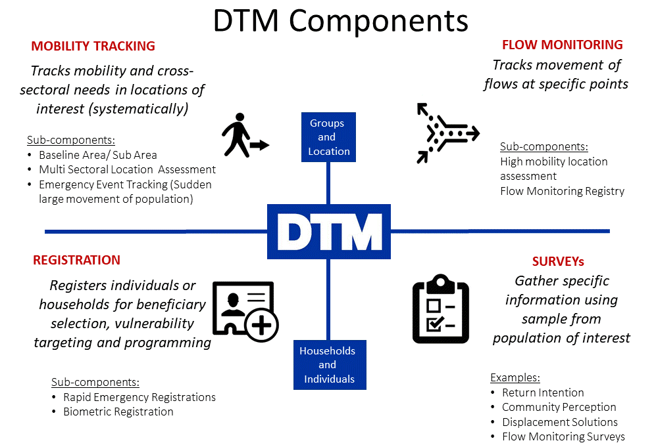
How are data collected?
DTM teams use a variety of methods for collecting data. For Baseline Assessment usually DTM interviews key informants, while direct observation generally accompanies key informants interviews in Multi Sectoral Location Assessments. Counting, key informants and observation can be used in flow monitoring registry. For Registration and Surveys DTM teams directly interview individuals or households. Information on the type of Key Informants that were interviewed is included in the data collected. DTM Methodological Framework is available here.
What DTM information may be useful for Cluster response?
DTM produces a variety of datasets, and sometimes datasets varies between operations. Here are some of the commonly collected types of information that can be relevant to the Cluster from the Mobility Tracking component.
Baseline Assessment usually can provide list of locations (e.g., camps, sites, communities) where displaced persons are, and initial information on the number of people, types of settlement they live in, type of population, reasons for displacement and places of origin, sectors of need.
Multi Sectoral Location Assessments (MSLA) usually collects information per each location, including access, number of persons, an indication of sex and age disaggregated data, an indication of scale of specific groups, available services, obstacles to accessing services and assistance, access to infrastructure by groups, settlement types.
Emergency Event Tracking is collecting very initial information on displacements caused by particular events. It can provide timely updates on new displacement events occurring between regular DTM assessment rounds on population group description and numbers, location the group is displaced from and displaced to. It can also include an initial sense of the settlement arrangements and some of the urgent sectoral needs.
How can Clusters/Sectors/WGs in countries use DTM information?
DTM data are often used to understand scope and scale of displacement, as well as trends. However, they are also used operationally, for example to raise alerts and red flags on locations in urgent sectoral need, and to help prioritize locations for follow up sectoral assessment and other action.

Methods and context have an impact on the information collected in any such exercise. DTM is not a Sectoral Needs Assessment tool. In its mobility tracking component, DTM does not interview individuals or HH, and DTM enumerators and key informants are not sectoral experts. DTM, however, has a large and consistent coverage of crisis, can be adjusted to collect information that clusters need, and provides regular updates on critical issues. In addition, its data are collected over time, and can indicate how displacement and conditions of displaced populations evolve over time.

DTM questions are designed to be answered by non-sectoral experts, in a way that results can be used by sectoral experts for analysis. Ideally, DTM teams provide the clusters with information and possibly descriptive analysis (with Cluster IM experts). Information is then jointly analysed by the cluster members (subject matter experts/decision makers) and context/cultural experts, bringing together available information from all sources.
Evidence-Based Decision-Making
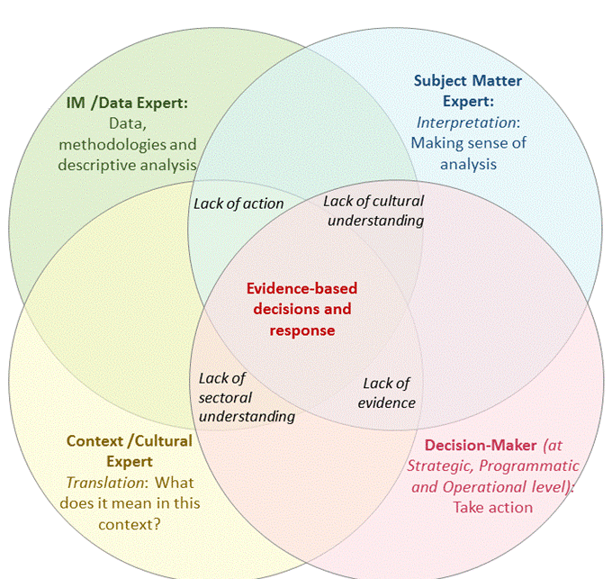
Visual was modified by EDAUUR – Grand Bargain Work Stream on Needs Assessments
Ideally, Cluster (Sectoral experts/decision makers) and Context Experts will analyse data provided by DTM and other sources, supported by DTM and/ Cluster IMO. Notice the complementarity among skillsets, and the risks of limited engagement.
How can DTM and Clusters further engage for the benefit of displaced persons?
At global level: In order to increase usefulness and usability of DTM data by clusters and cluster members, DTM worked with various Global Clusters, AoRs and WGs, to identify a recommended approach, useful tools and basic information clusters may need in most contexts. This information was transformed into proposed questions and included in the DTM Field Companion. Approach, Filed Companion and other tools are available in the online DTM& Partners Toolkit (https://displacement.iom.int/initiatives/dtm-partners-toolkit).
At country level: DTM teams and clusters in the countries will jointly discuss the type of information clusters are missing that could be collected by DTM. After identifying the missing information, they will jointly agree on the phrasing of the questions, on an analysis plan, on data-sharing modalities and their respective roles in interpreting the information. Clusters will also advise DTM teams on the most appropriate modality to communicate issues identified during data collection that require urgent response by clusters (Urgent Action). DTM and Partners can use the Field Companion and the other tools in the DTM& Partners Toolkit for help, when designing/amending their data collection exercises.
Are all DTM components rolled out in every country?
Not necessarily: DTM is implemented according to need, so different components may be rolled out in different countries, as need for information varies.
Where can I find DTM reports and data?
DTM public data and reports are online and available at: https://displacement.iom.int/, http://migration.iom.int/europe/ and http://www.globaldtm.info/ (through a search by Country). For support, contact the DTM coordinator in your country (ask DTMSupport@iom.int for his/her contact details).

