IOM Displacement Tracking Matrix Frequently Asked Questions on DTM and Cash
What is DTM?
The Displacement Tracking Matrix (DTM) is a system to track and monitor displacement and population mobility, provide critical information to decision-makers during crises, and contribute to better understand population flows. DTM was first conceptualized in 2004 to monitor internal displacement in Iraq and has since been adapted for implementation in 80 countries, in contexts of conflict, natural disaster, complex emergencies and protracted crises.
How does DTM work?
DTM’s effectiveness in meeting varying objectives in a diverse range of contexts relies on its ability to maintain a lightweight, flexible and modular structure, enabling quick adjustments and adaptation. To preserve operational flexibility, while promoting quality and coherence across DTM activities, various components, tools and methods have proven effective for quantifying displacement and mobility in DTM operations worldwide.
The four DTM Components are illustrated in the visual below:
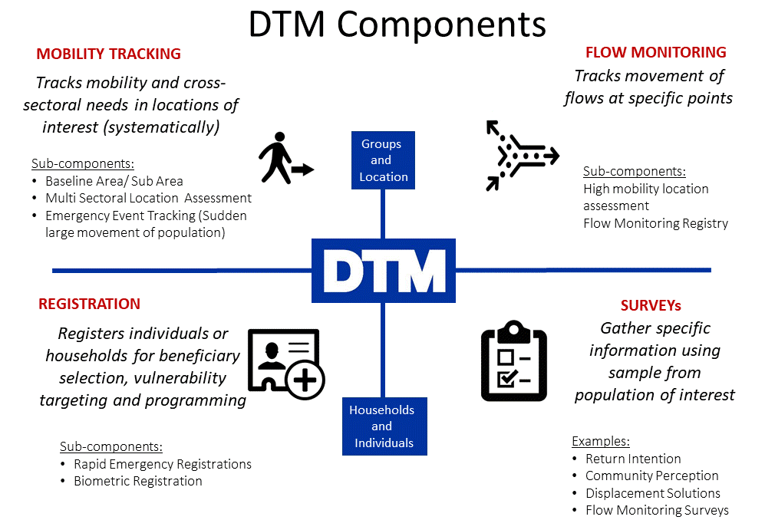
How are data collected?
DTM teams use a variety of methods for collecting data. For Baseline Assessment usually DTM interviews key informants, while observation generally accompanies key informants’ interviews in Multi-Sectoral Location Assessments. Counting, key informants and observation can be used in flow monitoring registry. For Registration and Surveys DTM teams directly interview individuals or households. Information on the type of Key Informants that were interviewed is included in the data collected. The DTM Methodological Framework is available here.
What kind of data does DTM produce?
DTM produces a variety of datasets, and sometimes datasets vary between operations. Here are some of the commonly collected types of information that can be relevant to discussions around modalities from the Mobility Tracking component.
Baseline Assessment usually can provide list of locations (e.g., camps, sites, communities) where displaced persons are, and initial information on the number of people, types of settlement they live in, type of population, reasons for displacement and places of origin, sectors of need.
Multi Sectoral Location Assessments (MSLA) usually collects information at community level per each location, including access, number of persons, an indication of sex and age disaggregated data, an indication of scale of specific groups, available services, obstacles to accessing services and assistance, access to infrastructure by groups, settlement types.
Emergency Event Tracking is collecting very initial information on displacements used by particular events. It can provide timely updates on new displacement events occurring between regular DTM assessment rounds on population group description and numbers, location the group is displaced from and displaced to. It can also include an initial sense of the settlement arrangements and some of the urgent needs.
All DTM component are not necessarily rolled out in every country: DTM is implemented according to need, so different components may be rolled out in different countries, as need for information varies.
Where can I find DTM reports and data?
DTM public data and reports are available at: https://displacement.iom.int/, http://migration.iom.int/europe/. Contact DTM coordinator in your country (ask DTMSupport@iom.int for contact details).
How can the DTM Multi-Sectoral Location Assessment data be used to inform discussions around response modalities?

Through its large and consistent coverage of crisis, the DTM MSLA may be adjusted to collect information that the Inter-Sector/Cluster Coordination Groups (ISWG/ICCG), clusters and Cash Working Groups (CWG) require. This may include information around the feasibility of using different modalities of response. While it is not a market assessment tool nor a comprehensive feasibility assessment tool, it can provide these groups with sufficient information for an initial indication regarding the potential to use cash in the response. Depending on the outcome, this may in turn prompt in-depth feasibility assessments designed to inform programming decisions.
With inter-agency Humanitarian Programme Cycle processes putting increasing emphasis on the collective analysis and understanding of response options, the DTM MSLA may hence offer one means of supporting a more joined up approach to collective analysis and decision-making.
To support such efforts, the DTM Field Companion for Cash offers suggested questions that can be used to yield information around relevant aspects of feasibility, and that are appropriate to collect through non-specialised key informant interviews at community level. This may include information on the presence of markets and obstacles in accessing markets for some groups, as well as around available modalities to deliver money in each location.
Questions can be adapted to fit the context, to yield information and possibly descriptive analysis.

How should ISWG/ICCGs and CWGs work with DTM colleagues for the benefit of displaced persons?

ISWG/ICCGs and/or CWGs should approach the DTM team in-country as soon as they identify their information gaps that DTM MSLA could help fill. They will discuss with DTM colleagues whether and how information of relevance may be collected through the DTM MSLA. Based on the generic questions in the DTM Field Companion for Cash, they can jointly develop contextually relevant questions that take into account how the data will be used.
DTM questions are designed to be answered by non-sectoral experts in a way that results can be used by sectoral experts for analysis. The DTM teams will provide the ISWG/ICCG and/or CWG with the data, which should then be jointly analysed by ICCG/CWG members (subject matter experts/decision makers) and context/cultural experts, bringing together available information from all sources.
For this purpose, the group(s) should also agree with DTM on how and who will analyse results, as well as the dissemination modalities for each dataset - ensuring the information is disseminated in a way that supports and promotes discussions and decision-making, without putting communities, organizations, Key Informants and enumerators at risk of harm.

2020 HNO and HRP Templates https://www.humanitarianresponse.info/en/programme-cycle/space
DTM worked with Global Clusters, AoRs and the Global Cluster Coordinators’ Task Team on Cash, to identify a recommended approach, useful tools and basic information clusters may need in most contexts. This information was transformed into proposed questions and included in the DTM Field Companion. The DTM Field companion for Cash is available at this link: https://displacement.iom.int/dtm-partners-toolkit/field-companion-sectoral-questions-location-assessment.
For a visual overview and specific details on the process, see the DTM&partners Toolkit (https://displacement.iom.int/dtm-toolkit/dtm-partners-toolkit) and the Pocket Guide to the Shared Approach, in: https://displacement.iom.int/dtm-partners-toolkit/predictable-approach

