Approach, Roles and Guiding Questions for Data you can use
DTM & Partners Cooperation Guide

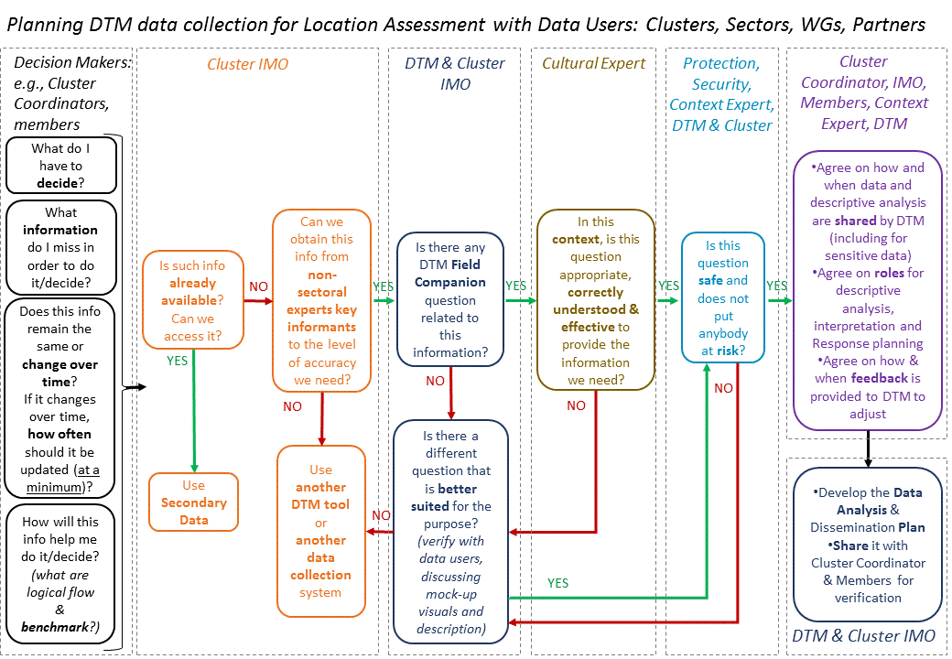
Main steps of jointly working with DTM to obtain useful and usable data.

In this document, when “partners” are mentioned, it should be understood as any organization, group or institution who uses DTM data for humanitarian response. They include Clusters, Sectors, Working Groups, AoRs, National, Regional and Local authorities, individual NGOs, UN agencies and others.

The approach in brief and how it came to be

Why Work Together?
- DTM data are aimed at informing humanitarian response
- DTM data from Location Assessments are shared with all humanitarian actors
- By working together you can make DTM data more useful for response

An analysis of the main reasons for partial use of DTM data highlighted the need for DTM and Partners to work together in order to obtain data and analysis that support humanitarian response.
Modality for this engagement, as well as roles and tasks have to be jointly agreed and predictable, so that DTM and Partners have a road map for cooperation, that is consistently applied in the field.

How do we work together?
- We use a predictable and consistent approach: DTM and Partners use and expect to use the same approach in all responses
- Proposed approach is built on best practices and shared agreement
- Agreement on the approach was reached through Grand Bargain Needs Assessment Work stream and global level cooperation between DTM and most Global Clusters, WG, AoRs.

How was the approach developed?
The approach and tools described here were not developed in isolation, but rather based on best practices in the humanitarian sector and developed through consultations with DTM, Global Cluster /AoR/WGs and other partners. Approach and tools are also adapted from work by the Working Group on Useful and Usable Data and Analysis (EDAUUR) under the Grand Bargain work stream on Needs Assessment. The EDAUUR working group is composed by:
- Global Clusters and AoRs (including Global CCCM Cluster, Global Child Protection AoR, Global Education Cluster, Global Food Security Cluster, Global GBV AoR, Global Health Cluster, Global Protection Cluster, Global Shelter Cluster, Global UNICEF Cluster Coordination Team, Global WASH Cluster
- UN Offices and Agencies (including UNHCR FICS, WFP VAM, OCHA FIS, OCHA NAAS)
- Donors (including DIFD, ECHO, OFDA)
- NGOs (including MapAction, REACH - Impact, DRC, Geneva Centre for Humanitarian Demining, Terre Des Hommes Lausanne) and
- Other organizations and initiatives (including ACAPS, JIPS, PIM, ICRC)

What are the principles of this approach?
- The main steps of the Assessment Process are common to most humanitarian organizations and groups/clusters.
- Cooperation is especially needed at specific steps of the Assessment Process.
- Cooperation must value, respect and make use of different but complementary skillsets:
  - Decision-Makers
  - Subject-Matter Experts
  - Context/Cultural Experts
  - Information Management/Data Experts
- DTM and Partners will engage at crucial steps of the assessment process according to their skillsets.
In some cases the same actor may have more than one skillset. Cluster Coordinators and members for example, are often both Decision-Makers (for strategic and operational response decisions) as well as Subject-Matter Experts. Local staff may be at the same time Subject-Matter and Context/Cultural Experts.
Details of the approach, guiding questions, visual explanations and checklists to help implementation are included in this document. More tools are available in the DTM & Partners Toolkit.

The theory behind: Skillsets needed for Evidence-based Decision Making and Response
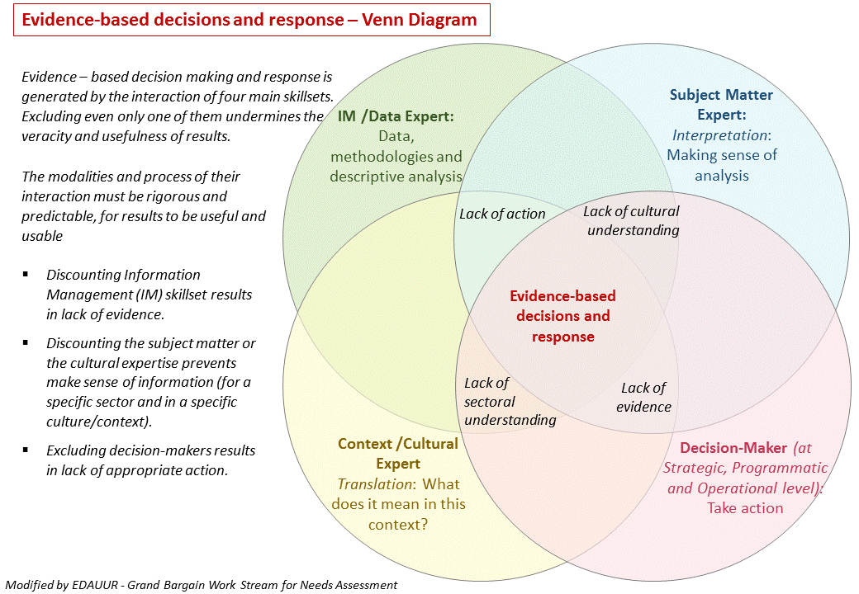
Examples of these Experts and Decision Makers in a humanitarian response
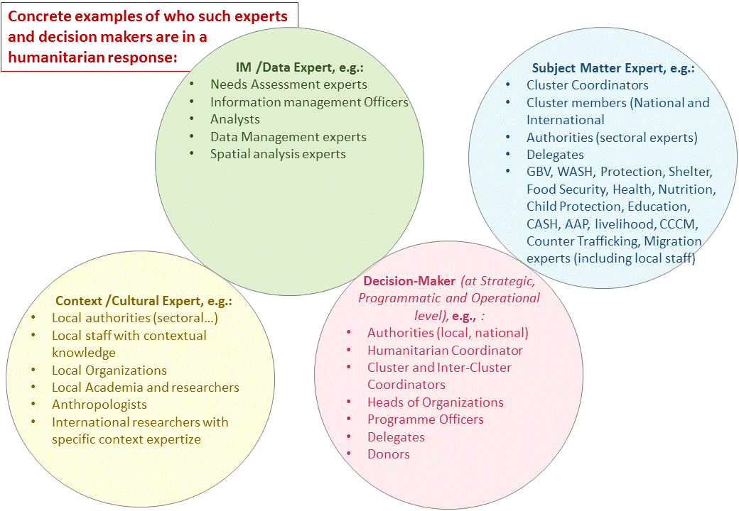

When should DTM & Partners cooperate?
DTM refers to the “DTM Common Process” for their exercises. The process is similar to those used by most other organizations and clusters, sectors, AoRs…
Close cooperation between DTM and partners is crucial along the whole Needs Assessment process, and particularly at these 5 key steps:
- Define Specific Information Needs
- Identify Questions and design Data Analysis Plan
- Planning sharing of Data and Products
- Analyzing
- Providing Feedback and adjust

How can DTM and Partners cooperate?
This Guide details modalities and provides tools for enhanced cooperation during the assessment process
- Identify Users of DTM Location Assessment data
- Reality Check from the field: Do we have time?
- DTM results in Partners’ analysis & decision-making
- Identify Information Needs
  - DTM and Partners roles when identifying information needs
- Is DTM Location Assessment the appropriate Source?
- Identify Questions and use the Data Analysis Plan
  - DTM and Partners Roles when Developing Questions and Data Analysis Plan
- DTM & Partners Cooperation on Enumerators Training
- Sharing Data
- Analysis
  - DTM and Partners roles in analysis
- Reporting
- Feedback and Adjust

Identify Users of DTM Location Assessment data
DTM provides data to the large humanitarian community, mostly through public dissemination, and when data are sensitive through modalities identified in MoUs and data sharing agreements at country level. DTM data is used by large number of partners, including Disaster Management Authorities, Ministries, Inter-Cluster, CCCM Cluster, other Clusters, AoRs, Sectors and Working Groups as well as individual organizations.
Coordination with other data producers (e.g., IMWG, Needs Assessment working group) and potential data users (e.g., CCCM Cluster, Inter-Sectoral Working Groups, Clusters, AoRs, sectors…) should happen at the start of the process. It will help DTM to define the overall purpose and specific Information Needs in the specific context.
Each response will have its specific partners: DTM should endeavour to engage them from the start, as much as Partners should do the same.
Cooperation only works when it is a shared responsibility

Reality Check from the field: Do we have time?
Collecting useful data without engaging with data users greatly limits data and analysis use. Lack of early engagement may also result to additional time spent clearing misunderstanding and correcting mistakes.
However, on the field time and human resources for engaging with all data users are limited. Clusters, IOM programmes and other partners are numerous while data are needed ASAP.
A phased approach is a practical suggestion to manage such competing priorities:
- Coordinate with other data producers (e.g., in IMWG, Needs Assessment WG…) to understand plans & main information gaps
- Start by using questions, answers and analysis suggested in the Field Companion. (These were developed together by Global DTM Support, Global Clusters, AoRs and Sectoral Experts).
- Prioritize responders⁶ to engage with, based on a) largest impact; 2) evolving information needs.
- Plan to reach all relevant stakeholders: Communicate the plan and articulate reasons for prioritization

DTM results in Partners’ analysis & decision-making
DTM is one of the tools partners use for their evidence-based decision making. Partners use all the data and information at their disposal, including DTM, for analysis and response planning.
The added benefit to DTM is that Partners can engage in the planning phase of a DTM Assessment, and shape DTM to fill their specific information gaps.

Identify Information Needs
Contributing questions without a clear link to the information gap may not provide useful information back to partners. It wastes resources and time.
Start from the decisions you have to make and identify the information you do not have to make such decisions. Only at that point, draft and validate questions, create the analysis plan and questionnaire.
Identifying detailed information needs before developing questions is essential: Questions can thus be more targeted and obtain the right data for your use.
Start from the planned use, not from the questions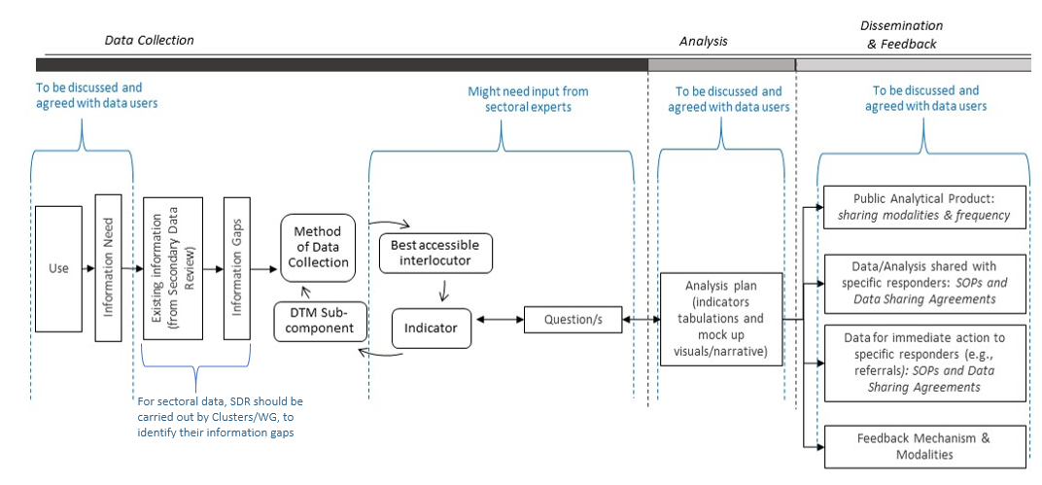

DTM and Partners roles when identifying information needs:
- Partners’ Decision-Makers (e.g., Sector/Cluster Coordinator/Members) clearly identify the decisions they have to take, and the information they need but do not have
- Partners’ Subject-Matter Experts (e.g., Sector/Cluster Coordinator/Members) identify what information is available and accessible, and where gaps are. They also identify the essential building blocks of sectoral information and the most appropriate sources of sectoral information
- Partners’ Cultural/Context Experts (e.g., local NGOs, Local staff, anthropologists and specialists of the context/culture) help turn abstract information needs into specific local ‘meaning’. They help “translate” information needs into questions that will be correctly understood in that specific context/culture.
- DTM & Partners’ IM Experts listen to and understand identified needs so to translate them into questions.

Partners will answer the following questions:
- What is it that we have to decide?
- What information do we miss in order to make that decision?
- How often should that information be updated, at a minimum, to be still usable?
- Is that information already available/ accessible?
- How will this information help in the decision-making (What are logical flow & benchmarks)?
- What are the components of the information (e.g., data that can be analysed to obtain the needed information)?
- Are any of these data already available/accessible? (conduct a Secondary Data Review)

Is DTM Location Assessment the appropriate Source?
Partners will have to evaluate if DTM Location Assessment is the appropriate source to fill their information gaps, considering method of data collection, level of analysis & measurement, feasibility, resources, time and access of DTM and alternative approaches.
DTM Locations Assessments mostly use Interviews with Non-Sectoral-Expert Key informants as a method of data collection, at community level. Data collection is carried out at regular time intervals (e.g., one, two or three months) enabling the monitoring of changes over time.
Partners’ IM experts will be able to explain strengths and weaknesses of the possible data collection methods⁷ and help partner select the appropriate data collection method for their information needs.
If a different method is necessary, partners can discuss alternative DTM tools /components (e.g., ad hoc surveys, registration…), and/or look for a different system (e.g., Cluster own assessment).
If you have a better source, please use it. Otherwise, let DTM know. They will gladly help.

The steps described are summarized in the visual below, a Decision-Making Tree.
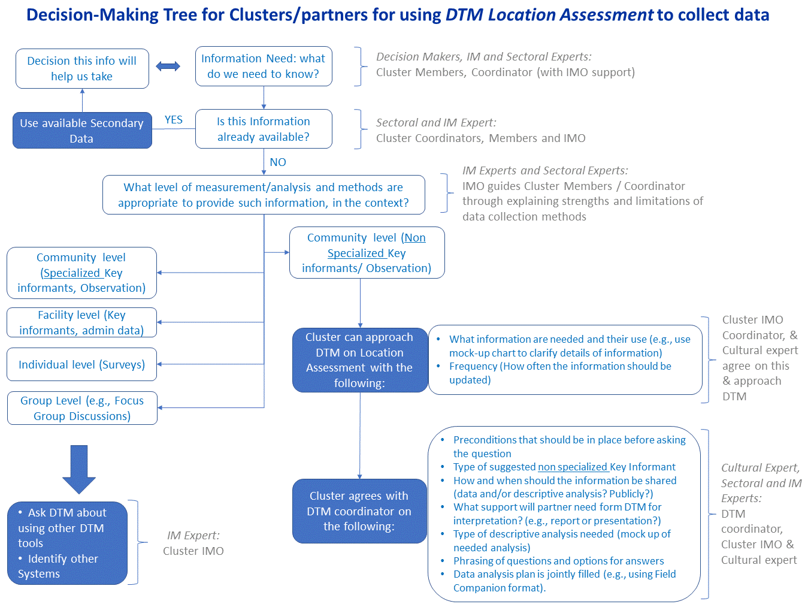

Identify Questions and use the Data Analysis Plan
Questions developed without a Data Analysis Plan may not support response.
A Data Analysis Plan links Use, Analysis, Information Need, Questions and Options for Answer. It helps DTM and Partners reach a shared understanding on what questions provides what results, & how results fill information gaps. Questions developed without a Data Analysis Plan will likely be de-linked from their analysis & use: DTM will still collect data but may not support partners’ response.
The Field Companion, available in the DTM & Partners Toolkit, is formatted as a Data Analysis Plan. It can be easily adapted to the specific DTM exercise in country, thus speeding up the work for field colleagues when they use the listed questions.
Field Companion was jointly developed by Global DTM Support, Global Clusters, AoRs and other subject matter experts.
Additional formats of Data Plan are also available.
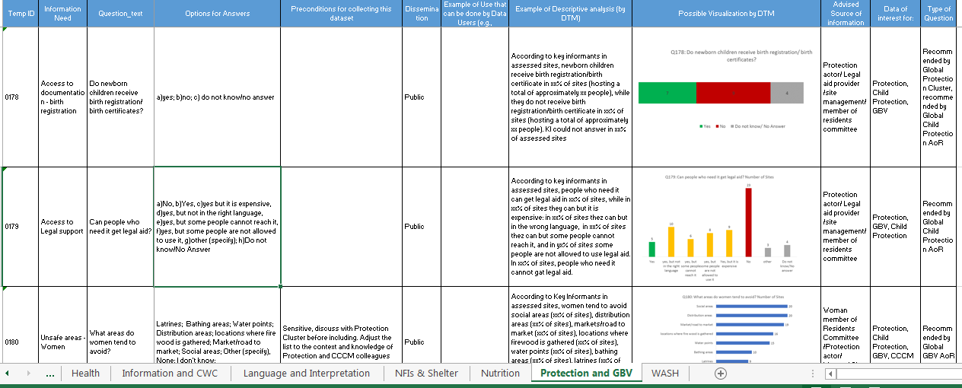
DTM Field Companion for Location Assessment Sectoral Questions is formatted as a Data Analysis Plan

DTM and Partners Roles when Developing Questions and Data Analysis Plan:
- DTM and Partner IM experts develop draft questions and options for answer with support of sectoral and cultural experts (e.g., Cluster Coordinator and members, local staff and local NGOs).
They answer the following:
  - In this context, using this methodology and this level of measurement, what questions should we ask in order to obtain the data we need?
  - In this context, using this methodology and this level of measurement, what options for answers we should give in order to obtain the data we need?
  - Is this question safe and does not put anybody at risk?
- DTM & Partner IM experts visualize and describe results using fake data (mock-up charts).
- Partner decision-makers, sectoral and cultural experts use the description and visualization to verify that drafted questions can indeed provide needed information and link questions to expected use.
- DTM & Partner IM experts make necessary changes to the questions, finalize and share the data plan.

DTM & Partners Cooperation on Enumerators Training
Specific partners can provide specialized training for DTM enumerators. This will ensure, for example, that definition are commonly agreed and questioning modalities are appropriate. Examples are the Child Protection training provided to DTM by Child Protection AoR colleagues.
Time investment by partners in training will result in increased reliability of results.

Sharing Data
DTM shares data and reports mostly through public dissemination (e.g., DTM global website: https://displacement.iom.int/ or country websites) and through mailing lists. DTM and Partners should ensure that Partners know where to find DTM data on the Internet, and how to add their address to the mailing list. Partners’ colleagues should communicate such information to their replacement when they leave, and ensure the new colleagues are on the mailing list.
DTM does not share sensitive data publically. When DTM & Partners identify specific datasets as sensitive in the Data Analysis Plan, they also agree on data - sharing modalities and sign agreements/MoUs to enable sharing.
DTM & Partners agree on modalities for URGENT ACTION data-sharing. This will ensure that DTM:
  - Recognize data needed by partners for immediate action
  - Know how and with whom to share such data in real time, even before data is processed.
Good examples are the agreements between DTM and Child Protection networks in the field, for immediate alerts when urgent needs of UASC are identified.
Some of the data for Urgent Action will be sensitive, so it is important to identify and include them in the Data Sharing Agreements/MoUs in the planning phase.

Partners & DTM should agree in the planning phase on modalities, times & frequency of data sharing

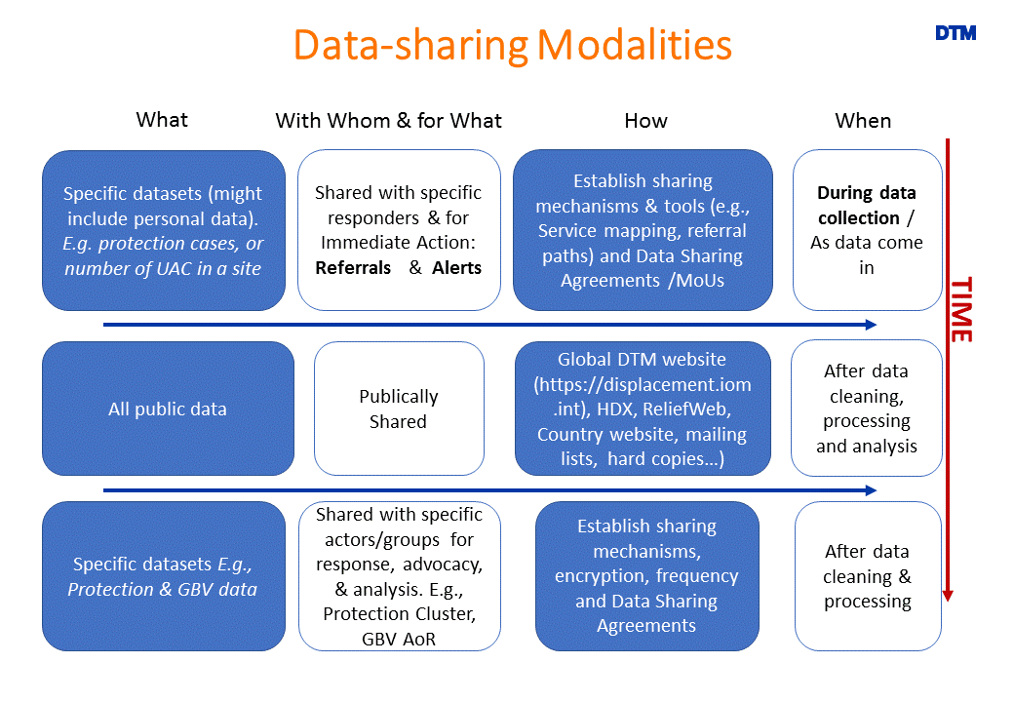

Analysis
Analysis is done at various levels, and those levels should be clear to all actors. Each level relies on the preceding ones.
DTM and Partners must agree in the planning phase on their roles at each analytical level.
DTM usually conduct explanatory and descriptive analysis of results. In some cases, some explanatory analysis can also be done (e.g., for movements of population).
Explanatory, Interpretative, Prescriptive Analysis and Response Planning are responsibility of the Partners, as per their mandate and skillsets.
DTM & Partners agree from the planning phase on whether DTM will only share data or also some type of descriptive analysis, depending on time and human resources available. They also agree on the type of descriptive analysis that will be done, through the Data Analysis Plan.
Field experience consistently highlights the effectiveness of targeted presentations of results by DTM. They spark & support accurate interpretation by Partners’ subject-matter experts, context experts and decision-makers.
Presentations can be done at clusters, inter-cluster and IMWG meetings, as well as at specific DTM events (DTM & Partners meetings, workshops…) where DTM products, activities and results are shared and feedback is captured. In some cases, a briefing on DTM results and planed activities can be included as a standing agenda point in regular coordination meetings.

DTM and Partners roles in analysis:
Exploratory Analysis:
- DTM and/or partner IM experts identify what is there & how usable it is.
Descriptive Analysis:
- DTM and/or partner IM experts develop visuals, charts &tables, according to data analysis plan.
- Partner Subject-Matter and Cultural experts (e.g., Cluster Coordinator, Members, local NGOs, external specialists) have previously agreed with DTM on types of descriptive analysis that will be useful for interpretation and include it in the Data Plan. Partner Subject-Matter and cultural experts can discuss with their IM experts initial findings and propose additional ways to compare and link data, if they have IM resources (e.g., Cluster IMO). If unplanned analysis is requested from DTM, this needs to be negotiated with DTM coordinator, and depends on resources.
- Decision Makers (e.g., Cluster Coordinator, Members) have also previously provided their information needs and those were used to design the data analysis plan.
Explanatory Analysis, Interpretation and Anticipatory Analysis:
- Partner Subject-Matter Experts and Context/Cultural Experts use descriptive analytical products to connect, relate, make sense of data and interpret information, for their specific sector and in the specific context and culture. This could happen, for example, in cluster meetings.
- DTM and partner IM experts support by providing guidance on correct interpretation of descriptive analysis products, and information on question phrasing and data collection modalities. Their involvement will also contribute to their increased understanding of sectoral information needs and likely lead to more effective IM support in coming assessments/data collection exercises. Involvement of DTM in supporting this phase (e.g., presentation of results to Partner) has to be agreed in advance, and it is contingent time and resources.
- Decision Makers involvement in the interpretation greatly increases the likelihood that their questions are addressed by the analysis. It also increases their ownership of results and likelihood that decisions are based on provided evidence. In most cases, for example when partner is a cluster, decision makers like cluster coordinator and members are also subject-matter experts and will be naturally participating to the analysis.
If Decision-Makers cannot participate, they take necessary time to understand the analytical results. These results should be presented to decision-makers in a format they easily absorb.

Prescriptive Analysis:
- Sectoral Experts, Cultural Experts (e.g., Cluster Coordinator, Members, experts of local context) develop Response Options on the basis of previous analysis and present them to Decision Makers.

Response Planning/Decision Making:
- Decision Makers (e.g., Sector/ Cluster Coordinator, Members) identify most feasible options for response and have them implemented.

Reporting
Most users receive DTM findings through DTM reports. Standard information on how the data was collected and analysed should be available in all reports, so to guide any analysis done by Partners. DTM data should not only be analysed and used, they should be well analysed and used appropriately.
This list of standard components to include in all reports is based on best practices and feedback from Partners:
- Questionnaire or Link to questionnaire
- Link to Public Datasets
- Contact details for feedback
- Contact details for non – public datasets
- Link to methodology (including how data reliability was calculated)
- Table of Content (to allow reader to find the topic they are interested in)
- Highlight the geographical boundaries of assessment, and identify what part/s of the country was not assessed
- Include definitions, for example what is a “site”, the minimum number of HH that form a site…
- Clearly identify the number of IDPs assessed, remarking if assessed areas varied compared to previous or other round (to avoid wrong comparisons of totals), and referring to previous or other round for non-assessed areas.
- Link to DTM Global and Country websites

Feedback and Adjust
Providing / Obtaining feedback is vital to keep DTM results relevant over time and it is a shared responsibility of DTM and Partners.
Feedback can be provided /obtained in various ways, for example:
  - Bilateral discussions or small meetings can provide specific input and enable in-depth understanding of challenges and solutions
  - Presenting DTM results to Partners and listening to their correlations, interpretation and planning will clarify information needs and greatly contribute to identifying necessary changes to DTM exercise
  - Email (contact details for feedback should be shared in reports and presentations)
  - Online surveys can help to capture feedback on analytical products

Feedback is then tracked and evaluated by DTM and adjustments are made as appropriate. After acting on feedback, DTM communicate to Partners how feedback was addressed or reasons for not addressing it.
Partners and DTM should agree on feedback modalities in the planning phase.
DTM & Partners Toolkit contains the tools in this document and other tools to help Partners (Clusters, Sectors, WGs, Organizations, Authorities, IOM Programmes…) & DTM teams in the field jointly obtain usable and useful data and analysis. Toolkit is available online and at this link: https://bit.ly/2Pe5KHW

Common Reasons for partial use of DTM data are summarized in the document by the same name and included in the DTM & Partners Toolkit (https://bit.ly/2Pe5KHW).
The approach and the toolkit material can be used to work with all humanitarian data users.
EDAUUR/Grand Bargain Visual representation of these findings is available in the DTM & Partners Toolkit.
Formats for such agreements are available in the DTM & Partners Toolkit
A list of common Data Users for DTM data is available in the DTM & Partners Toolkit
For another example of Data Analysis Plan, see page 14 of ACAPS Questionnaire Design, How to design a questionnaire for needs assessments in humanitarian emergencies, July 2016, available at: https://www.acaps.org/sites/acaps/files/resources/files/acaps_technical_brief_questionnaire_design_july_2016_0.pdf
Formats/examples for such agreements are available in the DTM & Partners Toolkit
A template in excel to track feedback and actions taken is included in the DTM & Partners Toolkit.

