WASH Analysis Framework DRAFT
The WASH Analysis Framework was designed in 2018 based on a review of WASH existing guidance and needs assessment reports. The framework represents the different topics and sub-topics generally being measured during WASH needs assessment. It is a working model and does not reflect a global endorsement by the WASH Cluster.
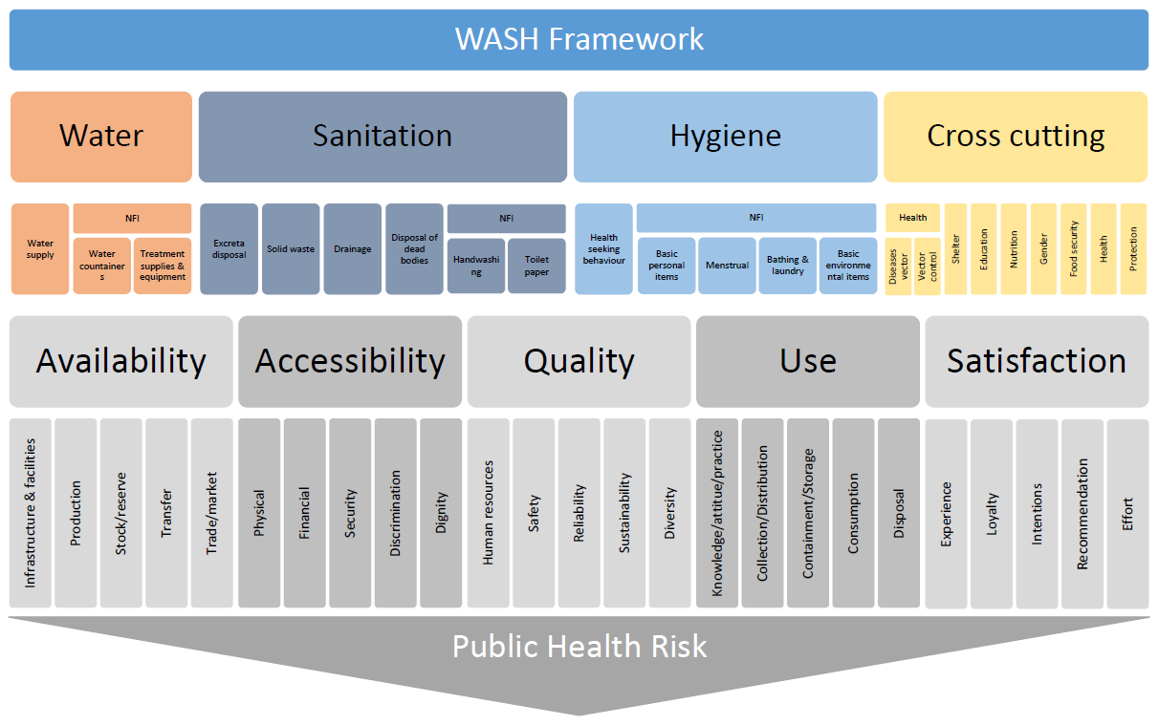

By Okular Analytics for the Global Cluster

