Needs Assessment Process - Common Steps among Organizations/ Clusters
When comparing Needs Assessment processes, it is evident that most steps are common among various organizations/clusters.
Sometimes the order of implementation may vary among processes, and often organizations/clusters have different denomination for the same step.
In a few cases, some steps are implemented only by some organization/cluster. This is mostly due to the specific mandate of each organization/cluster: e.g., some do not do primary data collection, others collect data as a service for other responders.
Main steps (and organizations/clusters that implement them) are visualized below.
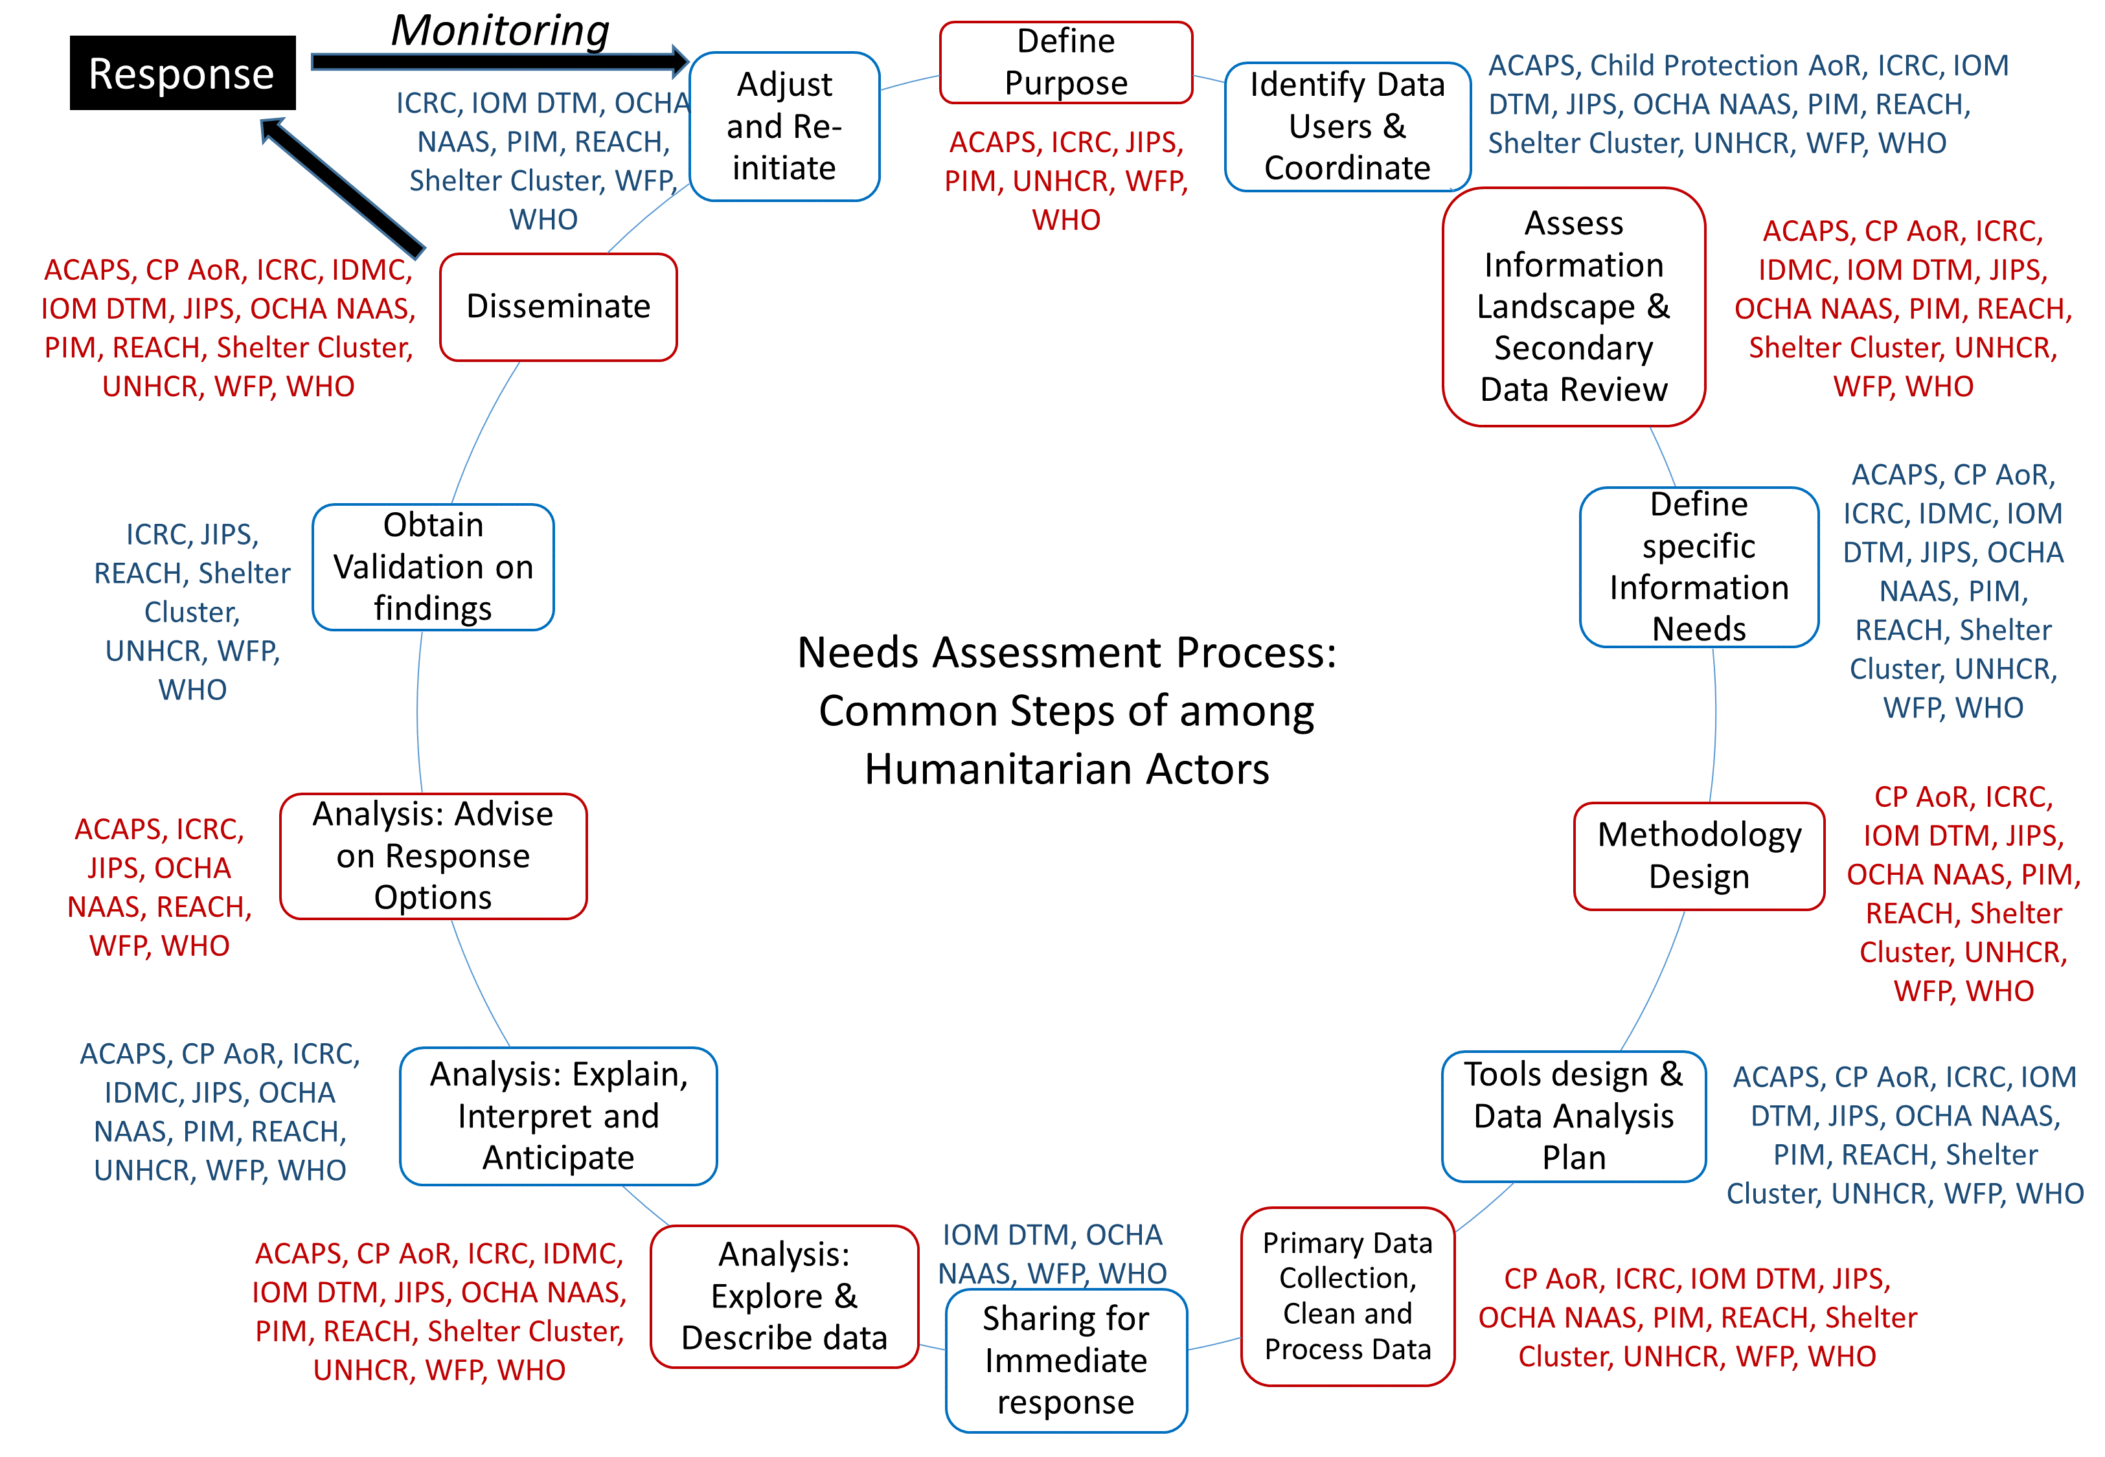

Excel with comparison filled by interested organizations is available at: https://drive.google.com/file/d/1aoHD7gk3BtpApP11adH-Tze0ssCeYjyC/view?usp=sharing

