Global Protection Cluster IOM Displacement Tracking Matrix

Frequently Asked Questions on DTM for the Global Protection Cluster, including the Child Protection, GBV, Mine Action, HLP AoRs and other members of the cluster

What is DTM?
The Displacement Tracking Matrix (DTM) is a system to track and monitor displacement and population mobility, provide critical information to decision-makers and responders during crises, and contribute to a better understanding of population flows. DTM’s mission is to gather and analyse data to disseminate critical multi-layered information on the mobility, vulnerabilities, and needs of displaced and mobile populations that enables decision-makers and responders to provide these populations with better context-specific assistance.
DTM is not a Protection Monitoring or Protection Needs Assessment tool. DTM’s Multi-Sectoral Location Assessments (MSLA) mostly interview key informants, and DTM enumerators and key informants are not usually protection experts. DTM, however, in many crisis contexts has a large and consistent coverage and provides regular updates on critical issues. It is useful for comparative situational analysis and identification of protection risks and can indicate how displacement and conditions of displaced populations evolve over time. DTM tools have been developed with inputs from various clusters and can be further adjusted to collect information that clusters need in a specific country context.

How does DTM work?
DTM’s effectiveness in meeting varying objectives in a diverse range of contexts relies on its ability to maintain a lightweight, flexible and modular structure, enabling quick adjustments and adaptation. To preserve operational flexibility, while promoting quality and coherence across DTM activities, various components, tools and methods have proven effective for quantifying displacement and mobility in DTM operations worldwide.
The four DTM components are illustrated in the visual below:

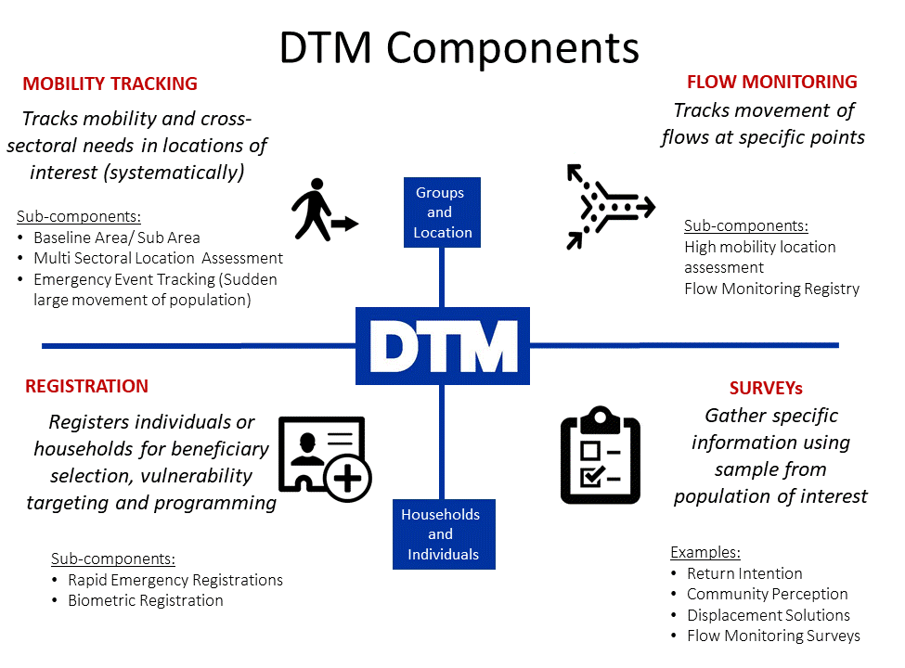

How are data collected?
DTM teams use a variety of methods for collecting data. For Baseline Assessment DTM usually interviews key informants, while observation accompanies key informant interviews in Multi Sectoral Location Assessments (MSLA). Information on the type of key informants that were interviewed is included in the data collected. Counting, short interviews with mobile populations, key informants and observation can be used in flow monitoring registry. For the Registration and Surveys components, DTM teams directly interview individuals or households. Not all DTM components need to be rolled out in every country.

How to collect, share and use DTM data without doing harm
Before contributing to the development of questionnaire and indicators, or using DTM data for analysis, protection staff should work with DTM teams to ensure the Do No Harm principle in data collection is observed and built in the process. DTM and protection colleagues can use the “Do No Harm checklist” developed in the DTM&Partners Toolkit to asses risk for each question at any stage of the data process (see https://displacement.iom.int/dtm-partners-toolkit/predictable-approach).
What does that mean? Designing questions that do no harm means considering potential risks for all stakeholders: enumerators, key informants, respondents, communities and organizations at all stages of the process, including data collection, storage, analysis, dissemination and use. It is crucial for DTM and Protection partners to consider the following, when designing data collection and analysis tools:
  - The security/political context. Whether asking certain questions or sharing results may put enumerators, key informants, communities, or humanitarian access at risk.
  - The complexity or sensitivity of questions versus the ability to do quality control in the field. Enumerators are given a brief introductory training on Protection including CP, GBV, Mine Action and HLP but they are not trained to, and it would go beyond the scope of their work, to collect any sensitive data usually collected in specialized assessments.
  - The humanitarian imperative. DTM data collection often has a wider geographic coverage within a country than existing geographic reach of response partners. It is therefore important to assess the balance between the benefits/risks of asking each question in areas without current response capacity, weighing the need of obtaining data from those non-covered areas to advocate for programmatic expansion/funding of response against the risks of holding data which may require urgent action but lacking the capacity to respond immediately.
  - Incident disclosure. Whereas DTM does not collect protection incident data, there can be cases of unprompted protection incident disclosure during the process of data collection. Consider: Is there a referral mechanism in place? Have the enumerators been trained on the Urgent Action Process? (see Urgent Action Process Guidelines for DTM available at: https://displacement.iom.int/dtm-partners-toolkit/data-sharing-guidelines).
  - Identify questions that require additional training for DTM enumerators, particularly with regards to sensitivity, terminology, or when enumerators should not read out the potential answer options during the interviews.

How can the Protection Cluster benefit from DTM-generated information?
It is very important to understand that, while DTM is not a Protection Monitoring tool, it does provide information that is useful for protection analysis if well triangulated and considered within its methodological limitations.
DTM data varies between operations, as tools are adjusted in line with the information gaps identified by partners in each context.
Here are some of the commonly collected types of information that can be relevant to the Protection Cluster from the Mobility Tracking component and specifically from the Multi Sectoral Location Assessments (MSLA).
Baseline Assessment provides a list of locations (e.g., camps, sites, villages, neighbourhoods) where displaced persons are, and initial information on the number of people, types of settlement they live in, type of population, reasons for displacement and places of origin. It can provide also some high-level information on sectors in need.
Emergency Event Tracking is collecting very initial information on displacements caused by particular events. It provides timely updates on new displacement events occurring between regular DTM assessment rounds on population group description and numbers, location the group is displaced from and to. It can also include an initial sense of the settlement arrangements and some of the urgent sectoral needs, including flagging potential protection concerns.
Multi Sectoral Location Assessments (MSLA) usually collect information per each location with presence of the mobile population group(s) of interest, including access, number of persons, an indication of sex and age disaggregated population data, available services, obstacles to accessing services and assistance, security issues, access to infrastructure (potentially disaggregated by different population groups), scale of population per dwellings and settlement types. For displacement sites, it also includes information on site management structures.
In addition, MSLA can provide some information on access, use and availability of protection services, as well as on infrastructure to be used as proxy information for increased or decreased protection risks.
DTM MSLA can, for example, collect information on the following:
  - Population estimates, including SADD (sex and age disaggregated data) and specific vulnerable groups estimates (keeping in mind that they are indeed estimates, and recording and sharing the method used to capture such data, ideally at each assessed location, to prevent misuse of- and conflicts on- data), whilst also ensuring to do no harm
  - Availability or perception of availability of services, and perceptions and indications of life-saving assistance or immediate support needed to help prioritize and trigger more in depth assessments
  - Infrastructure issues that increase or decrease the risk of protection incidents, e.g., absence of lights at the toilets or on the paths, locks on the toilets, on shelters and on bathing facilities.
  - Presence or perception of presence of security actors (however, a different data-collection method should be used to understand if the actors are effective in protecting the population, e.g., individual interviews, focus group discussions, interviews with GBV, CP, MA or Protection services providers…)
  - Indications on access including: documentation for people in the sites, groups that may have limited access to services and basic needs, material support specific to different groups, groups that may have limited representation on committees, factors that limit access to services and basic needs, for the whole population or a group, eviction threats, relationship with host community and amongst groups of displaced populations, languages spoken and means of communication used by majority
Please see DTM Field Companions for a comprehensive list of suggested questions developed with the Global Protection Cluster, Global Child Protection AoR, The Global GBV AoR, the Global MA AoR and other experts.

How can Protection Clusters in countries use DTM information?
DTM data can be helpful:
- As one of the sources to understand the scope and scale, and trends of displacement.
- DTM data can be used to raise alerts and red flags on locations in urgent need of protection interventions. It can contribute to prioritize locations for follow up actions or further inquiry through a protection monitoring mechanisms, based on a comparative assessment.
- Moreover, DTM data can be used for triangulation when conducting protection analysis.
Methods and context have an impact on the information collected in any such exercise. As highlighted before, DTM is not a Protection Monitoring or Protection Needs Assessment tool. In its mobility tracking component, DTM does not survey a sample of individuals, and DTM enumerators and key informants are not usually protection experts.
It is crucial that Protection colleagues refrain from using DTM MSLA to obtain prevalence or protection incidence data including Child Protection, Gender Based Violence, Mine Action and HLP. The methodological, ethical and contextual challenges are such that doing so could result in doing harm.

How does DTM fit in Cluster analysis?
Protection actors can use DTM MSLA data together with data from other data sources, collected through different methods, to deepen their understanding of the protection context, both at location and at aggregate levels (area, region, country…). A visualization of this is below:
DTM data in Partner’s Analysis and Decision-Making
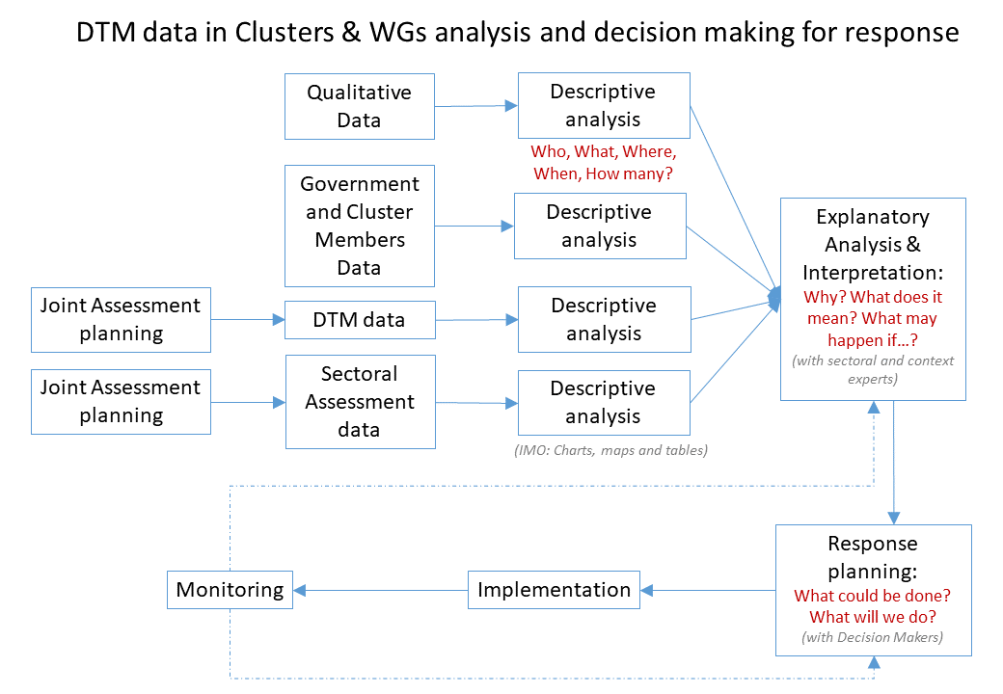

How can DTM and Protection Clusters better cooperate for the benefit of displaced persons?
At global level: Realizing that cooperation is a shared responsibility between DTM and partners, DTM and global partners (e.g., Global Protection Cluster, the Global GBV AoR, the Global Child Protection AoR, the Global Mine Action AoR, as well as with other global experts) are working together to support their field colleagues increase application and usability of DTM data. The outputs of their cooperation can be found in the Partner Toolkit (https://displacement.iom.int/dtm-toolkit/dtm-partners-toolkit) and on the partners’ respective global websites.
DTM and global clusters/AoRs/experts identified a basic set of information that field clusters may need in most contexts. This was transformed into proposed questions, accompanied by analysis mock-ups and included in the DTM Field Companion for Protection, Child Protection, GBV, Mine Action and others, available here: https://displacement.iom.int/dtm-partners-toolkit/field-companion-sectoral-questions-location-assessment
At country level: DTM teams, WGs and clusters in the countries should take the time to jointly discuss the type of information the cluster and the AoRs need and could be collected with the DTM methodology.
After identifying the missing information, they should also jointly agree on the phrasing of the questions and ensure that questions are in line with the do no harm principle. DTM and partners in countries can use the DTM Field Companions for guidance, when designing/amending the questionnaires.
Finally, clusters, AoRs and DTM colleagues can use mock-up descriptive analyses to ensure that the needed information can be obtained with the agreed questions. This can be included in the shared plan for the final descriptive analysis.
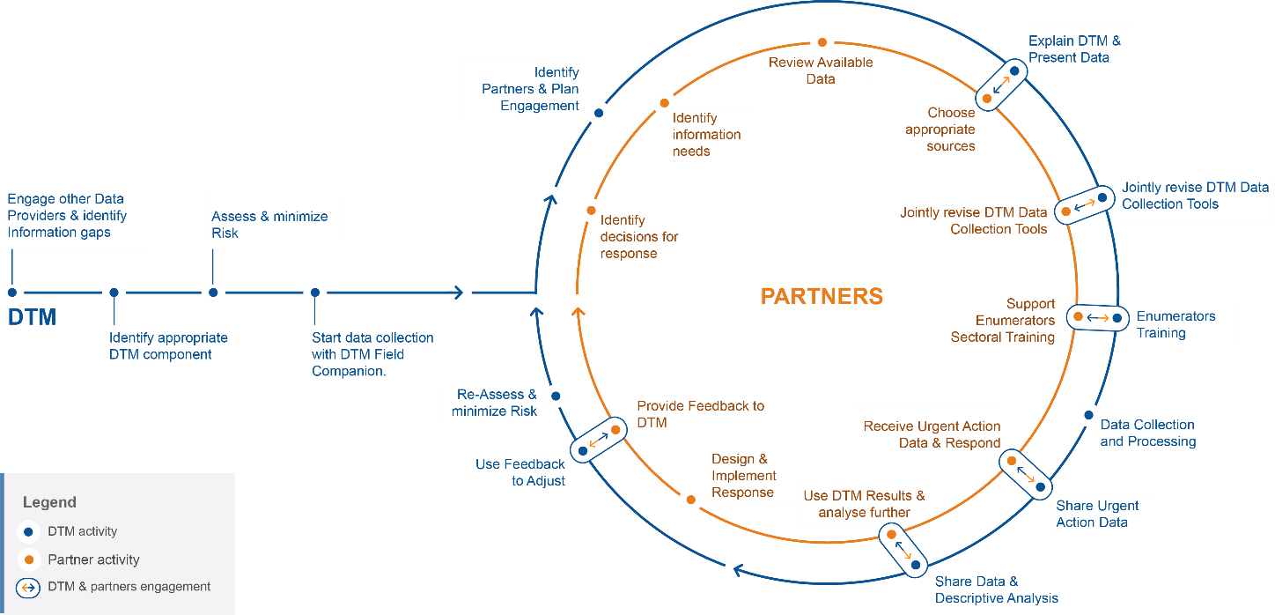
*Jointly revise DTM Data Collection Tools include: Jointly use Field Companion to identify questions that provide needed information. Add /Modify according to context; Ensure that asking each question, analysing, sharing and using results does not cause harm to population, enumerators, key informants and organizations; Ensure effective phrasing of questions and reply options by verifying simulated description of expected results; Jointly identify dissemination modality for each dataset & sign Data Sharing Agreements for sensitive data; Be aware of when, where & how DTM data & reports will be shared; Agree on Roles in analysis for DTM and Partners; Share/receive final Data Analysis Plan; Agree on Feedback mechanism.
The visual above summarize the process and highlights key steps for cooperation between DTM and clusters, based on the outcomes of the Grand Bargain work stream for Needs Assessment. Detailed guidance on how and when to engage can be found at: https://displacement.iom.int/dtm-partners-toolkit/predictable-approach and: https://displacement.iom.int/dtm-partners-toolkit/other-tools

Who analyses DTM data?
DTM questions are designed to be asked and answered by non-sectoral experts, in a way that results can be used by sectoral experts for interpretation. DTM shares data with partners, and can do some descriptive analysis for sectoral data, as detailed in the Data Analysis Plan. Interpretation, explanation and higher levels of sectoral analysis are the responsibility of Cluster, that may analyse DTM data together with additional sources.
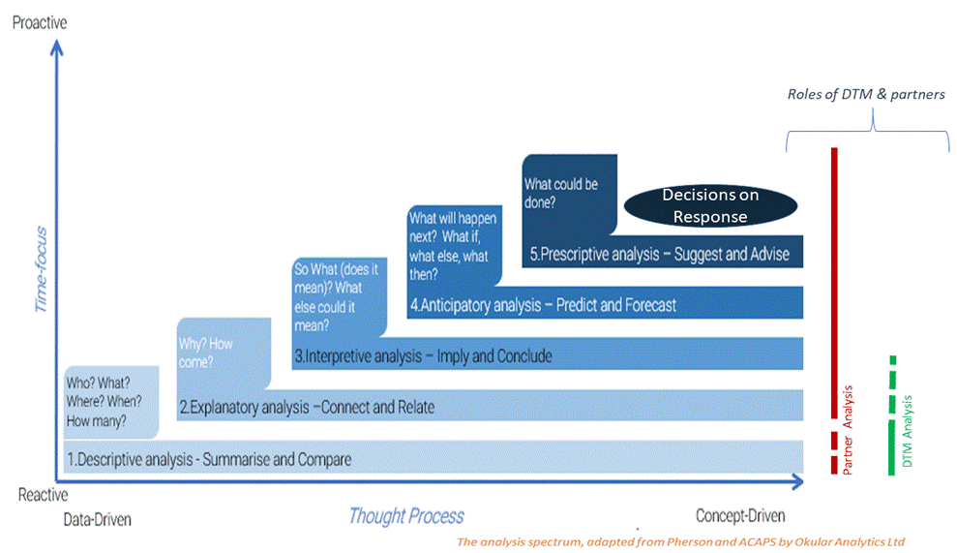
It is crucial that DTM and cluster agree on whether DTM will only share data or also some type of descriptive analysis, as well as the modalities (public/restricted) and frequency of that sharing for each dataset during the planning phase.
Field experience consistently highlights the effectiveness of targeted presentations of results by DTM to Inter-Cluster, WGs and Clusters. This is useful as few people have the time to read whole reports and presentations of results can be very effective in supporting accurate interpretation by subject-matter experts, cultural/context experts and decision makers (e.g., in a cluster meeting).
Time constraints may limit DTM capacity to reach out to the clusters or relevant working groups (WGs), and Protection colleagues are encouraged to be proactive in asking for such presentations (as cooperation is a shared responsibility).

Where can I find DTM reports and data?
DTM public data and reports are online and available at: https://displacement.iom.int/, http://migration.iom.int/europe/ and http://www.globaldtm.info/. For support, contact the DTM coordinator in your country (ask DTMSupport@iom.int for his/her contact details).
DTM teams in the field may also identify issues for urgent follow up by the Protection Cluster or its members. Ideally, the Protection Cluster and WGs in each country will advise DTM teams (while developing the questions) on the most appropriate modality to communicate such issues to protection actors or inform beneficiaries of relevant focal points. For any data deemed sensitive or confidential by DTM and clusters/WGs when developing the questions, in fact, a Data Access Request form or Data Sharing Agreement will need to be signed, ideally before data collection starts.
How does DTM contribute to PIM systems?
When DTM discusses MSLA with Protection colleagues, it is a good practice to clarify what Protection Information Management (PIM) systems DTM MLSA can and cannot provide information for. The PIM Matrix lists the PIM systems as follows:
- POPULATION DATA (DTM MSLA usually provides information of pop figures and estimates of some vulnerable groups)
- PROTECTION NEEDS ASSESSMENTS (DTM MLSA is not a Protection Needs Assessment tool/System. However, it can provide some information on some aspects that can be used by protection actors)
- PROTECTION MONITORING (DTM MLSA is not a Protection Monitoring tool/System. However, it can provide some information on some aspects that can be used by protection actors)
- CASE MANAGEMENT (DTM MLSA is NOT a case management system, but enumerators should know how to refer cases to protection actors if they come across any. Protection actors keep the responsibility of establishing functioning referral pathways, and inform DTM of them, so to enable referrals)
- PROTECTION RESPONSE MONITORING AND EVALUATION (DTM MLSA is not a Protection Response Monitoring and Evaluation tool/System)
- SECURITY & SITUATIONAL AWARENESS (DTM MLSA is not a Security assessment tool/System, however it can provide information on access to displacement locations)
- SECTORAL SYSTEMS / OTHER (DTM MLSA is a multi-sectoral system, collecting information on needs, services, infrastructure, material, and physical support for many sectors. The information can be used by protection actors to enable protection outcomes, e.g., improving access to basic needs, reducing risk of protection violations…).
- COMMUNICATING WITH (in) AFFECTED COMMUNITIES (DTM can provide some information on main means of communication used in the communities, and languages used. These can support sectoral colleagues design their communication plans)

Additional Tools and References
- GBV: 4-pager by the Global GBV AoR, Using DTM Multisectoral Location Assessment to inform GBV response, in: https://displacement.iom.int/dtm-partners-toolkit/gbv
- Child Protection: 2-pager by the CP AoR, “Use of DTM data for Child Protection” and the comprehensive CP AoR Guidance Obtaining useful data from IOM’s Displacement Tracking Matrix (DTM) to inform child protection humanitarian planning and response, both in: https://displacement.iom.int/dtm-partners-toolkit/child-protection-0
- DTM Field Companions for Protection, CP and GBV in Excel and in PDF, in: https://displacement.iom.int/dtm-partners-toolkit/field-companion-sectoral-questions-location-assessment
- IOM Protection, Integrating protection indicators in DTM: standard operating procedure (SOP), in: https://displacement.iom.int/dtm-partners-toolkit/protection-0
- Draft and final Analytical Frameworks are available in the toolkit, https://displacement.iom.int/dtm-partners-toolkit/analytical-frameworks
- UNICEF Guide for Sector severity and priority IDP locations with DTM data, and the narrated briefing that explains it, in https://displacement.iom.int/dtm-partners-toolkit/analysis)
- Do No Harm checklist in: https://displacement.iom.int/dtm-partners-toolkit/predictable-approach
- PIM Matrix: http://pim.guide/essential/principles-matrix-process-quick-reference-flyer/
- Child Protection AoR, NIAF briefing note, in: https://displacement.iom.int/dtm-partners-toolkit/other-tools-1
For more info, see the DTM&Partners Toolkit at: https://displacement.iom.int/dtm-toolkit/dtm-partners-toolkit

For support, contact the DTM coordinator in your country or DTMSupport@iom.int

In many contexts, there is the risk of misuse and misinterpretation of population data and their definitions to the disadvantage of the populations themselves. Certain movements are not of a voluntary nature and this distinction should be explained as clearly as possible. In addition, we should consider how specific rights are linked to recognition of status. It is therefore good norm for DTM and Protection colleagues to jointly consider such risks and identify modalities of categorizing and presenting population figures that “Do no harm” to all the persons we serve in that specific context.
For example, the GBV IMS collects data on incidents from service providers not from KI interviews, observation or HH interviews. When we need data to justify a GBV intervention, we should remember that it is widely accepted in the humanitarian community that reported number of protection/GBV or Child Protection incidents is not only impacted by the actual number of incidents, but rather is influenced by many other factors. Especially for GBV, CP and sensitive issues, caution is needed when using the number of incidents to provide evidence for response, as it can be misleading and can result in a disservice to beneficiaries. A low number of reported cases may be due to the lack of trust in the reporting mechanism, while a high number of reported incidents can be a sign that the reporting mechanism is available, it works and is trusted by the community. “Waiting for or seeking population-based data on the true magnitude of GBV should not be a priority in an emergency due to safety and ethical challenges in collecting such data. With this in mind, all humanitarian personnel ought to assume GBV is occurring and threatening affected populations; treat it as a serious and life-threatening problem; and take actions based on sector recommendations in these Guidelines, regardless of the presence or absence of concrete ‘evidence’”, IASC Guideline for Integrating Gender-Based Violence Interventions in Humanitarian Action, page 2.
See: Do no Harm checklist, in: https://displacement.iom.int/dtm-partners-toolkit/predictable-approach
These are commonly known as “Data Analysis Plan”, that can be developed using the DTM Field Companion templates in pdf or excel, in: https://displacement.iom.int/dtm-partners-toolkit/field-companion-sectoral-questions-location-assessment
See Tools to ensure data is useful and usable in: https://interagencystandingcommittee.org/improve-joint-and-impartial-needs-assessments/content/workstream-5-tools-and-guidance-advancing).
For templates of Data Sharing Agreements, see: https://displacement.iom.int/dtm-partners-toolkit/dtm-data-sharing-forms and sub-folders; for guidance on data sharing, see: https://displacement.iom.int/dtm-partners-toolkit/data-sharing
Protection Information Management (PIM) is the “principled, systematised, and collaborative processes to collect, process, analyse, store, share, and use data and information to enable evidence-informed action for quality protection outcomes”. The objective of PIM is to provide quality data and information on people in displacement situations in a safe, reliable, and meaningful way. PIM is helpful in ensuring the efficient and targeted use of resources and to enable the coordination, design, and delivery of protection responses. See: pim.guide for the PIM Matrix listing and describing such systems
For conflicting population data among data providers, see: Planned Redundancy, Practical approaches to different Population data, available in: https://displacement.iom.int/dtm-partners-toolkit/population-data

