Displacement Tracking Matrix Frequently Asked Questions for Mine Action AoR
What is DTM?
The Displacement Tracking Matrix (DTM) is a system to track and monitor displacement and population mobility, provide critical information to decision-makers and responders during crises, and contribute to better understandings of population flows. DTM was first conceptualized in 2004 to monitor internal displacement in Iraq and has since been adapted for implementation in 80 countries, including in contexts of conflict, natural disaster, complex emergencies and protracted crises.
How does DTM work?
DTM’s effectiveness in meeting varying objectives in a diverse range of contexts relies on its ability to maintain a lightweight, flexible and modular structure, enabling quick adjustments and adaptation. To preserve operational flexibility, while promoting quality and coherence across DTM activities, various components, tools and methods have proven effective for quantifying displacement and mobility in DTM operations worldwide. The four DTM Components are illustrated in the visual below:
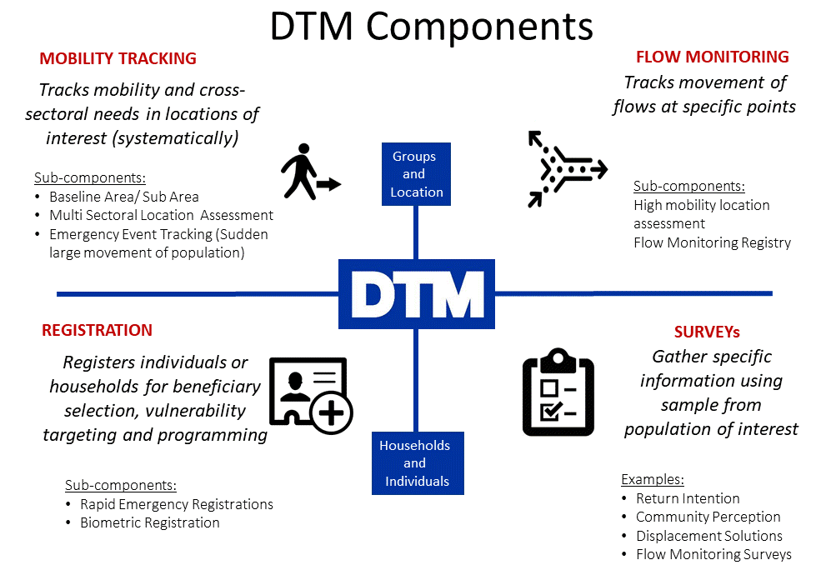
Are all DTM components rolled out in every country?
Not necessarily: DTM is implemented according to need, so different components may be rolled out in different countries, as need for information varies.
How are data collected?
DTM teams use a variety of methods for collecting data. For Baseline Assessment usually DTM interviews key informants, while direct observation generally accompanies non-sectoral specialist key informants interviews in Multi Sectoral Location Assessments. Counting, key informants and direct observation can be used in flow monitoring registry. For Registration and Surveys DTM teams directly interview individuals or households. Information on the type of Key Informants that were interviewed is included in the data collected. DTM Methodological Framework is available here.
What DTM information may be useful for Mine Action AoR response?
DTM produces a variety of datasets, and sometimes datasets varies between operations. Here are some of the commonly collected types of information that can be relevant to the Cluster from the Mobility Tracking component.
Baseline Assessment usually can provide list of locations (e.g., camps, sites, communities) where displaced persons are, and initial information on the number of people, types of settlement they live in, type of population, reasons for displacement and places of origin, sectors of need.
Emergency Event Tracking is collecting very initial information on displacements caused by particular events. It can provide timely updates on new displacement events occurring between regular DTM assessment rounds on population group description and numbers, location the group is displaced from and displaced to. It can also include an initial sense of the settlement arrangements and some of the urgent sectoral needs.
Multi Sectoral Location Assessments (MSLA) usually collects information per each location, including access, number of persons, an indication of sex and age disaggregated data, an indication of scale of specific groups, geographical coordinates, obstacles to accessing services and assistance, settlement types, reasons for displacement, place of origin of the communities, concerns about place of origin.
Mine Action AoR may specifically make use of the following DTM MSLA information, as per MA Analysis Framework:
DTM Core Datasets (available for all MSLA exercises)
- Displacement locations names and geographic coordinates
- Number of people per location with Age and Gender estimation
- Reasons for displacement
- Place of origin (admin level details to be agreed with DTM)
- Locations and District DTM MSLA has NOT assessed (Information GAPS)
Intersectoral Standard datasets (optional – AoR should agree with DTM on including them, if they need the information)
- Community’s concerns about Place of origin (may include Explosive Ordnance - EO)
- Reasons preventing return (may include Explosive Ordnance - EO)
- Reasons for limited freedom of movement (may include Explosive Ordnance - EO)
- Language/s spoken in the location
- Preferred means of obtaining information used by community
- Access to media and means of communication
- Planned relocation of community and where
Sectoral Mine Action information (optional – AoR should agree with DTM on including them, if they need the information to help prioritize Non-technical assessment)
- Perceived presence of contamination /EO in or around the community
- Marked or unmarked EO
- Impact on access to livelihood, basic needs and basic services
- If there have been Incidents/victims in the reporting period due to Explosive Ordnance (Yes/No answer only. It is not advised to try and obtain the exact number and/or break-down of victims using a KI methodology. MA AoR can use records from Healthcare centres or other sources)
- If there have been killing of injuring of animals in the reporting period due to Explosive Ordnance
- Whether or not Explosive Ordnance Risk Education was received by the community, which group and how recently (before or since a giver time period - the KI methodology is not appropriate for understanding further details on the Explosive Ordnance Risk Education, including quality and type of information provided)
How can Mine Action AoRs in countries use DTM information?
DTM data are often used to understand scope and scale of displacement, as well as trends. However, they are also used operationally, for example to raise alerts and red flags on locations in urgent sectoral need, and to help prioritize locations for follow up with a non-technical assessment and other action.

Methods and context have an impact on the information collected in any such exercise. DTM is not a Mine Action Needs Assessment tool. In its mobility tracking component, DTM does not interview individuals or HH, and DTM enumerators and key informants are not Mine Action experts. DTM, however, has a large and consistent coverage of crisis, can be adjusted to collect information that Mine Action AoR colleagues need, and provides regular updates on critical issues. In addition, its data are collected over time, and can indicate how displacement and conditions of displaced populations evolve over time.

Evidence-Based Decision-Making
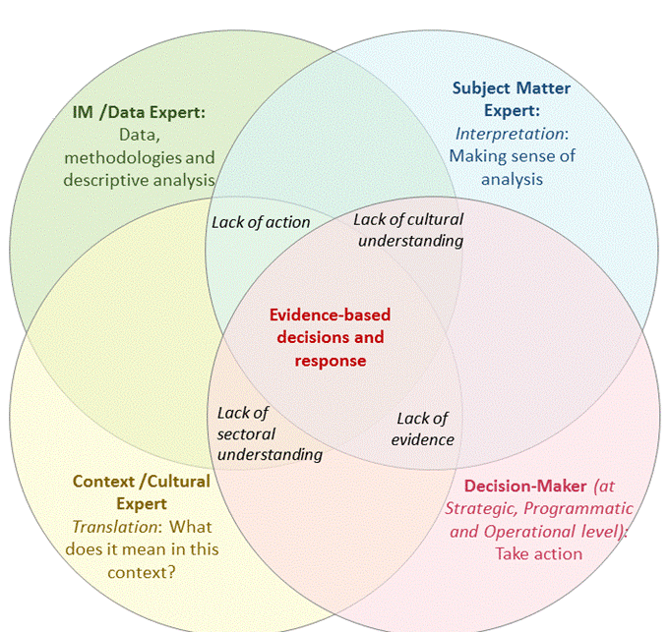
Visual was modified by EDAUUR – Grand Bargain Work Stream on Needs Assessments

AoR (Sectoral experts/decision makers) and local Cultural/Context Experts analyse data by DTM & other sources. Notice the complementarity among skillsets, & the risks of excluding any skillset from evidence-based decision-making process.

DTM questions are designed to be answered by non-sectoral experts, in a way that results can be used by sectoral experts for analysis. Ideally, DTM teams provide the clusters with information and possibly descriptive analysis (with AoR IM experts). Information can be then included in the Mine Action AoR analysis and jointly analysed by the AoR members (as they are subject matter experts/decision makers) and local context/cultural experts. For help using DTM data for Mine Action analysis, bringing together available information from all other sources, as per Global Mine Action AoR Analysis Framework and Explaining Notes (https://www.globalprotectioncluster.org/themes/mine-action/mine-action-essential-guidance-and-tools/).
How can DTM and AoR further engage for the benefit of displaced persons?
At global level: In order to increase usefulness and usability of DTM data by clusters and cluster members, DTM worked with various Global Clusters, AoRs and WGs, to identify a recommended approach, useful tools and basic information clusters may need in most contexts. This information was transformed into proposed questions and included in the DTM Field Companion. Approach, DTM Field Companion for Mine Action & other tools are available in the online DTM& Partners Toolkit section on Mine Action (https://displacement.iom.int/dtm-partners-toolkit/guide/dtm-msla-mine-action).
At country level: DTM teams and Mine Action AoR in the countries will jointly discuss the type of information the AoR is missing, that could be collected by DTM. After identifying the missing information, they will jointly agree on the phrasing of the questions, on an analysis plan, on data-sharing modalities and their respective roles in analysing the information.
AoR will also advise DTM teams on the most appropriate modality to communicate issues identified during data collection, and those data that may be sensitive & should not be shared publicly, or that require urgent response by Mine Action actors (Urgent Action). DTM and Partners can use the Field Companion and the other tools in the DTM& Partners Toolkit for help, when designing/amending their data collection exercises.
Where can I find DTM reports and data?
DTM public data and reports are online and available at: https://displacement.iom.int/, http://migration.iom.int/europe/ and http://www.globaldtm.info/ (through a search by Country).
For support, contact DTM coordinator in your country (ask DTMSupport@iom.int for his/her contact details).

